University of Guam Experiment Stations Online GIS Map Third Report
Western Pacific Tropical Research Center
Research Station GIS Web App User Guide
The Research Station Web App can be visited at the following internet addresses found at the Western Pacific Tropical Research Center website:
Ija: https://govguamgis.maps.arcgis.com/apps/webappviewer/index.html?id=8961cad327914c7cbf6de1aca8ffccee
Inarajan: https://govguamgis.maps.arcgis.com/apps/webappviewer/index.html?id=6f1e7d9250f245eb90c3ab9f28ec7e3a
Yigo: https://govguamgis.maps.arcgis.com/apps/webappviewer/index.html?id=fe72738e2afb4f54a09680edc10e4645
The web app is a tool for visualizing and exploring WPTRC research stations and offers much of the benefits of using GIS maps without the difficulties associated with using the full GIS software.
This guide outlines most of what the user can do with the app and includes screen shots of the app to demonstrate the functions being discussed. If the user cannot see the screen shots very well, he/she can click on ‘View’ and ‘Zoom’ in the Word document and then click the dot next to 200%.
With the web app the user can:
1) Zoom in and out/ return to the default map view after zooming
2) Change the base map
3) Turn layers on and off
4) Click on a feature to see its data/information
5) Open the attribute table to view all available data columns
6) Zoom to layers and/or features
7) Change the transparency and visibility range of layers.
The web app shows a ‘Streets’ map image of each station by default, but as part of ArcGIS online it has full functionality so in the search bar where it says, ‘Find address or place’, the user can enter an address or place name, and it will take his/her to a street map image of that place.
Whether the user is looking at one of the research stations or somewhere else, he/she may want to zoom in to see more detail.
Zoom in/Zoom out/Default extent - To the left of the search bar there are little boxes with a plus and a minus sign.
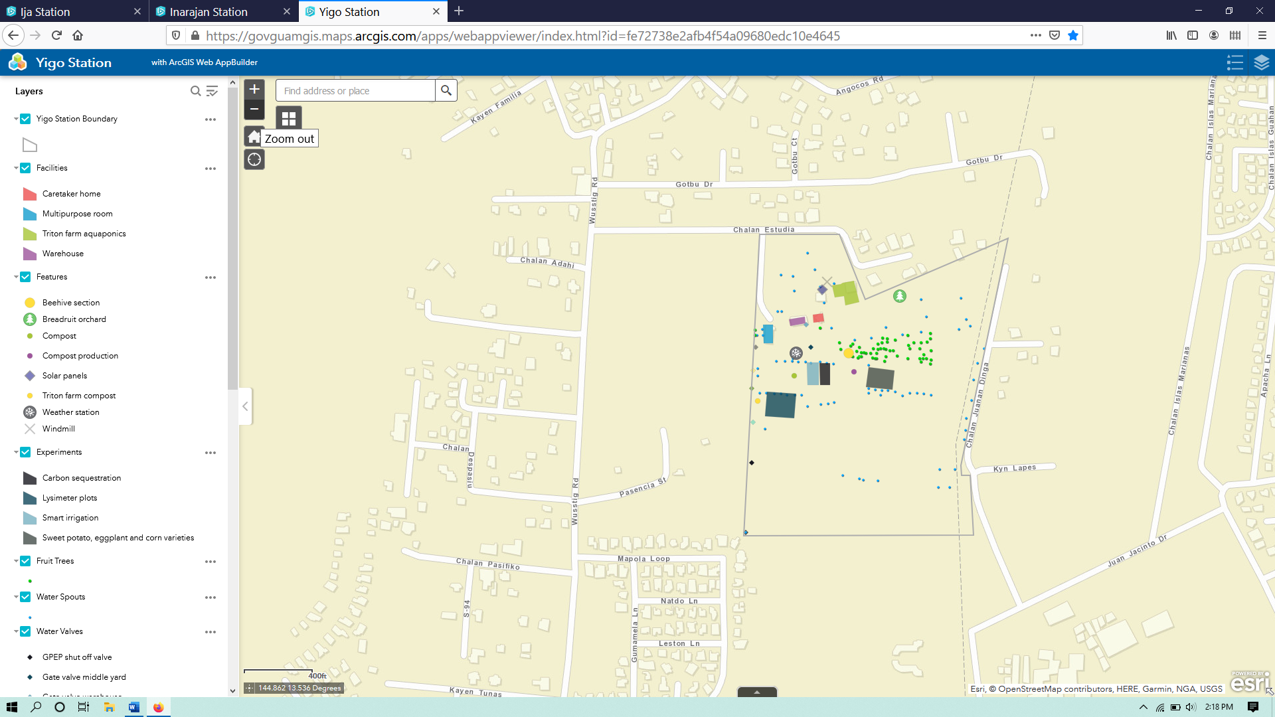
If the user clicks on the plus sign you will zoom in by a factor of two, and clicks on the minus sign he/she will zoom out likewise. If you the user is using a computer with a mouse that has a wheel, pushing the wheel forward will zoom in and pulling it back will zoom out.
If the user getslost or just want to go back to the original extent, can click on the icon with a house symbol in it below the minus sign box called ‘Default extent’.
The icon with the compass looking symbol below the home button is for finding where the user is, wherever that is, and if he/she wants to use it the device has to be set to allow your location access. If it is and the user clicks on the icon, he/she will be whisked to a street map image of wherever the device is being used.
Changing the base map – Depending on the interests, the user may want to change the base map to see a satellite image, for example. Directly below the search bar in the upper left corner of the picture window of the web app, there is a small box with a window icon. If the user hovers the mouse pointer over it, it should say ‘Basemap Gallery’.
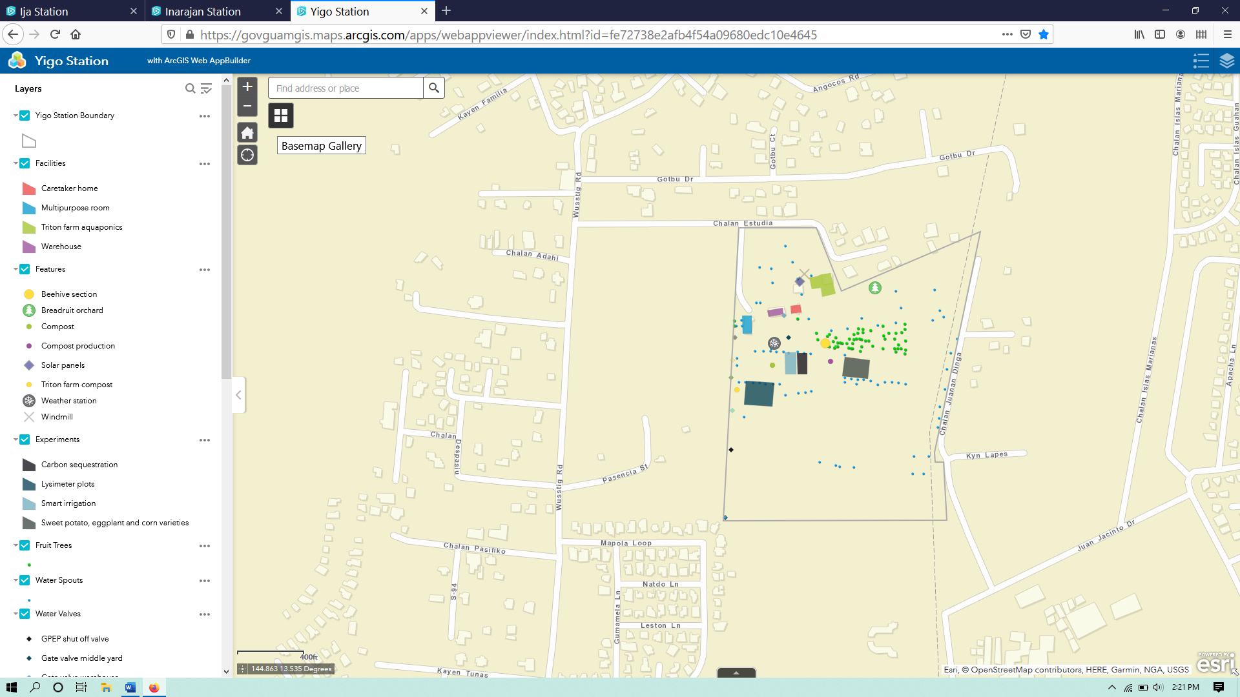
If the user clicks on the icon, a small window will open with a couple dozen base map options to choose from.
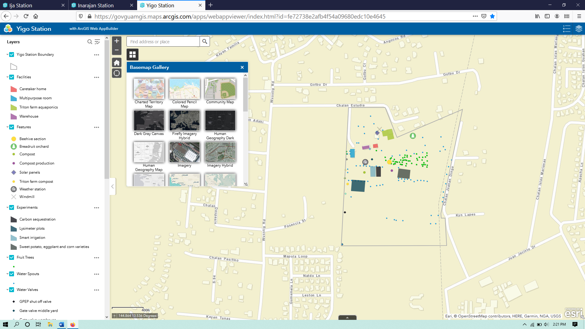
The options may change sometimes, but can be tried them all, by clicking on them. To see a satellite image of the station, the user should select ‘Imagery’.
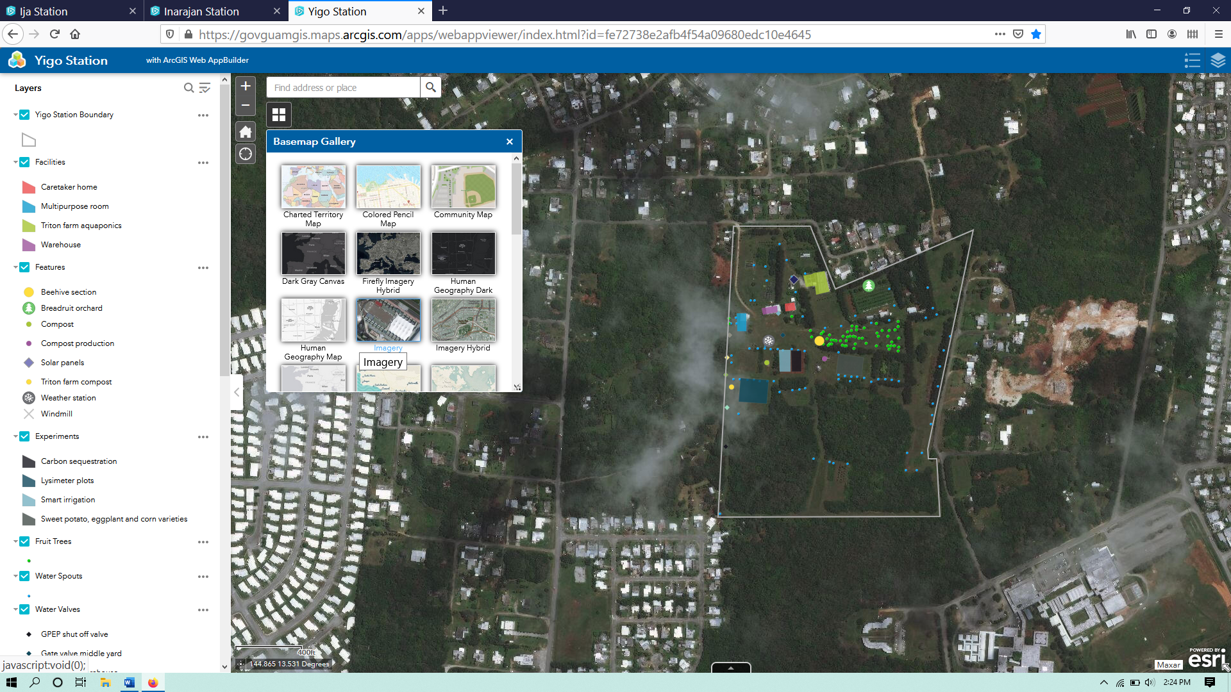
If the user wants to go back to the street view of the island, he/she should click on the basemap titled ‘Streets’.
Notice that regardless of which basemap is selected, there is a vertical tab open on the left hand side of the screen with a list of the layers available to view in the app. There are blue check boxes next to some of the layers and empty white boxes next to others. If the user clicks on a box with a checkmark, the mark and the layer will disappear, and if the user clicks on a empty box, the mark and layer will appear. Zoom in once and click on the Yigo Station Boundary layer would make it disappear.
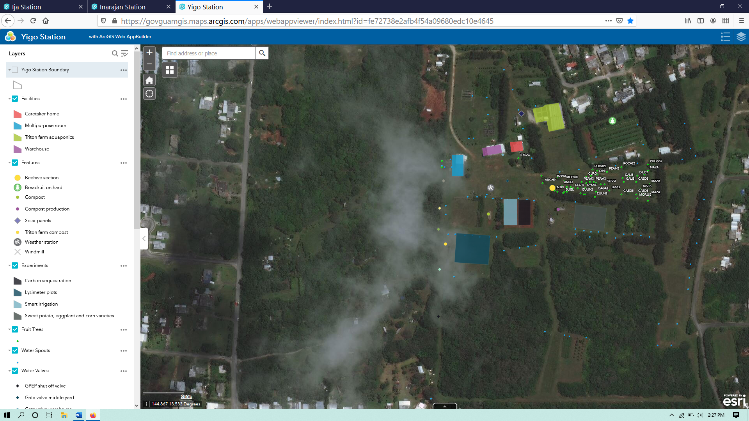

To see vegetation, soils, or contours on the map, the user should click once on all of the empty white check boxes to turn them on, including the Yigo Station Boundary layer to turn it back on.
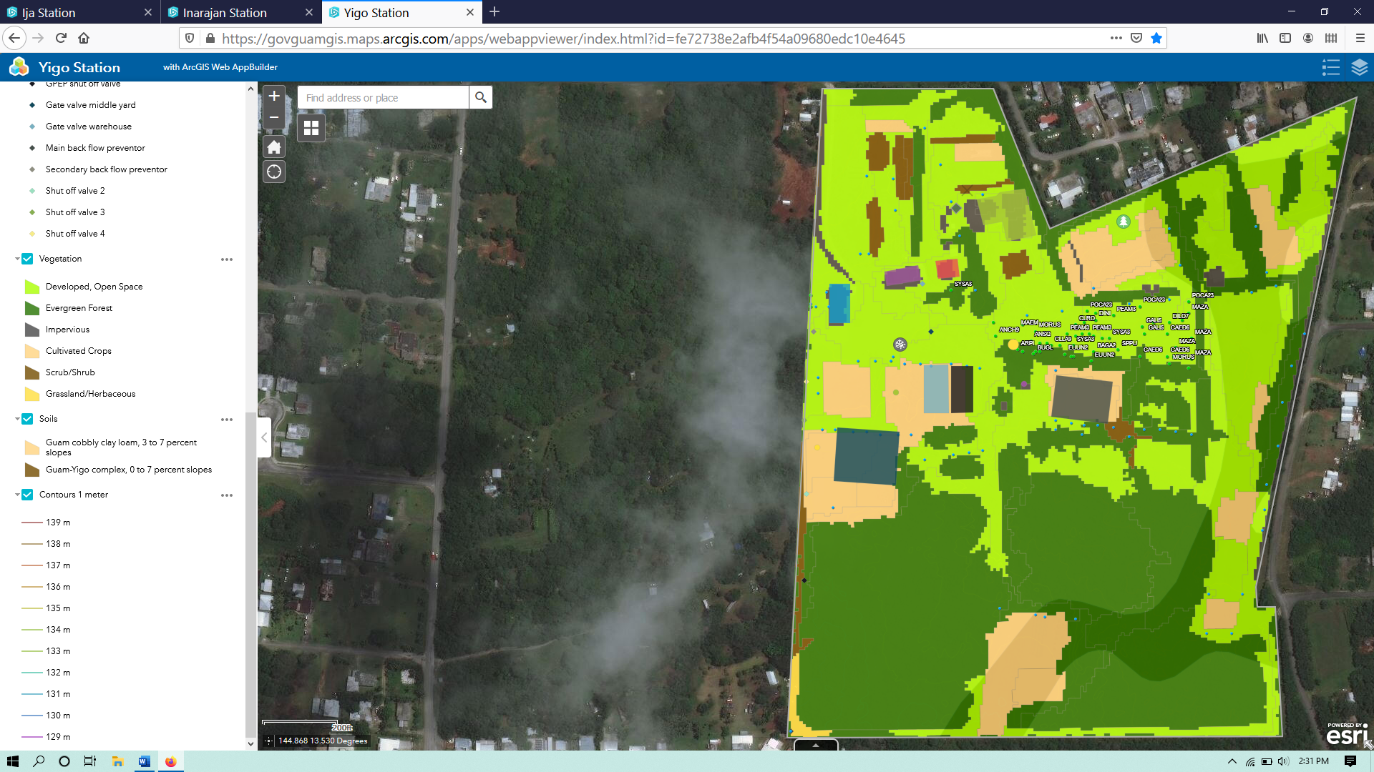
The map should look something like this. The vegetation, soils, and contours only show up within the station boundaries.
Click on a feature to see data/information – The user can click on anything within the station boundary, and a small window will appear with the data/information associated with that map feature. Note that if multiple layers are turned on and overlap at the place where you click, more than one feature will show up in the box, and the user can use the arrow(s) at the top to switch between them.
Zoom to from information box - The ‘Zoom to’ option at the bottom of the box will recenter the image around the clicked feature, and how much the image zooms in depends on the size of the feature. Perhaps the user is interested in what the vegetation type is at the southern end of Yigo station. To do this, he/she should click within the dark green area in the lower left corner somewhere.
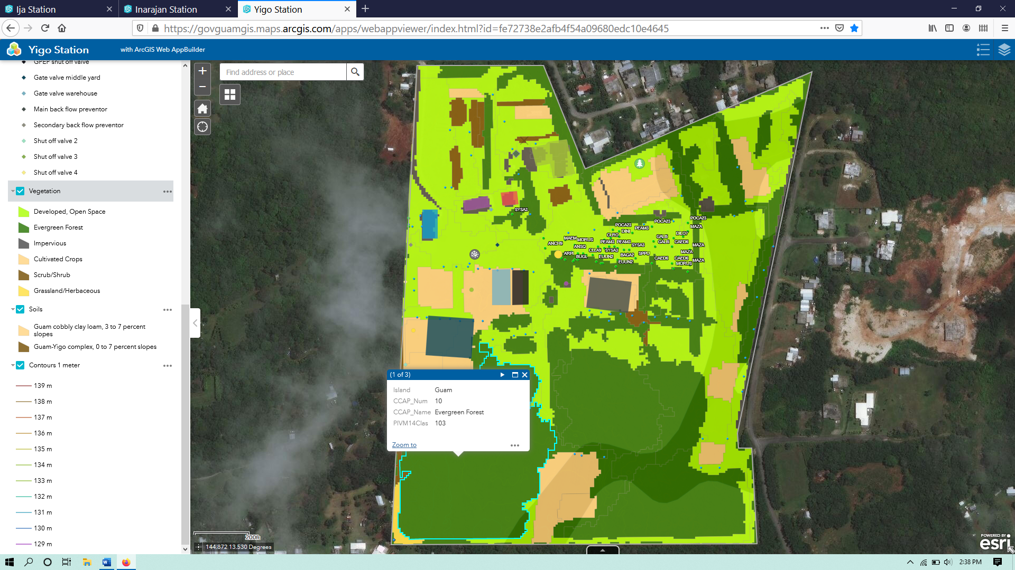
In this case there are three features that overlap at this location, and the data shown in the window is usually in the same order as the drawing order of the layers. There is evergreen forest at this location, with Guam cobbly clay loam soil. How does the user know that? He/she can see the vegetation type in the data window, and then click on the forward arrow at the top of the data box.
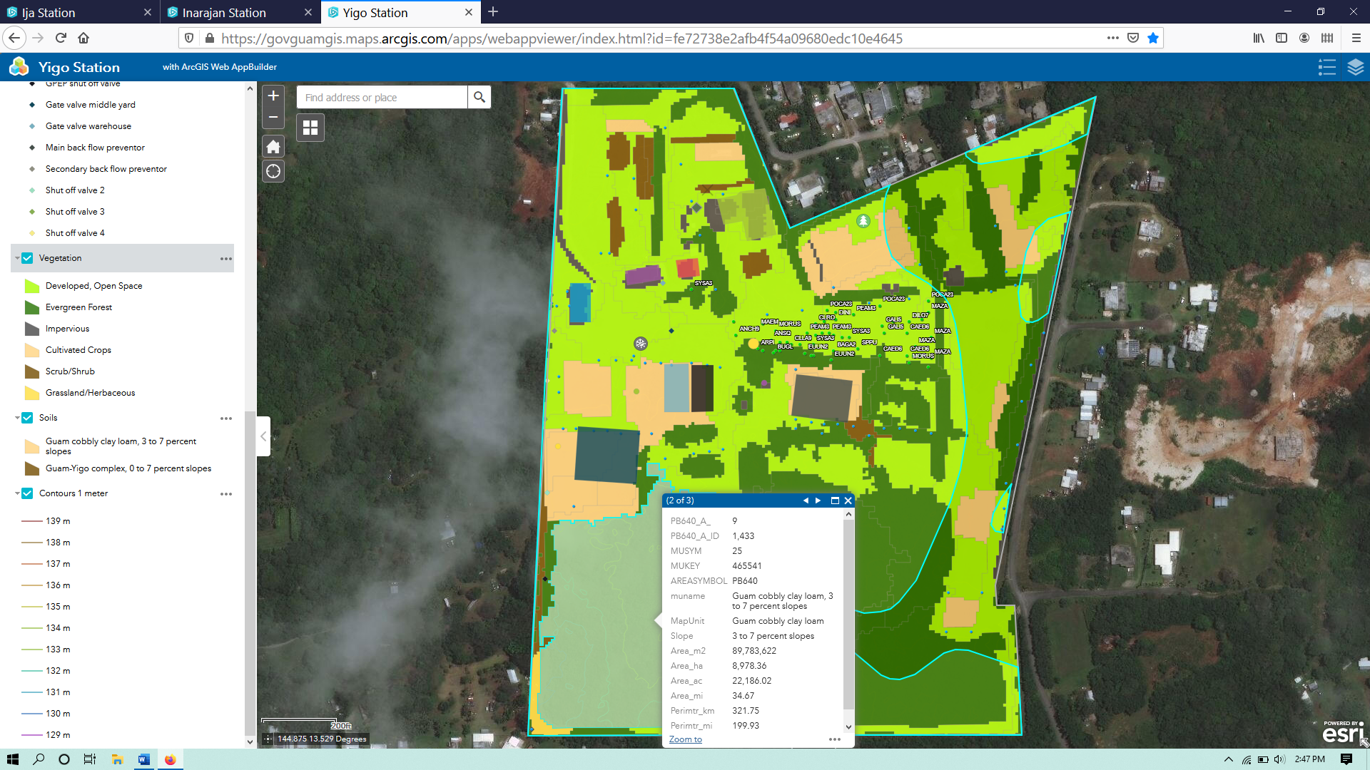
Here the user can see the soil type and all of the other information for that location in the soil layer. The data window can be closed by clicking the x in the upper right corner.
Open the Attribute Table/View all Data/Information – To see the entire data table, called the attribute table for a layer, the user can click on the small button called ‘Open Attribute Table’ in the bottom center of the screen, and the attribute table will scroll into view.
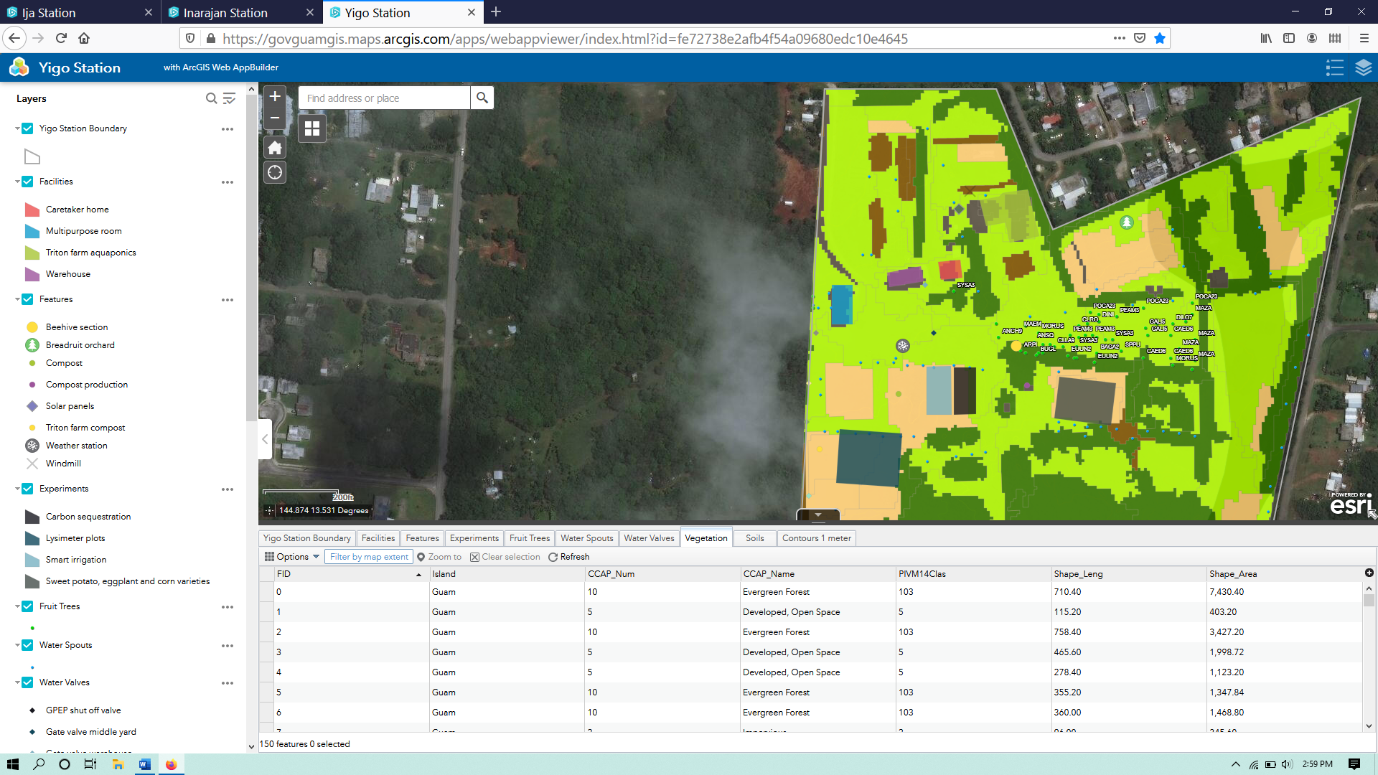
Notice at the top of the table there are little tabs for all of the layers available to view. If the user clicks on a tab, then you will see the data for that layer. Each table has different information stored depending on the layer. If a layer is turned off, the user would not normally see it available to view in the attribute table. He/she can still open and view the attribute table of a layer that is turned off, by clicking on the little three dots next to the layer in the layer tab and select ‘View in attribute table’.
Columns can be sorted by ascending or descending values, or show summary statistics, when applicable.
Zoom to from attribute table - Perhaps the user sees something interesting in the attribute table and would like to know where it is on the map. He/she can click on the ‘Features’ tab at the top of the table and see the row with ‘Breadfruit orchard’ in the ‘Text’ column.
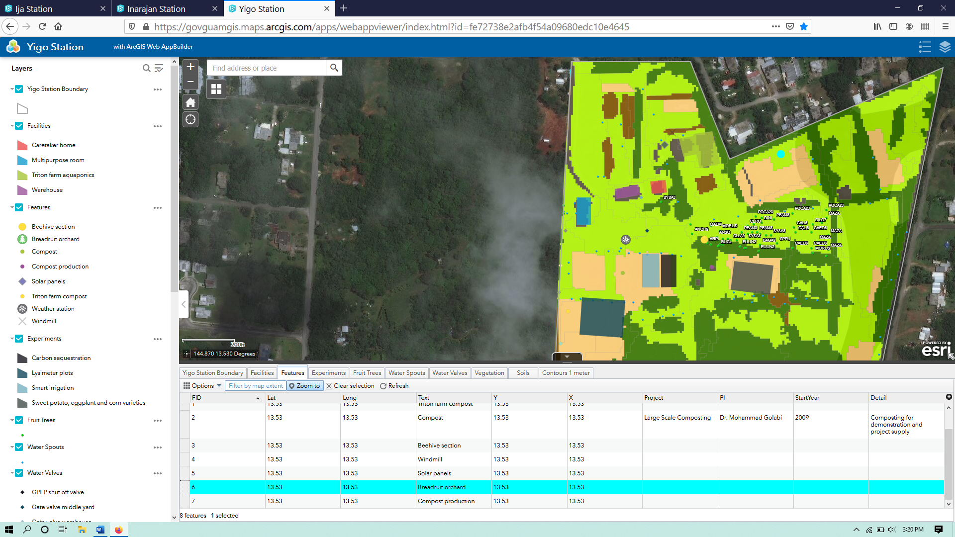
The user can select a feature (point or polygon) by clicking on the empty gray box in the leftmost column next to the row containing the data, and in the table menu options click ‘Zoom to.’ A feature is selected when it is highlighted bright blue. If the user wants to deselect the feature he/she can click on ‘Clear selection’ in the table menu.
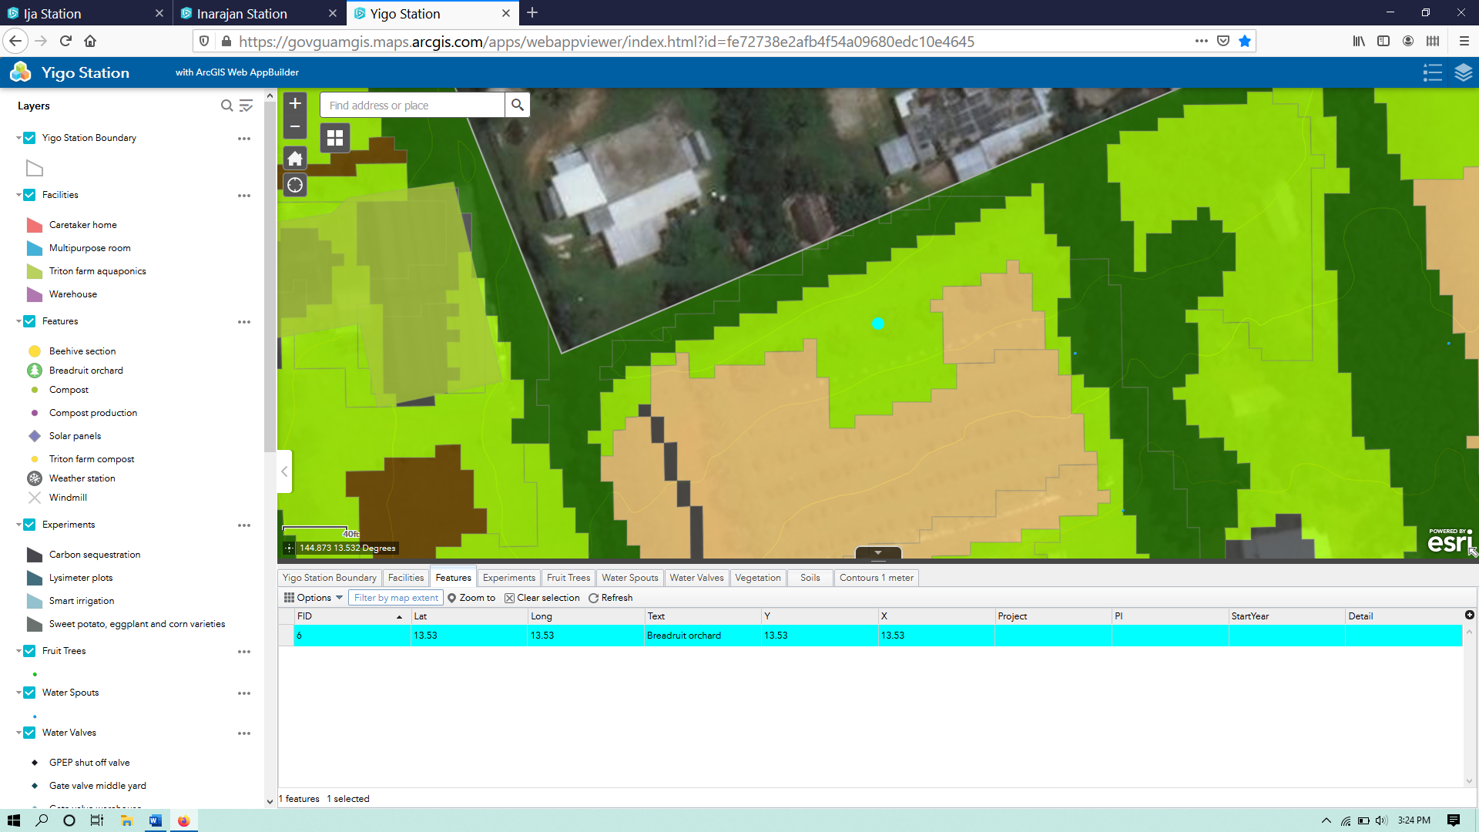
To see if there is anything in the imagery that is represented by the breadfruit orchard feature, the user should turn the ‘Vegetation’ layer off by clicking on the blue box next to it in the layer column.
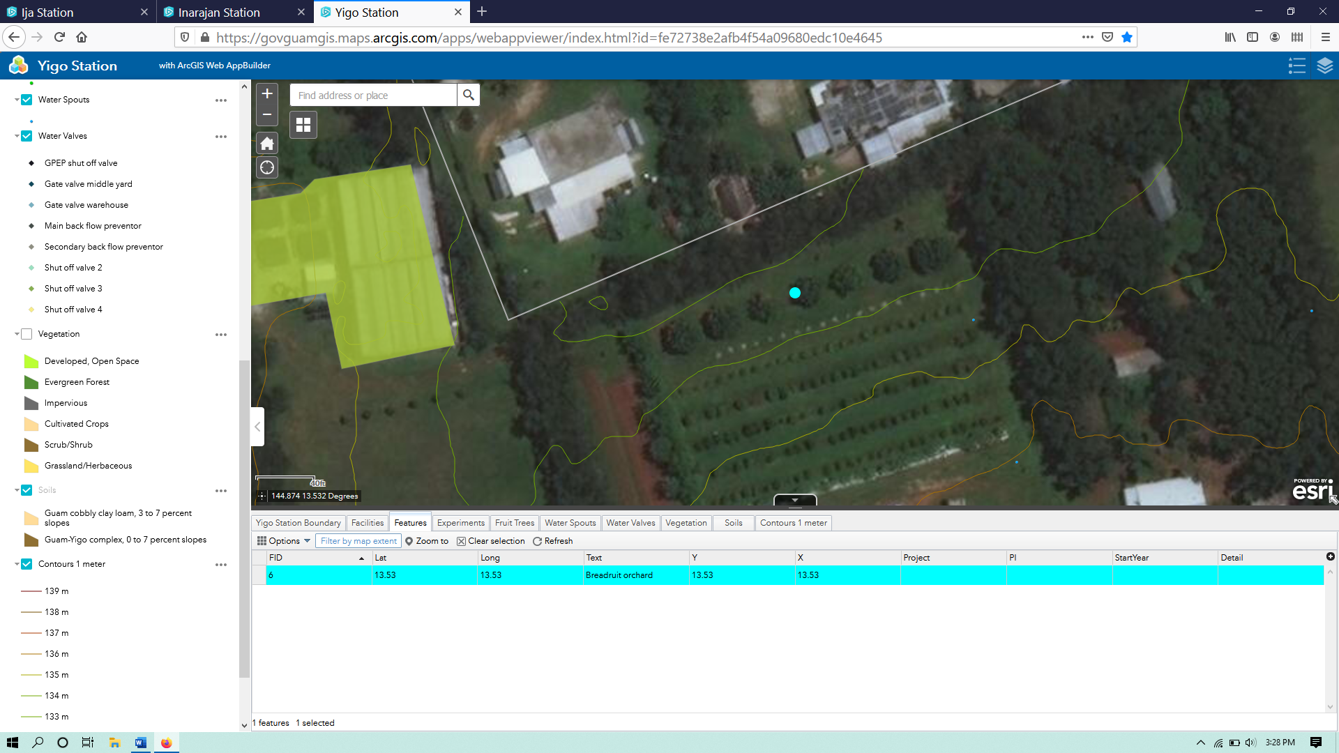
The map should look like this. It looks like there are some trees in a row, which should be the breadfruit orchard. The user can turn layers on or off to better view them when they overlap, or can adjust the transparency. To see how the vegetation layer overlaps with the imagery without turning layers on and off endlessly, the user should lick on the box next to ‘Vegetation’ to turn it back on.
Change the transparency of layers – The user can adjust the transparency of any layer by clicking on the three little dots to the right of the layer in the layer tab on the left side of the screen, and then selecting ‘Transparency’. When the ‘Transparency’ slider bar is selected, it will appear to allow to slide to the transparency level of choice. At the far left is 0% which means the layer is solid color, and at the far right is 100% which means the layer will be invisible. If the user is looking at several to many different layers, it is best to choose a higher transparency with upper layers and a lower transparency with lower layers. This also tends to result in layer color changing.
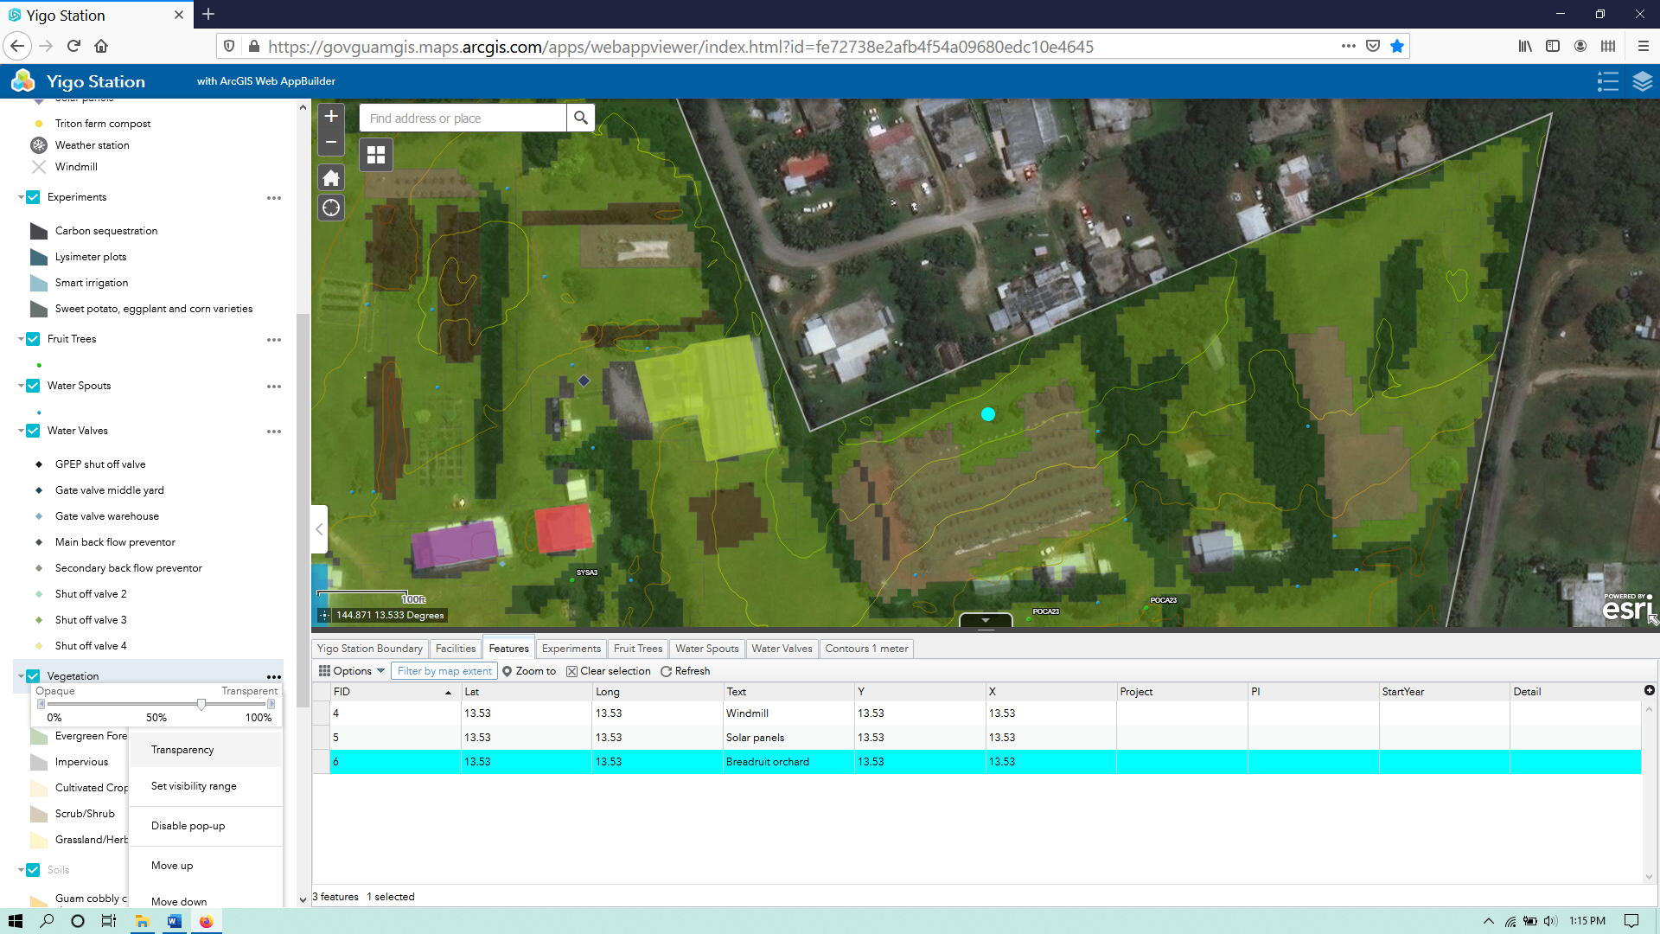
In this case the transparency for ‘Vegetation’ was set to about 70%, resulting in lighter colors, and allowing some visibility of the imagery below it. The user may have noticed that the ‘Soils’ layer is turned on but not visible at this scale. If the user likes to adjust the visibility range to see it here, he/she should close the attribute table by clicking on the down arrow in the small tab at the top center of the table.
Adjusting visibility range – The user can adjust the visibility range of any layer by clicking on the three little dots to the right of the layer in the layer tab on the left side of the screen, and then selecting ‘Set visibility range’. A slider bar will appear with two adjustable knobs. The one on the left adjusts how far zoomed out you will still see the layer, and the one on the right adjusts how far zoomed in you will see the layer. The user can click on the three dots next to the ‘Soils’ layer in the layer tab and select ‘Set visibility range.’
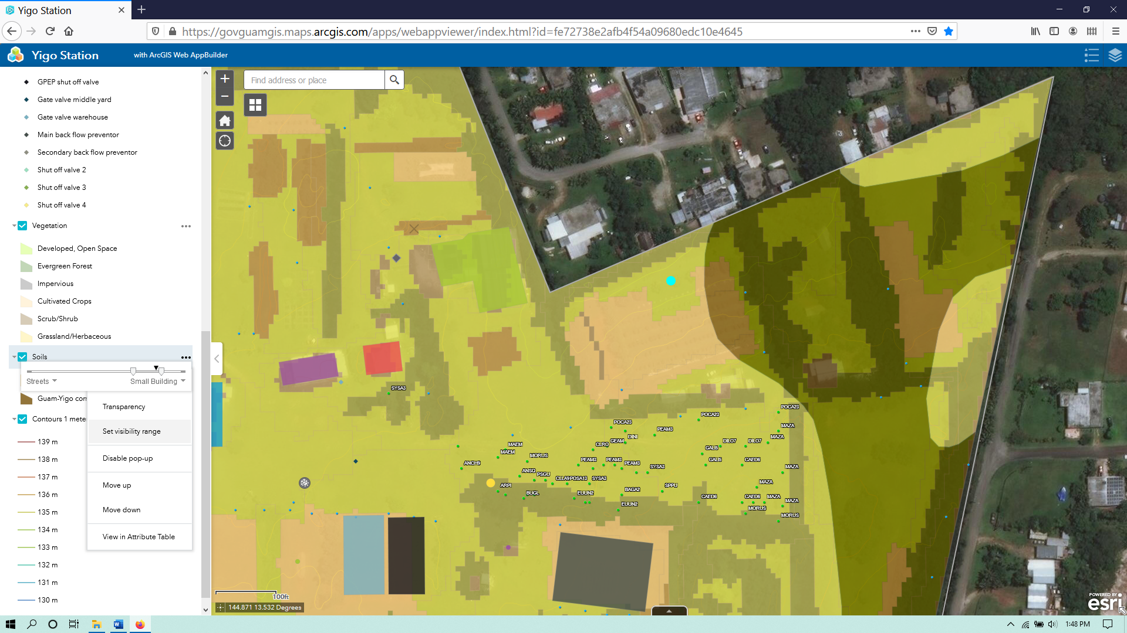
In this case the zoomed in visibility knob was set to ‘Small Building’, and the soil layer is displayed.
Changing drawing order of layers – The user can change the drawing order of any layers (or its vertical position in the layer tab) by clicking on the three dots next to it in the layer tab and selecting ‘Move up’ or Move down.’ He/she should click on the three dots next to the ‘Soils’ layer and select ‘Move up.’
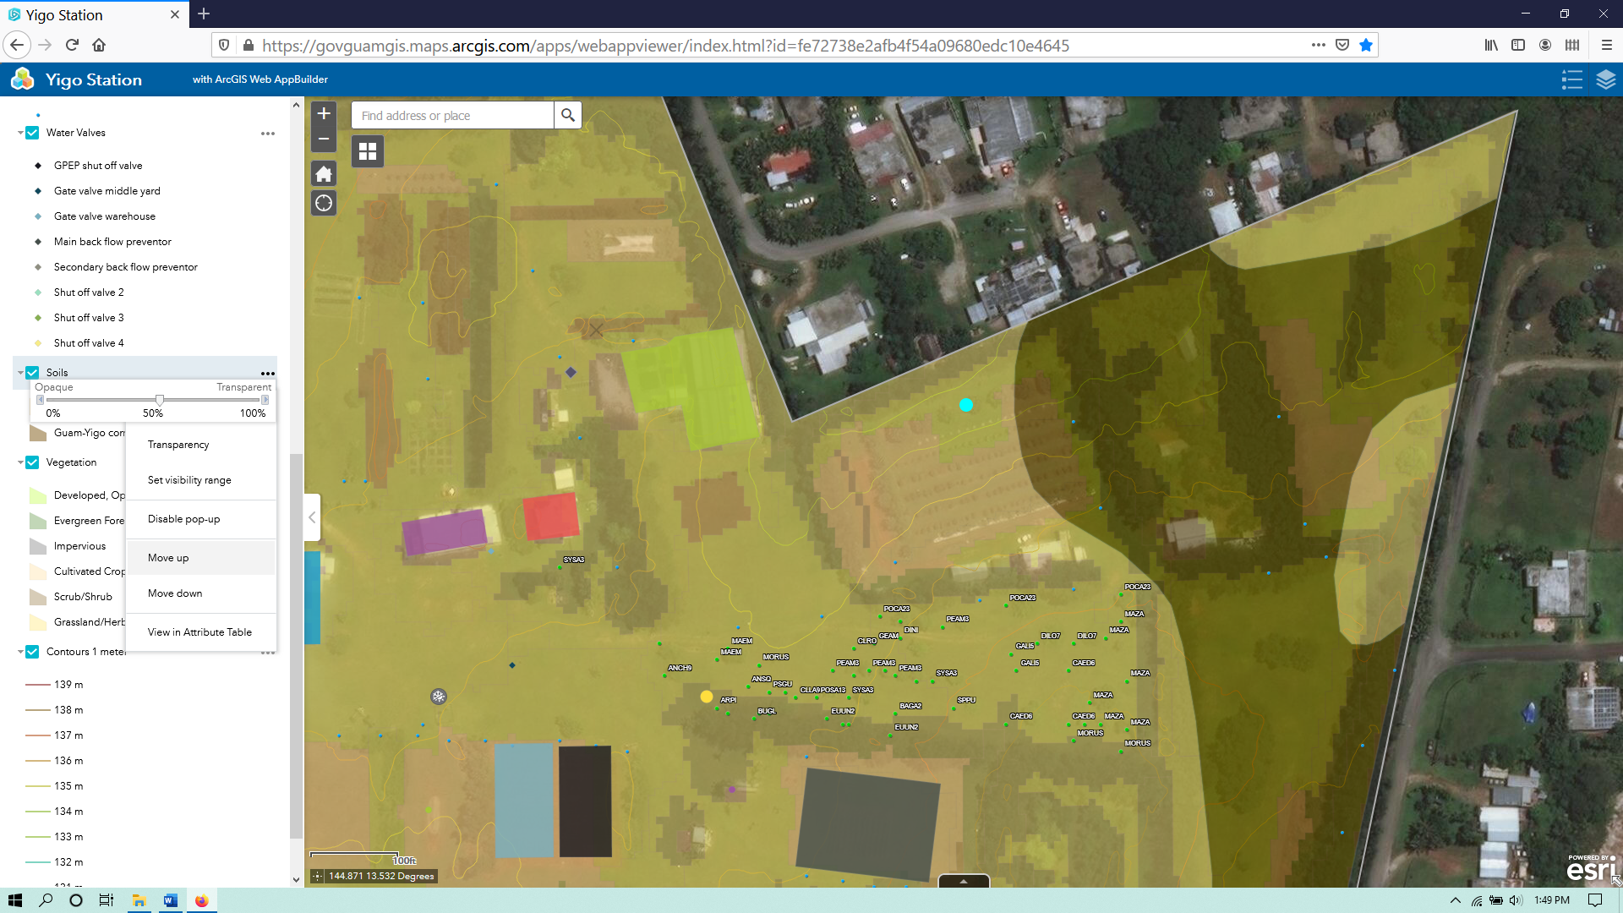
In this case the transparency of the ‘Soils’ layer was also changed to about 60%, to see the vegetation layer underneath. It does not look much better than when it was below the ‘Vegetation’ layer. To improve that, the user can click the three dots next to the ‘Soils’ layer and select ‘Move down.’
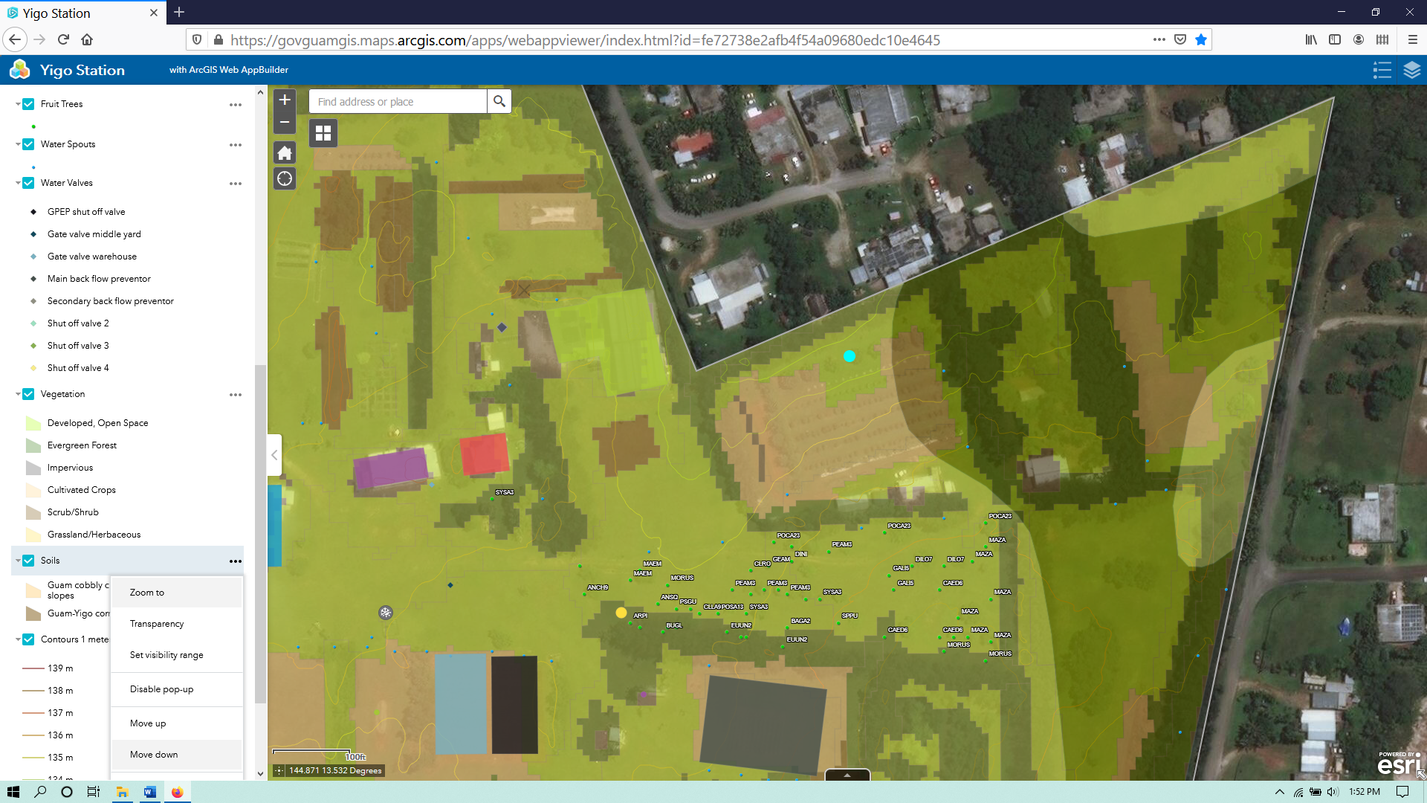
Now the user is back at the same drawing order but with the transparencies of both the vegetation and soil layers and the visibility range of the soil layer adjusted. Perhaps the user noticed some of the facilities to the west of the breadfruit orchard, and would like to see them more clearly.
Zoom to feature from layer tab – The user can zoom to any feature from the layer tab by clicking on the three dots next to it and selecting ‘Zoom to.’ He /she should click on the three dots next to ‘Facilities’ and select ‘Zoom to.’
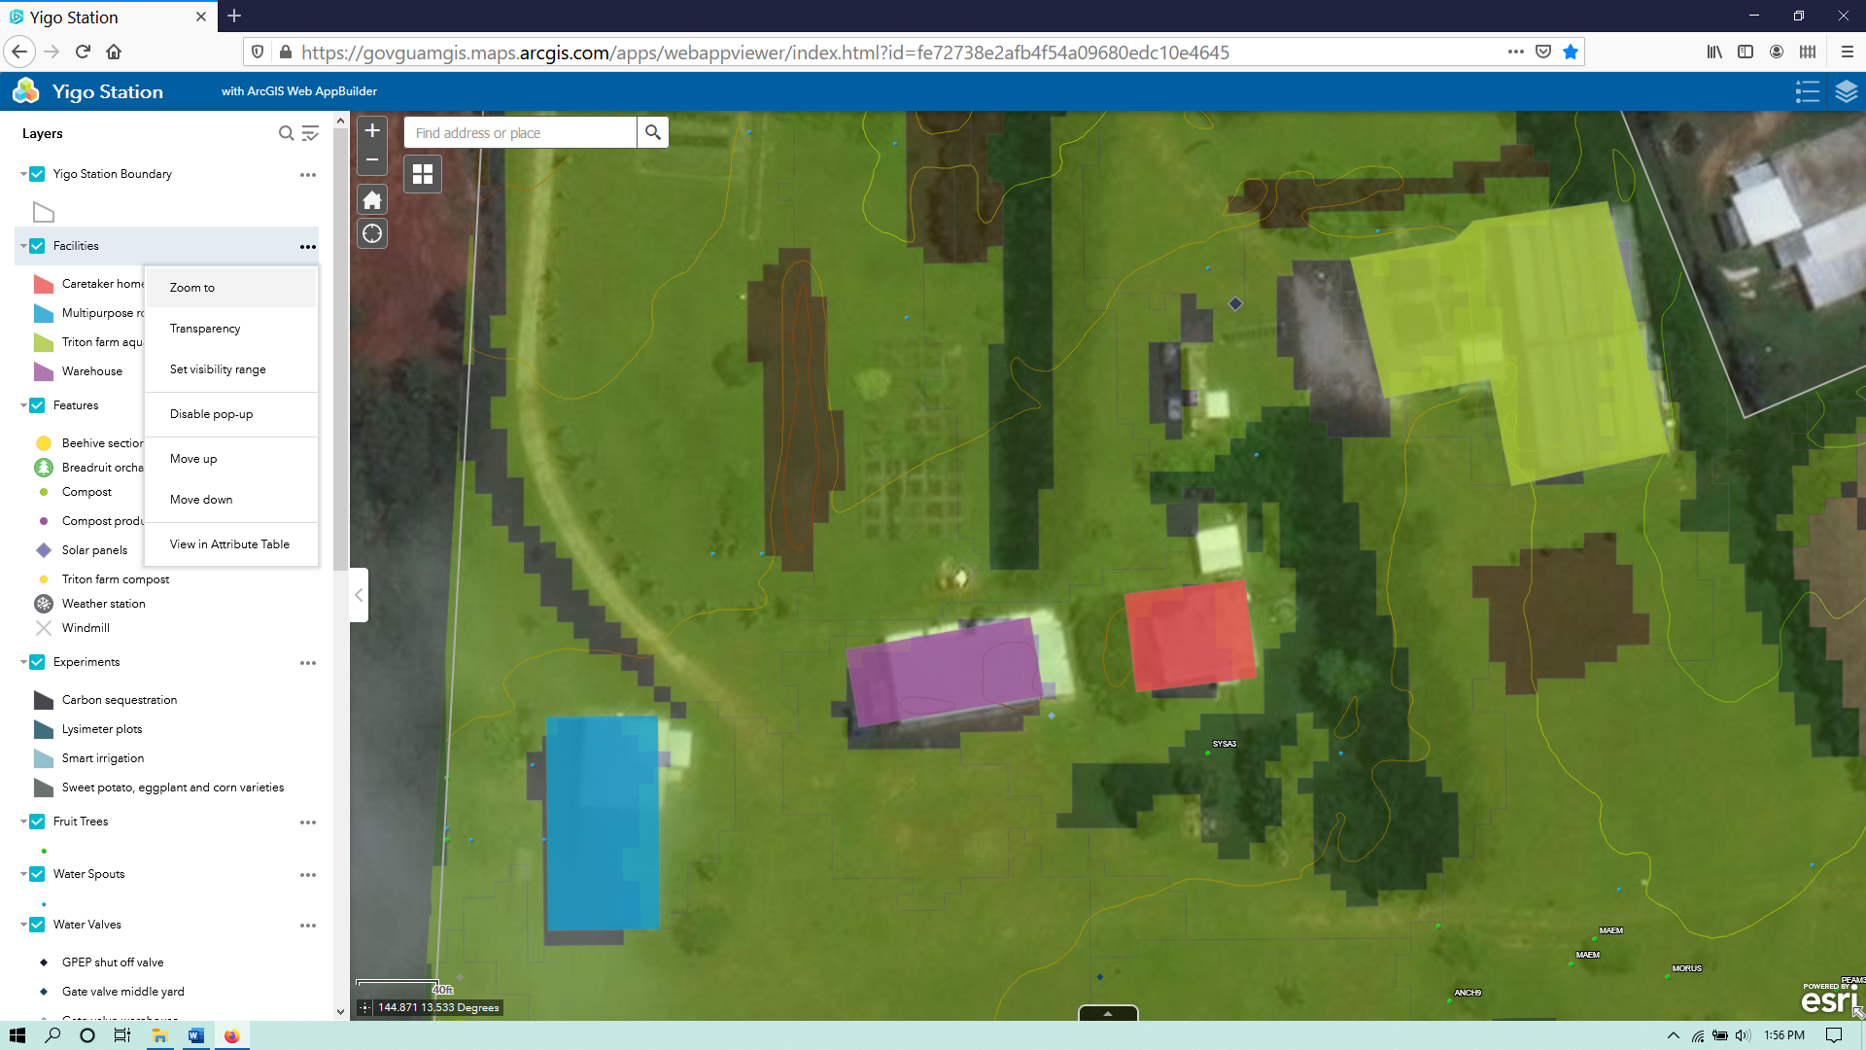

If the user wants to go back to the beginning without changing back everything he/she may have changed, the user can always close the window and revisit the website app. If the user closes the app and quickly opens it again, there will be a little box in the bottom right corner called App State, which if clicked it will restore the previous view of the app, but it will not restore changes to transparency, visibility range, or drawing order.

