RCUOG Business Manual

UOG Station  Mangilao, Guam 96923 |  | p. 671-735-0249/50/51  f. 671-735-0252 |  | gtravis@triton.uog.edu  www.uog.edu/rcuog
Table of Contents
- Organization Summary
Introduction
Board of Directors
Important Information
Administration
- Business Policies and Procedures
Award Processing
Advance Authorizations
No-Cost Time Extensions
Reporting Requirements
Time and Effort Reporting – Resolution #17-05
Accounting Records and Reports
Petty Cash Purchases ($150 limit) - Memorandum 6/22/15
Furniture and Equipment Purchases - Memorandum 5/18/15
Directive on Buyouts Memorandum 7/20/16
Subaward/Subrecipient Agreements
Accounting System
- Board of Directors Resolutions
Delegation of Authority - Resolution #14-07
Travel Policy – Resolution #17-06
Procurement Policy – Resolution #18-05
Purchase Card Policy – Resolution #15-06/17-04
Records Retention Policy – Resolution #17-03
Student Employee Hiring Policy – Resolution #15-02/16-03
Stipends and Honoraria Policy – Resolution #15-08
Indirect Cost – Resolution #16-32
Employee Handbook and Policy Manual – Resolution #15-03
- Appendix (RCUOG Forms)
A- Payment Request Form
B- Receiving Report
C- Petty Cash Voucher
D- Travel Request and Authorization
E- Travel Clearance
F- Leave Application
G- TB Screening Form

Organization Summary

Introduction
REFERENCES: Public Law: 32-114, February 10, 2014
BOD Resolution 14-01: Articles of Incorporation and By-Laws of RCUOG

The Research Corporation of the University of Guam (RCUOG) was established by PL 32-114 as a public corporation. The purpose of the RCUOG includes the promotion of assigned educational, scientific and literary pursuits of the University of Guam’s grants and contracts through aiding in the development of study, training, and research and to furnish the means and methods to do so.

Board of Directors
The affairs of RCUOG shall be under the general management and control of the RCUOG Board of Directors (Board). The composition of the Board shall consist of ten members as follows:
- Ex-officio Chief Executive Officer – University of Guam President
- Ex-officio Member – Senior Vice President of Academic and Student Affairs
- Ex-officio Member – Vice President of Administration and Finance
- UOG President appointee of three (3) members
- UOG Research Council appointee of one member
- UOG Faculty Senate appointee of one member
- UOG Board of Regents appointee of two (2) UOG BOR members

Important Information
EIN: 98-0032933
DUNS number: 779908151
Physical Address: First Floor, Health Science Building
Mailing Address: UOG Station, Mangilao, Guam 96923
Telephone Number: 671-735-0249/50/51
Fax Number: 671-735-0252
E-Mail Address: cmoore@triton.uog.edu
Website: www.uog.edu/rcuog

Hours of operation: 8am-5pm, Monday thru Friday, closed on holidays
Fiscal Year: October to September

Administration
Executive Director – Cathleen Moore-Linn (cmoore@triton.uog.edu)
Chief Business Officer – Gloria Travis (gtravis@triton.uog.edu)

Business Policies and Procedures
The policies and procedures must be followed to maintain the highest integrity and to ensure conformance with the Articles of Incorporation and By-Laws.
The University of Guam accepts the awards. If the PI so chooses, he/she can submit an internal service order form which is the mechanism that allows RCUOG to manage the funds. The internal order form is signed by the PI, the PI’s Dean, the Assistant Vice President, the Senior Vice President, the RCUOG Chief Business Officer and the RCUOG Executive Director.
The original copy of the award document must be attached to the internal service order form.

It is the combined responsibility of RCUOG staff and PI to ensure the award does not contain terms and special conditions with which RCUOG or PI cannot comply. The common award terms to which RCUOG will take exception to are:
- Unreasonable reporting requirements
- Unacceptable payment terms
- Payments in foreign currency
- Adherence to rules/laws which conflict with the laws of Guam

Advance Authorizations
Contract/Grant work should not begin before a contract/award is in place. However, the PI may request the funding agency to approve specific pre-award expenditures. Upon written approval from the funding agency, pre-award charges may be charged to a grant project.

No-Cost Time Extensions
If additional time beyond the established expiration date will be required to assure adequate completion of the project within the funded budget, a no-cost extension may be requested from the sponsoring agency. Such a request should be made at least forty-five (45) days prior to the expiration date. The request may include a brief summary of progress, funds remaining, and plans to complete the project. The need for an extension of time should be well justified. Usually, the fact that funds may remain at the expiration date is, in itself, insufficient justification for an extension. PIs are cautioned not to make commitments beyond the established expiration date until RCUOG has received notification from the sponsor that the time extension request has been approved.

Reporting Requirements
- Technical Reports
The PI will be responsible for the preparation and submission of all required technical/progress reports. The technical/progress reporting requirements are set forth in the award document and/or handbooks and guidelines published by the sponsor. The PI should apprise the sponsor anytime the project timelines cannot be met.
- Financial Report
RCUOG will be responsible for maintaining the official fiscal records and for the preparation of all financial reports and billings to the sponsor. A copy of the final financial report on a project will be sent to the PI for review and concurrence, prior to submission of the report to the sponsor.
- Annual Reports (PL32-114)
RCUOG shall submit an annual report to the UOG Board of Regents, Governor of Guam, and the Guam Legislature. The report shall include, but not limited to, audited financial statements and progress and accomplishments during the year.

Time and Effort Reporting - Resolution #17-05

Recipients of federal funds must maintain an accurate payroll distribution system allowing for periodic after-the-fact certification of charges made to specific activities for the purpose of documenting reasonable estimations of actual work performed on those activities.
In the most basic terms, RCUOG, Principal Investigators and Timekeepers must confirm that charges made to the payroll system “reasonably reflect” each employee’s activity.

Accounting Records and Reports
Monthly accounting reports on each account will be supplied to the PI or his/her designee. The reports should be reviewed very carefully. Any erroneous transactions should be reported in writing to RCUOG.

Petty Cash Purchases - $150 limit (Memorandum June 22, 2015)

Under certain circumstances, petty cash may be authorized as a means of making limited recurring or small emergency purchases under $150.00. Prior approval must be secured from appropriate administrator. Only original receipt or itemized ticket signed or marked paid by the vendor will be accepted. Reimbursement will only be made for receipts that are within 90 days from the purchase date. Exceptions require approval from the RCUOG Executive Director.

Small repeat purchases using petty cash should not be used to avoid purchasing procedures where volume and bidding might secure lower prices. Services rendered from individuals or items purchased from Military Base stores are not permitted to be reimbursed from or paid with petty cash funds.

Furniture and Equipment Purchases (Memorandum May 18, 2015)
Capital Assets
RCUOG shall follow UOG’s capitalization guidelines in the treatment and recording of furniture and equipment that meet the criteria for capital assets. A capital asset is defined as property (tangible and intangible) meeting the dollar cost threshold of $5,000 or more with a useful life of more than one year. Identification tags shall be affixed to the items and maintained in an equipment database. Federal and other external auditors require a physical inventory of equipment to be taken at least once every two years.

Small Equipment and Tools Inventory
Department administrators or PI must maintain an inventory of all small equipment/tools valued above $500 and below $5,000 purchased through RCUOG (example tablets, cameras and laptops). These moveable items can be easily stolen or misplaced.

All administrators are required to maintain all equipment and supplies for institutional use only and not allow any use for private purposes. An administrator may authorize institutional equipment or supplies for use off University-owned or controlled premises, but only for the performance of University or RCUOG related duties.
Administrators/PI must establish proper controls to adequately safeguard assets against loss and to ensure all equipment is properly maintained and in good working order.

Directive on Buyouts (Memorandum July 20, 2016)
The University of Guam practices internal distribution of buyout funds. Buyouts occur when a grant buys out faculty/administrator time. In the case of locally funded faculty/administrators, the buyout can be deposited into a discretionary account at RCUOG (for those grants running through the Research Corporation) or at UOG (for those grants running through the UOG business office). In the case of federally funded faculty, funds bought out by another grand are returned to the original federal grant for reprogramming. Buyout funds will be distributed as follows:
- 30% to The Senior Vice President’s Office
- 70% to Unit/PI

Furthermore, the Unit/PI split on buyouts should be no more than 20% to the Unit (and can be less) and a minimum of 50% to the PI. Buyouts are subject to cost recovery, i.e. covering adjunct faculty salary costs in the case of a partial buyout of a teaching load, before funds are distributed as indicated above.

Subaward/Subrecipients
Subrecipients vs Vendor
Subrecipients may have some or all of the following characteristics:
- Their performance is measured against meeting the objectives of the program
- They have the authority for administrative and programmatic decisions
- They provide ongoing service for the life of the program
- They carry out a program of the subrecipient as compared to providing services for a program of the prime recipient
- They are responsible for applicable program compliance requirements

Subrecipients should be budgeted as a subcontract in the sponsor proposal. This is then recognized as a budgeted item and approved by the sponsor in the terms and conditions of the subsequent award.

On a federally funded sponsored project, subrecipient funds are passed through from the recipient by a subcontract agreement. This agreement will flow down the various federal regulatory and compliance requirements. Standard subrecipient subcontract terms and conditions which incorporate the regulatory and compliance requirements of OMB Uniform Guidance are then used to prepare a subrecipient subcontract.

Vendors have the following characterstics:
- They provide the service as part of their normal business operations
- They provide a similar service to many different purchasers
- They operate in a competitive environment (compete with others who can provide a similar service)
- Their program compliance requirements do not pertain to the service provided

A vendor is responsible for providing ancillary services in support of the award for the recipient or subrecipient use.

In summary:
A subrecipient serves as a co-investigator, is responsible for the end results of the research effort equally with the principal investigator where federal funds are being passed through to another entity. By definition, a subrecipient relationship can only be established where federal funds are involved.

A vendor provides ancillary goods or services that the principal investigator needs to conduct the research effort. A vendor is not responsible for the research results.

Importance of Making the Proper Determination
It is important to be aware that it is the nature of the relationship that determines whether or not an entity is a subrecipient or vendor. The dollar amount of the purchase order or subrcontract is not a determining factor. A careful review of the nature of services to be provided and an appropriate determination as part of the proposal budget review process will eliminate such post award problems such as:
- Obtaining sponsor prior to approval for unbudgeted subcontracts;
- Delays in processing requisitions for purchased services budgeted as subcontracts;
- Meeting audit and compliance requirements with for-profit organizations where a vendor relationship should exist.

By making a proper determination in the proposal stage, the appropriate relationship can be established from the start. This is especially true for an unbudgeted subcontract. If the unbudgeted subcontract is of a subrecipient nature, sponsor approval is required prior to entering into a subcontract. If it is a vendor relationship, no sponsor approval is required unless specified in the award terms and conditions.

Additional auditing requirements and other compliance regulations apply if the subcontractor is a subrecipient. It is best to make the determination at the proposal stage so if a subrecipient relationship exists, that relationship is recognized by the award agency and approved in advance.

Debarment
RCUOG prohibits the creation of subawards with individuals that are suspended or debarred. The project director must verify before accepting projects that the entity is not suspended or debarred or otherwise excluded. Those on the debarment list will not be able to work under the Federal Government.

Accounting Systems

Colleague Account Set Up
The system that UOG uses is the Colleague Integrated System, developed by Ellucian. It consists of several modules interfacing with each other to form the system. These modules consist of Admission (Registration), Financial Aid, Payroll, Personnel, Accounting (general ledger, accounts payable, accounts receivable, cash receipts, purchasing), curriculum management, and fixed assets.

General Ledger Account Structure
The general ledger structure consists of five components: fund, source, unit, function, and object. Every financial transaction of UOG applies to a particular fund. Each fund is a distinct fiscal entity, having its own self-balancing group of accounts which consists of assets, liabilities, reserves, fund balance, revenues, encumbrances, expenditures, and appropriation. The accounting element can be identified on the first digit of the object component of the general ledger structure called the GL class:
- GL class - 1 is assets
- GL class - 2 is liabilities
- GL class - 3 is fund balance of direct expense account
- GL class - 4 is revenues
- GL class - 5 is expenditures

Balance Sheet Accounts
These accounts reflect the financial position of a fund at any given time an interim report is prepared. Within the balance sheet accounts, there are seven major classifications that are identified in the coding structure: assets, liabilities, fund balance, revenue, encumbrance, expenditures, and appropriation. Assets record properties owned by the University, which have monetary values. Liabilities record debts or other legal obligations arising out of past transactions which are to be liquidated, renewed or refunded at a future date. Fund balance record the excess assets of fund over its liabilities. Revenue accounts are established to collect revenues consistent with the Board of Regent’s policies and operational practices of the University. Six major sources of revenue are recognized by the University, namely Government of Guam appropriation, tuition and fees, Federal grants-in-aids, income from endowment fund, and miscellaneous revenue. Encumbrance account is a record of all encumbrance transactions against appropriation accounts. Expenditure account records all expenditure transaction against appropriation accounts. Appropriation account is to record all approved appropriation as passed through public law, federal grant-in-aid, contracts, donations, etc. This is also known as allocated budget.

Payment Processing
Invoices will be processed through the Accounts Payable Systems (a sub-system of Colleague). Types of payments include:
- Payment against encumbrances
- Direct payment (i.e.: utilities, subscription, honorarium)
- Advance payment

Accounting Procedures

Allowable Costs

Procedures regarding determining the reasonable, allocability, and allowability of costs charged to federally funded projects address who verifies the proposed costs before expense is incurred. It is initially reviewed by the program manager, approved by the PI, and department head, and then certified by the RCUOG Chief Business Officer. OMB’s Uniform Guidance is used in the determining reasonableness, allocability, and allowability of costs charged to federally-funded awards. The allowable portion is charged to the federal award.

Unallowable and Indirect Costs

Several stages of review are followed similarly to allowable costs. It is initially reviewed by the program manager, approved by the PI, and department head, and then certified by the RCUOG Chief Business Officer. Once it is identified to be an unallowable and indirect cost, it will be charged to a discretionary fund - unrestricted funds, which are assigned separate account numbers. They are recorded under unrestricted funds. Upon the discovery of unallowable direct cost mistakenly charged to a federally-funded project, the charges will be immediately reversed. Unallowable indirect costs are excluded from indirect cost rate calculation. Different account numbers are used to record the different types of cost allowing identification of items to be included or excluded.

Approval Supporting Documentation

Supporting documentation for payment requests include written approval of the PI/Department Head, copies of invoices, and receiving report. Payroll transactions have different units which each have procedures for accounting for employees’ time. At a minimum, each employee must have an approved personnel action form, processed and entered into HR/Payroll System by the UOG-HRO. The department timekeepers would enter the employee time/hours onto the official timesheets submitted to the UOG Payroll office for processing.

Budget Modification Procedures
Budget modifications are initiated by the principal investigator (PI) and approved by the Dean/Direcotor. The modifications must be approved and processed by the RCUOG Chief Business Officer or designee. All budget modifiations must adhere to the grant/contract terms and conditions. If necessary, the PI will seek approval from the Grantor. The PI will submit a memo requesting revision to their Dean/director for approval then follow up with RCUOG for processing. Modification and revision requests will be denied if it is in violation of the terms and conditions of the grant award and/or is not approved by the Grant Program Officer. All updates of the project budget in the accounting system after approval will be handled by the RCUOG Chief Business Officer or designee.

Drawdown Procedures (Federal Grants)

Drawdowns are based on actual cost incurred. Drawdowns are calculated based on total cumulative expenses less reimbursements received. Reports used are GLSA and SEFA. Once funds are received, journal vouchers are created to record the deposit. The journal voucher is created by RCUOG-CBO, reviewed by another accountant for accuracy, and then approved by the RCUOG Executive Director before entry is made in the accounting system. RCUOG-CBO is responsible for preparing, reviewing, certifying, and submitting drawdown request.

Board of Directors Resolutions

Delegation of Authority - Resolution #14-07
Resolution no. 14-07 dated September 23, 2014 approved the delegation of authority which establishes protocols for the expenditure of funds at established threshold that correlate to signatory approval.

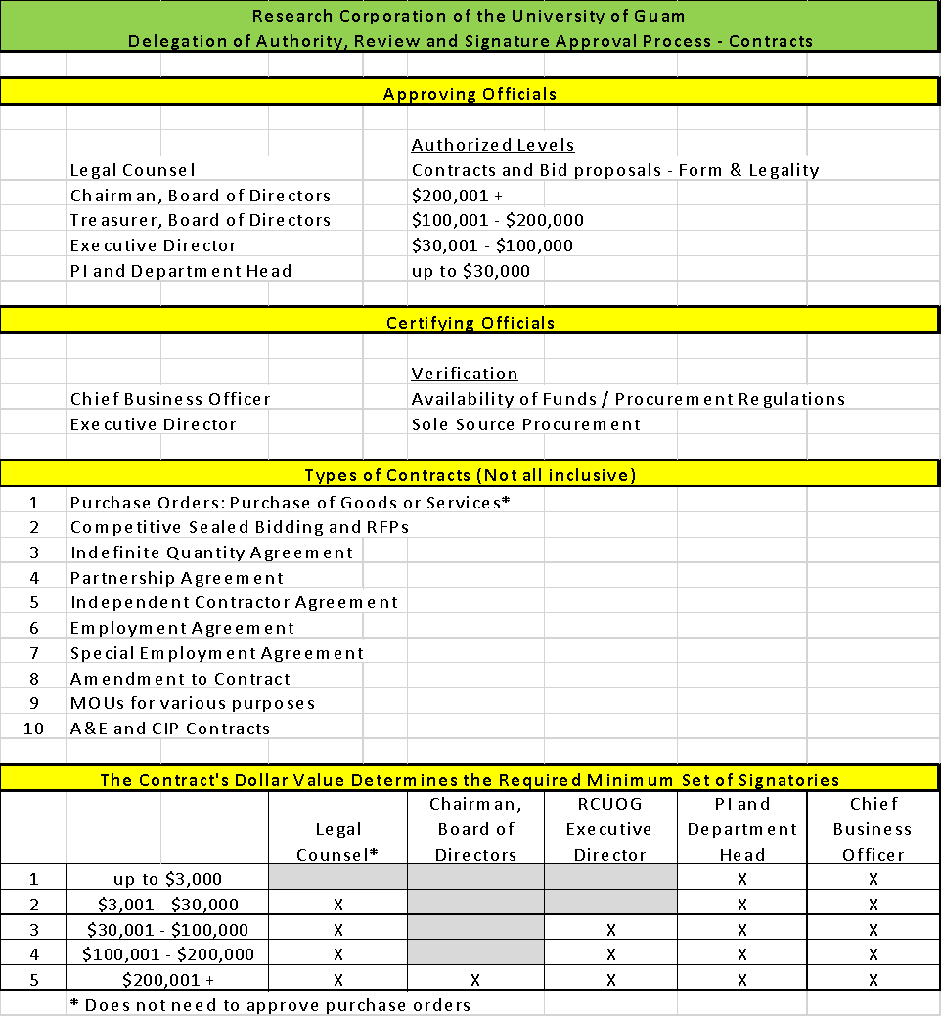

Travel Policy – Resolution #17-06
It is the declared policy of RCUOG that all travel must be performed either for the direct benefit of UOG and/ or RCUOG or to fulfill a real and legitimate obligation of UOG and/ or RCUOG. Please see attachments.

Procurement Policy – Resolution #16-04, 18-05
All persons engaging in purchasing and purchasing-related activities shall conduct business dealings in a manner that is above reproach in every respect. Expenditures should be customary and reasonable in the conduct of RCUOG business. Questionable disbursement requests will be submitted to the RCUOG Executive Director for review and approval.

The PI will serve as his/her own purchasing agent and avoid purchasing unnecessary items. PIs are encouraged to obtain bids/quotes to ensure compliance with open, fair, and competitive procurement practices.

The UOG Procurement Office will serve as a resource in providing advice on bidding and identification of vendors, when requested.

Purchase Card Policy and Card Holder Agreement – Resolution #17-04
The purpose of this policy is to provide instructions on the proper use of a RCUOG purchase card. This policy augments the RCUOG Procurement Policy’s small purchase procedures. All purchase card transactions must comply with RCUOG Procurement policy.

Records Retention Policy – Resolution #17-03
The Research Corporation of the University of Guam’s Record Retention Policy guides the retention and disposition of records.

Records are defined as all electronic and paper-based documents, regardless of physical form or characteristics, made or received by RCUOG in connection with the transaction of RCUOG business and retained by the organization as evidence of the organization’s functions, policies, decisions, procedures, operations, or other activities.

Student Employment Hiring Policy - Resolution #15-02/16-03
Student Employees of the Research Corporation of the University of Guam (RCUOG) are University of Guam students assigned to University units to deliver grant or externally funded objectives. These employees will work 39 hours or less per week and receive Social Security and Medicare.

Medical and dental benefits may be offered to part-time employees working 20 to 39 hours per week depending on whether or not there is funding in the grant or contract to support the annual employer portion of medical and dental benefit premiums. For those employees working 30-39 hours per week, the Affordable Care Act may apply.

The definition of student employee also covers high school students who may be hired for short periods to work with researchers.

Guidelines for Stipends and Honoraria - Resolution #15-08
To ensure that RCUOG properly accounts for stipends and honoraria made available through federal grants where allowable.

Indirect Cost Recovery– UOG Resolution #16-32
It is declared under policy by UOG Board of Regents that in addition to paying direct costs of research, the federal government reimburses UOG for the indirect costs of research, also referred to as Facilities and Administration Costs. Indirect costs is incurred for a common or joint purpose benefiting more than one cost objective, and not readily assignable to the cost objectives specifically benefitted without effort disproportionate to the results achieved. Recovered indirect cost is allocated via UOG Board Resolution.

RCUOG Administration Fee
Under the circumstance that there is no indirect cost recorded in the budget, they will be subject to an administration fee. The administration fee will charge 10% of total award.

Employee Handbook and Policy Manual - Resolution #15-03
The Employee Handbook and Poicy Manual provides the foundation for an effective work environment and is a primary resource for both employees and management to consult regarding dailt work related functions and activites.

Appendix (RCUOG Forms)
The following forms can be found on the RCUOG website: www.uog.edu/rcuog.

A- Payment Request Form

B- Receiving Report
Please submit Receiving Report along with vendor invoice promptly upon receiving items purchased.

C- Petty Cash Voucher

D- Travel Request and Authorization

E- Travel Clearance

F- Leave Application

G- TB Screening Form
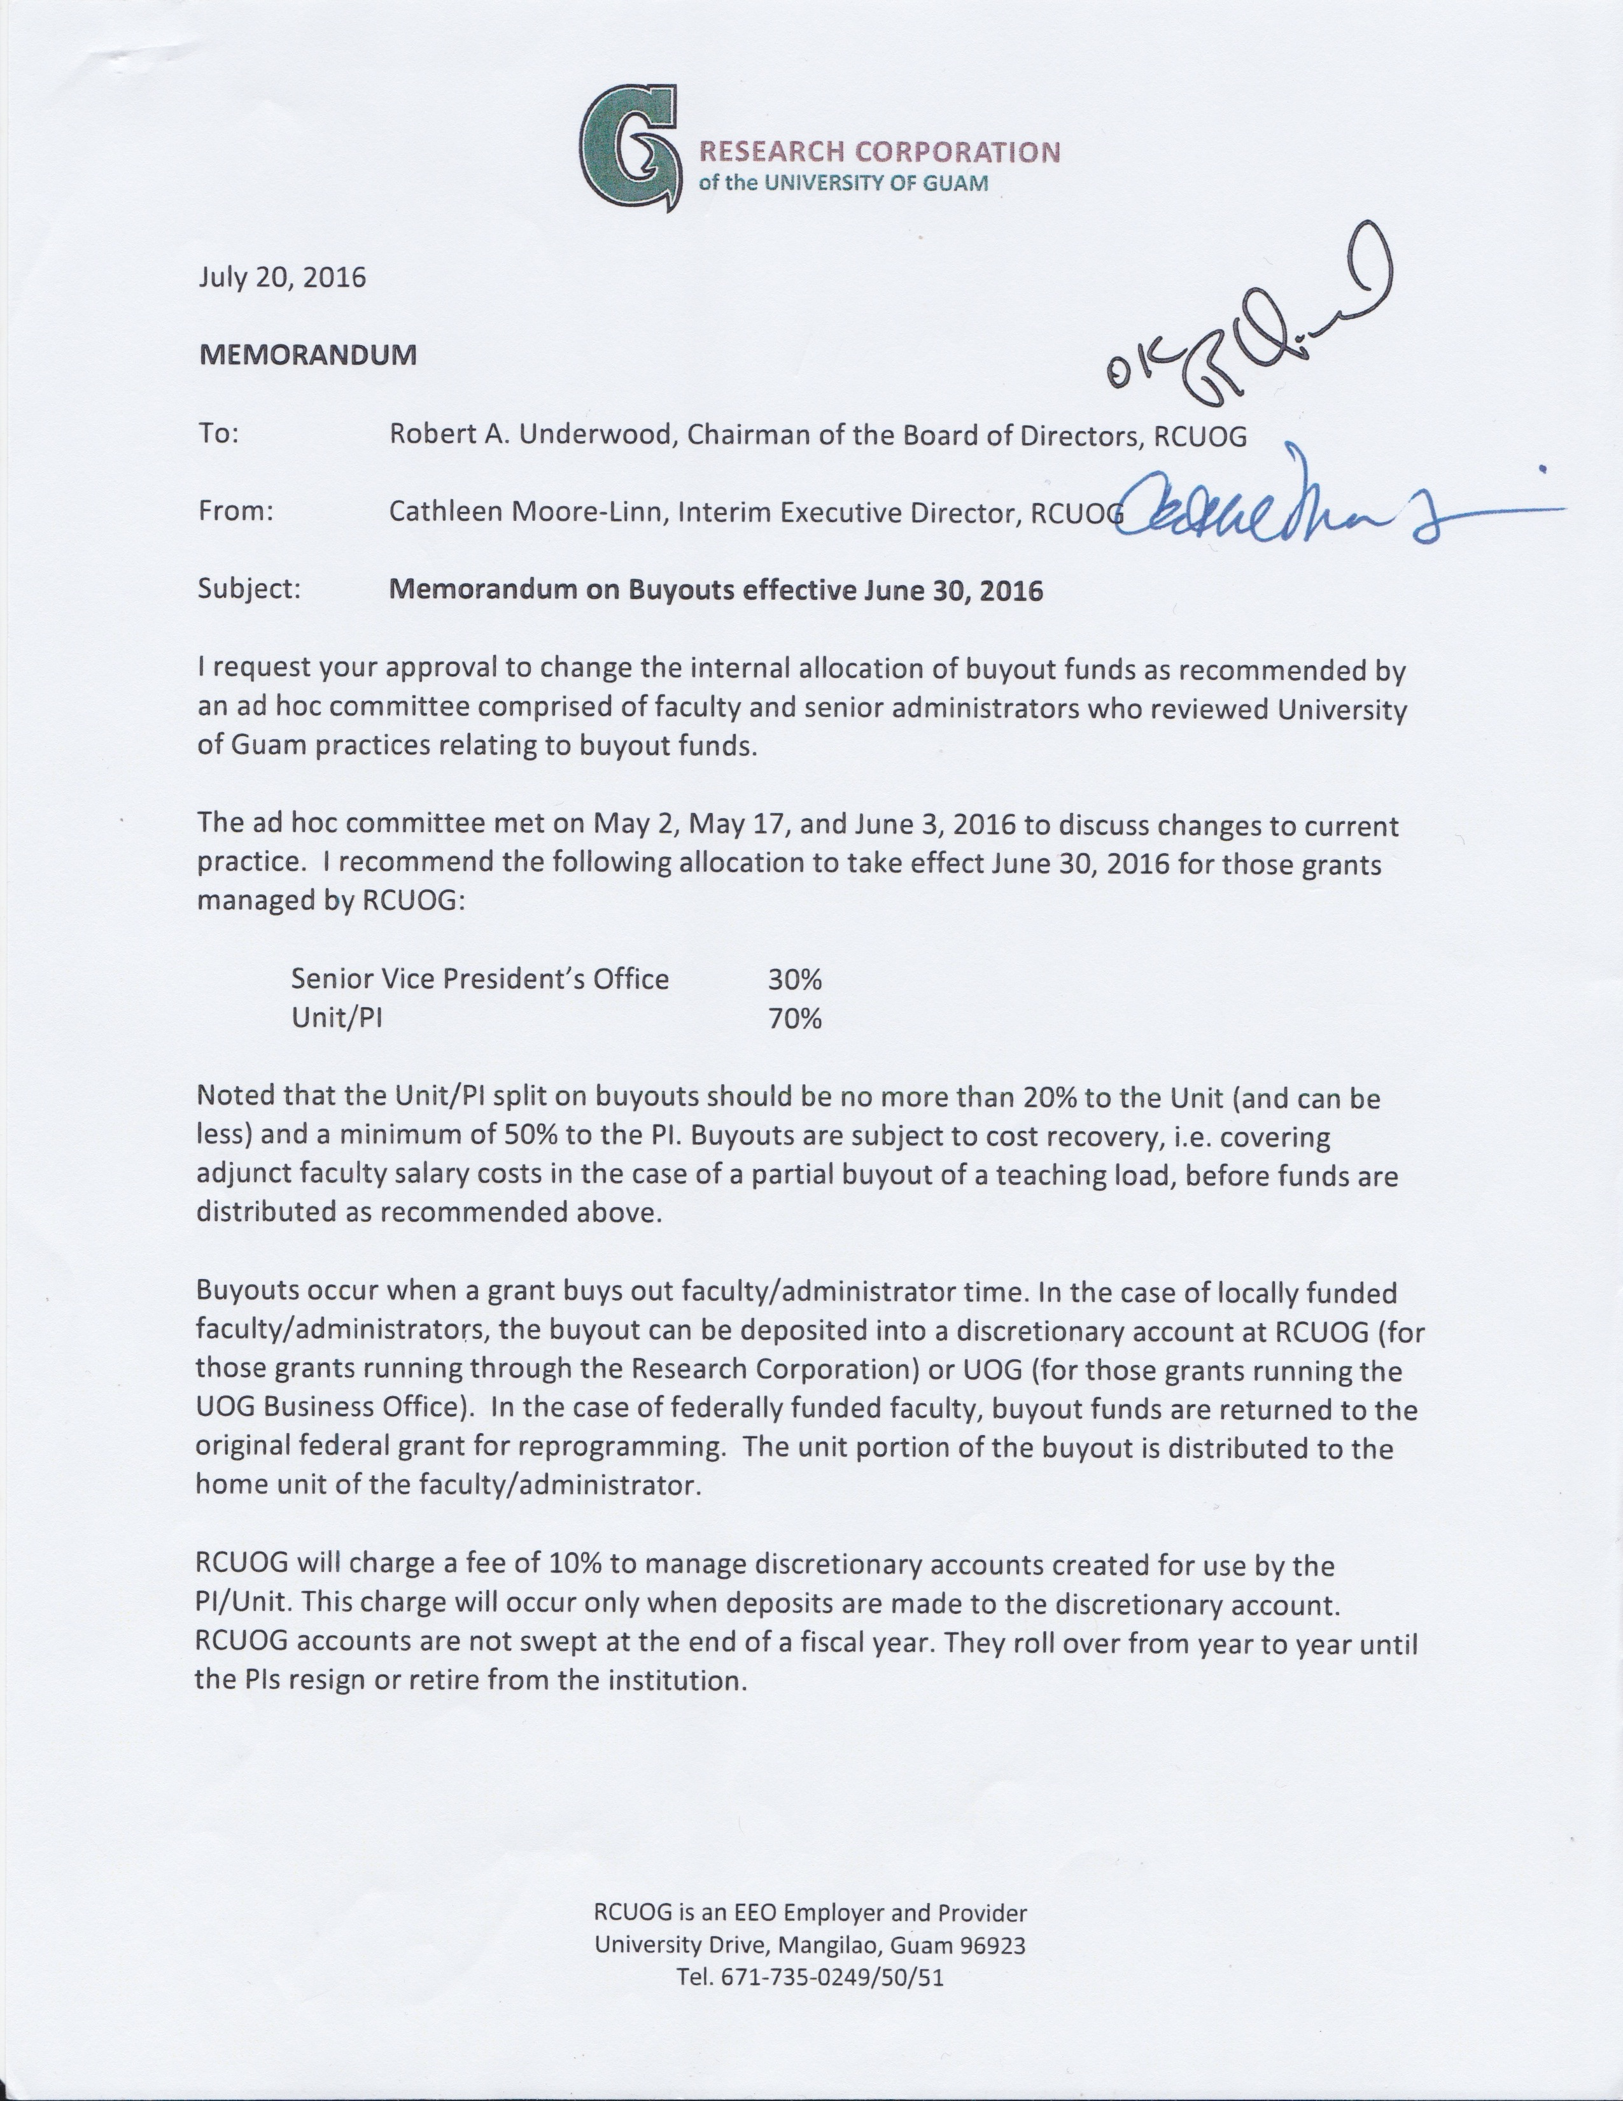
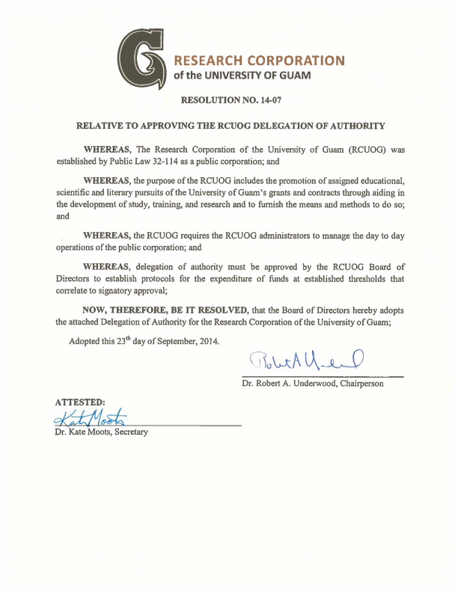
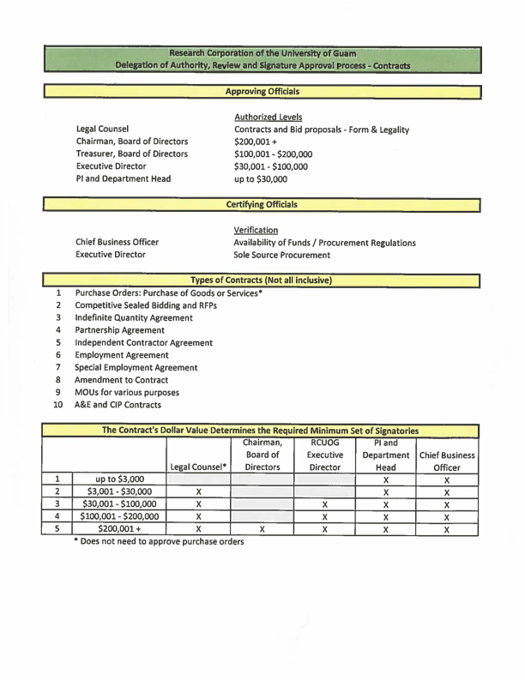
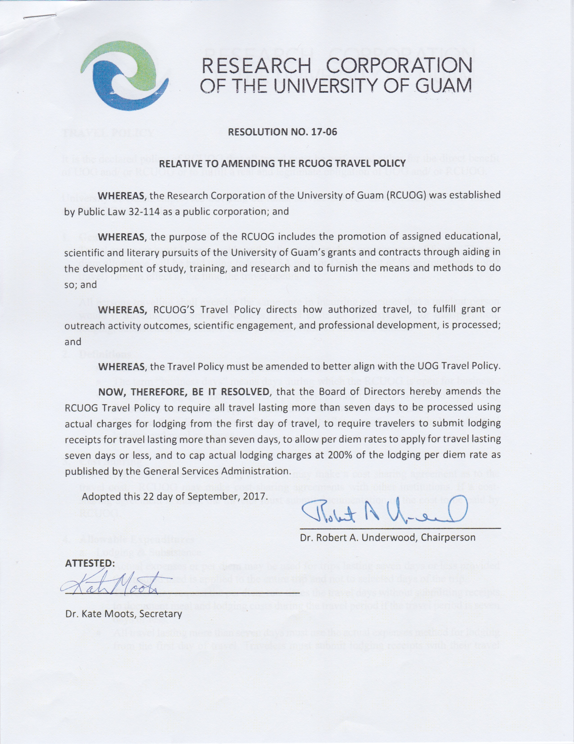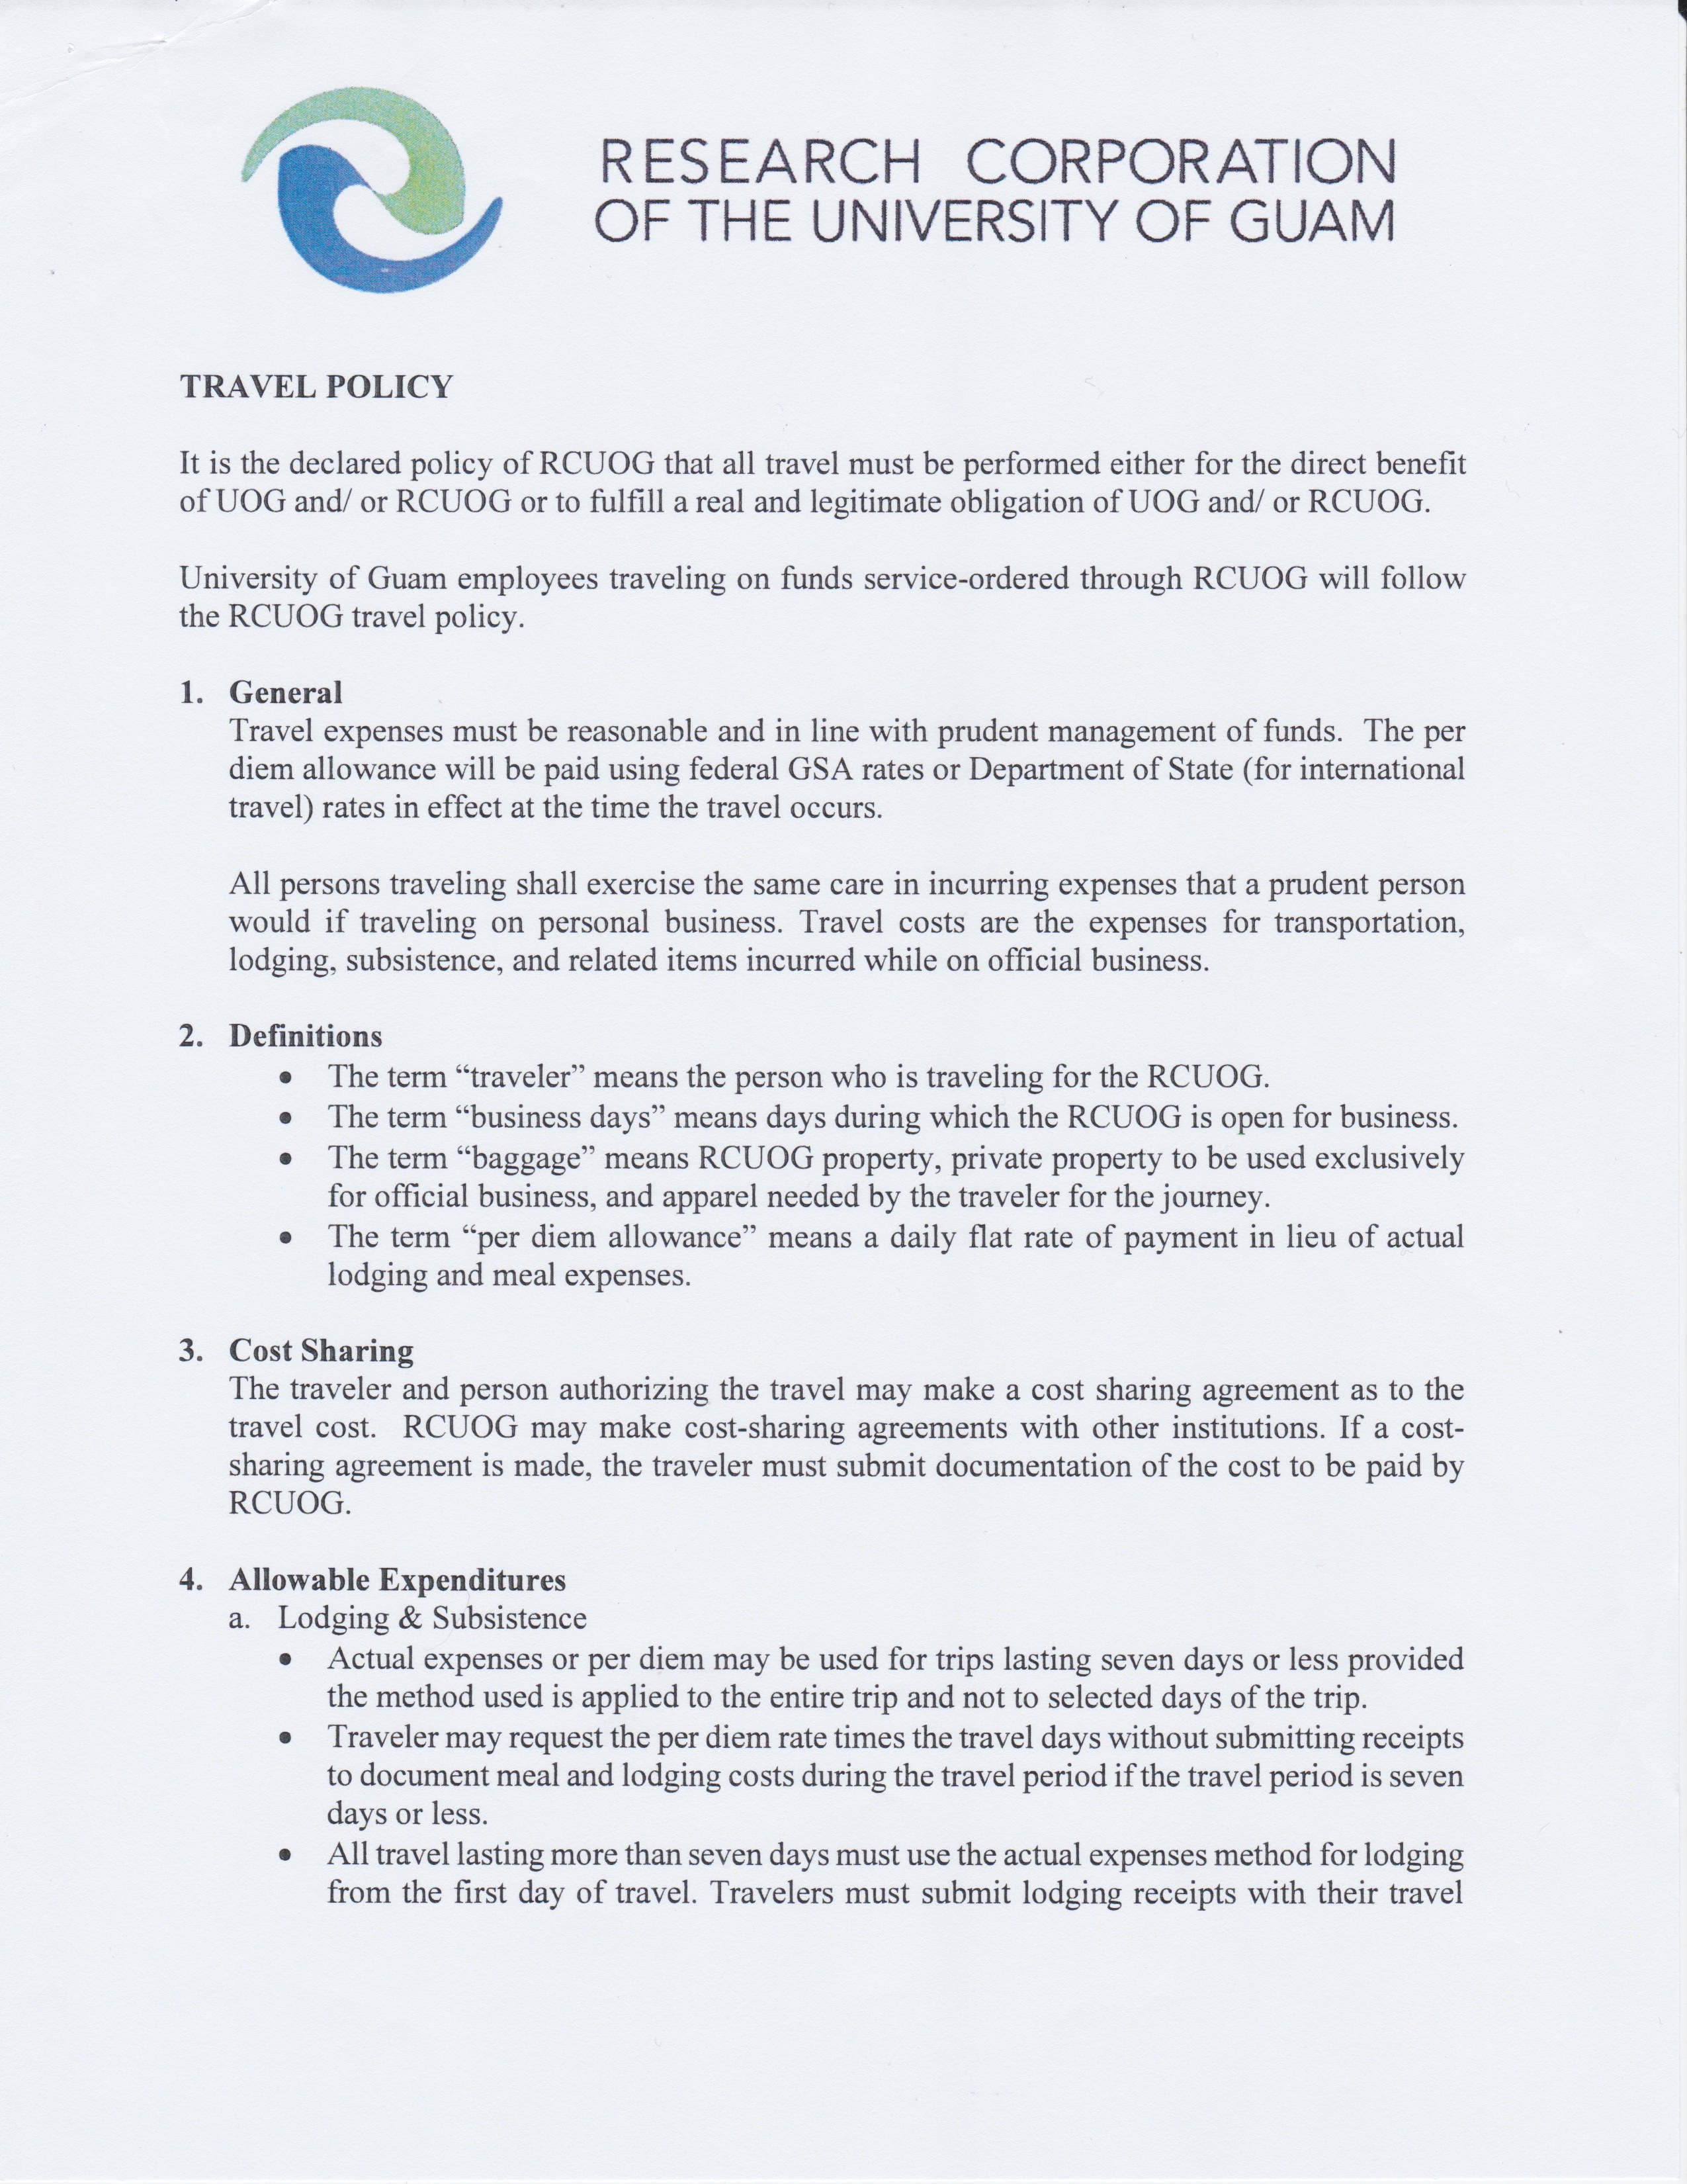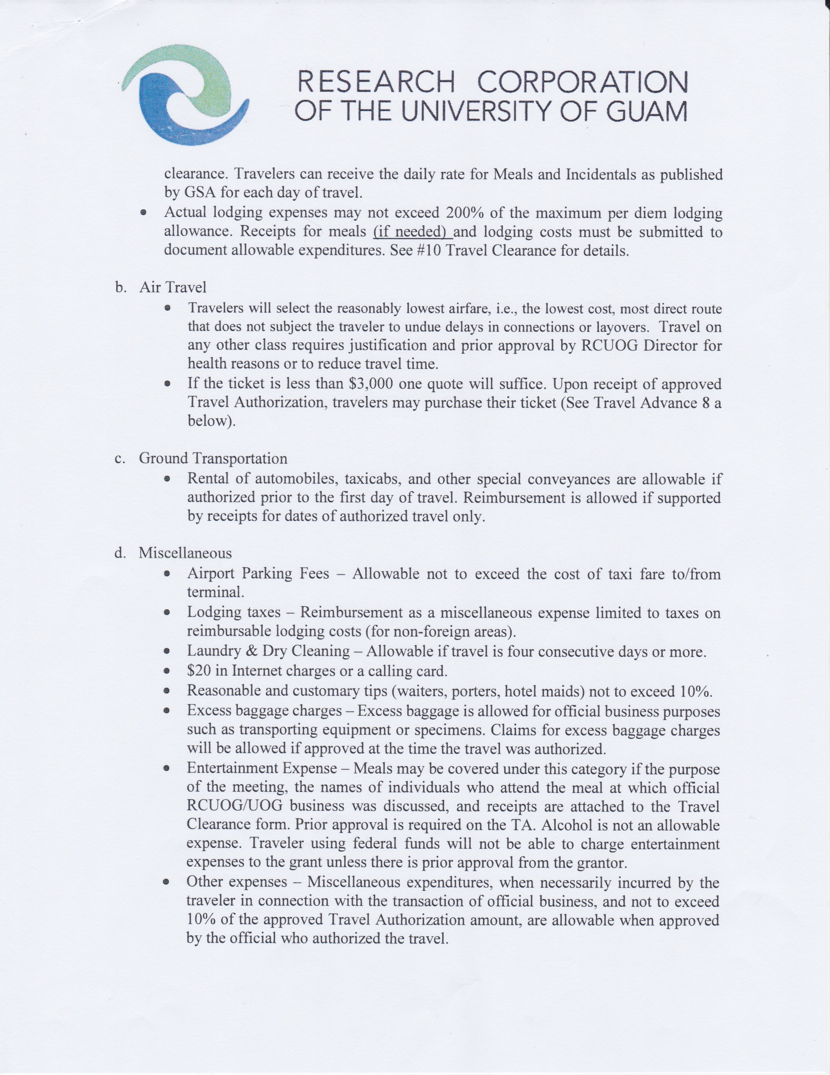
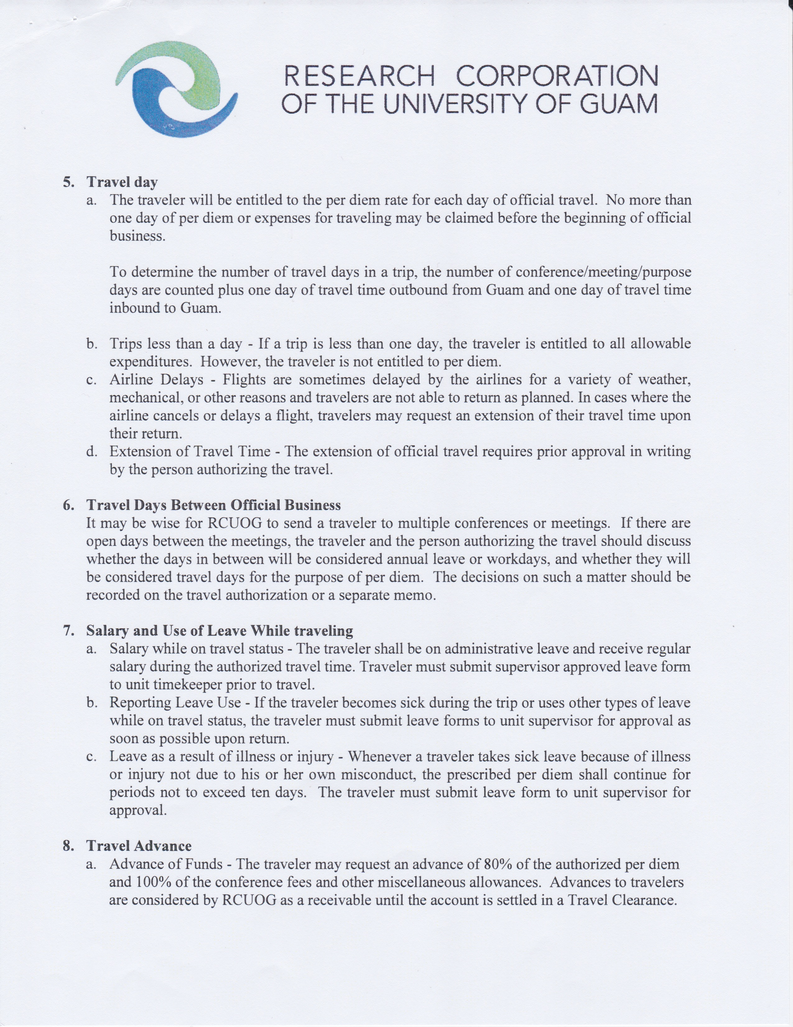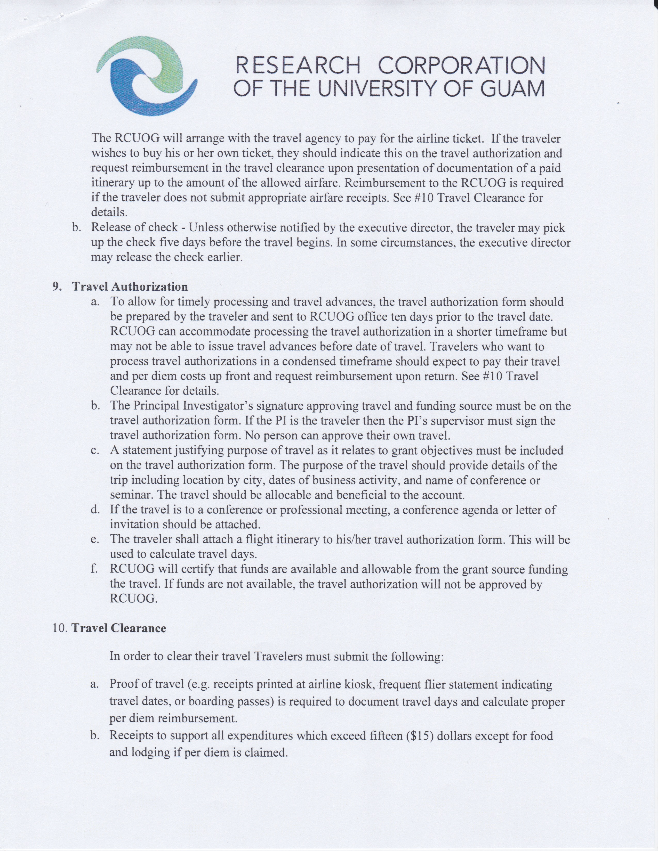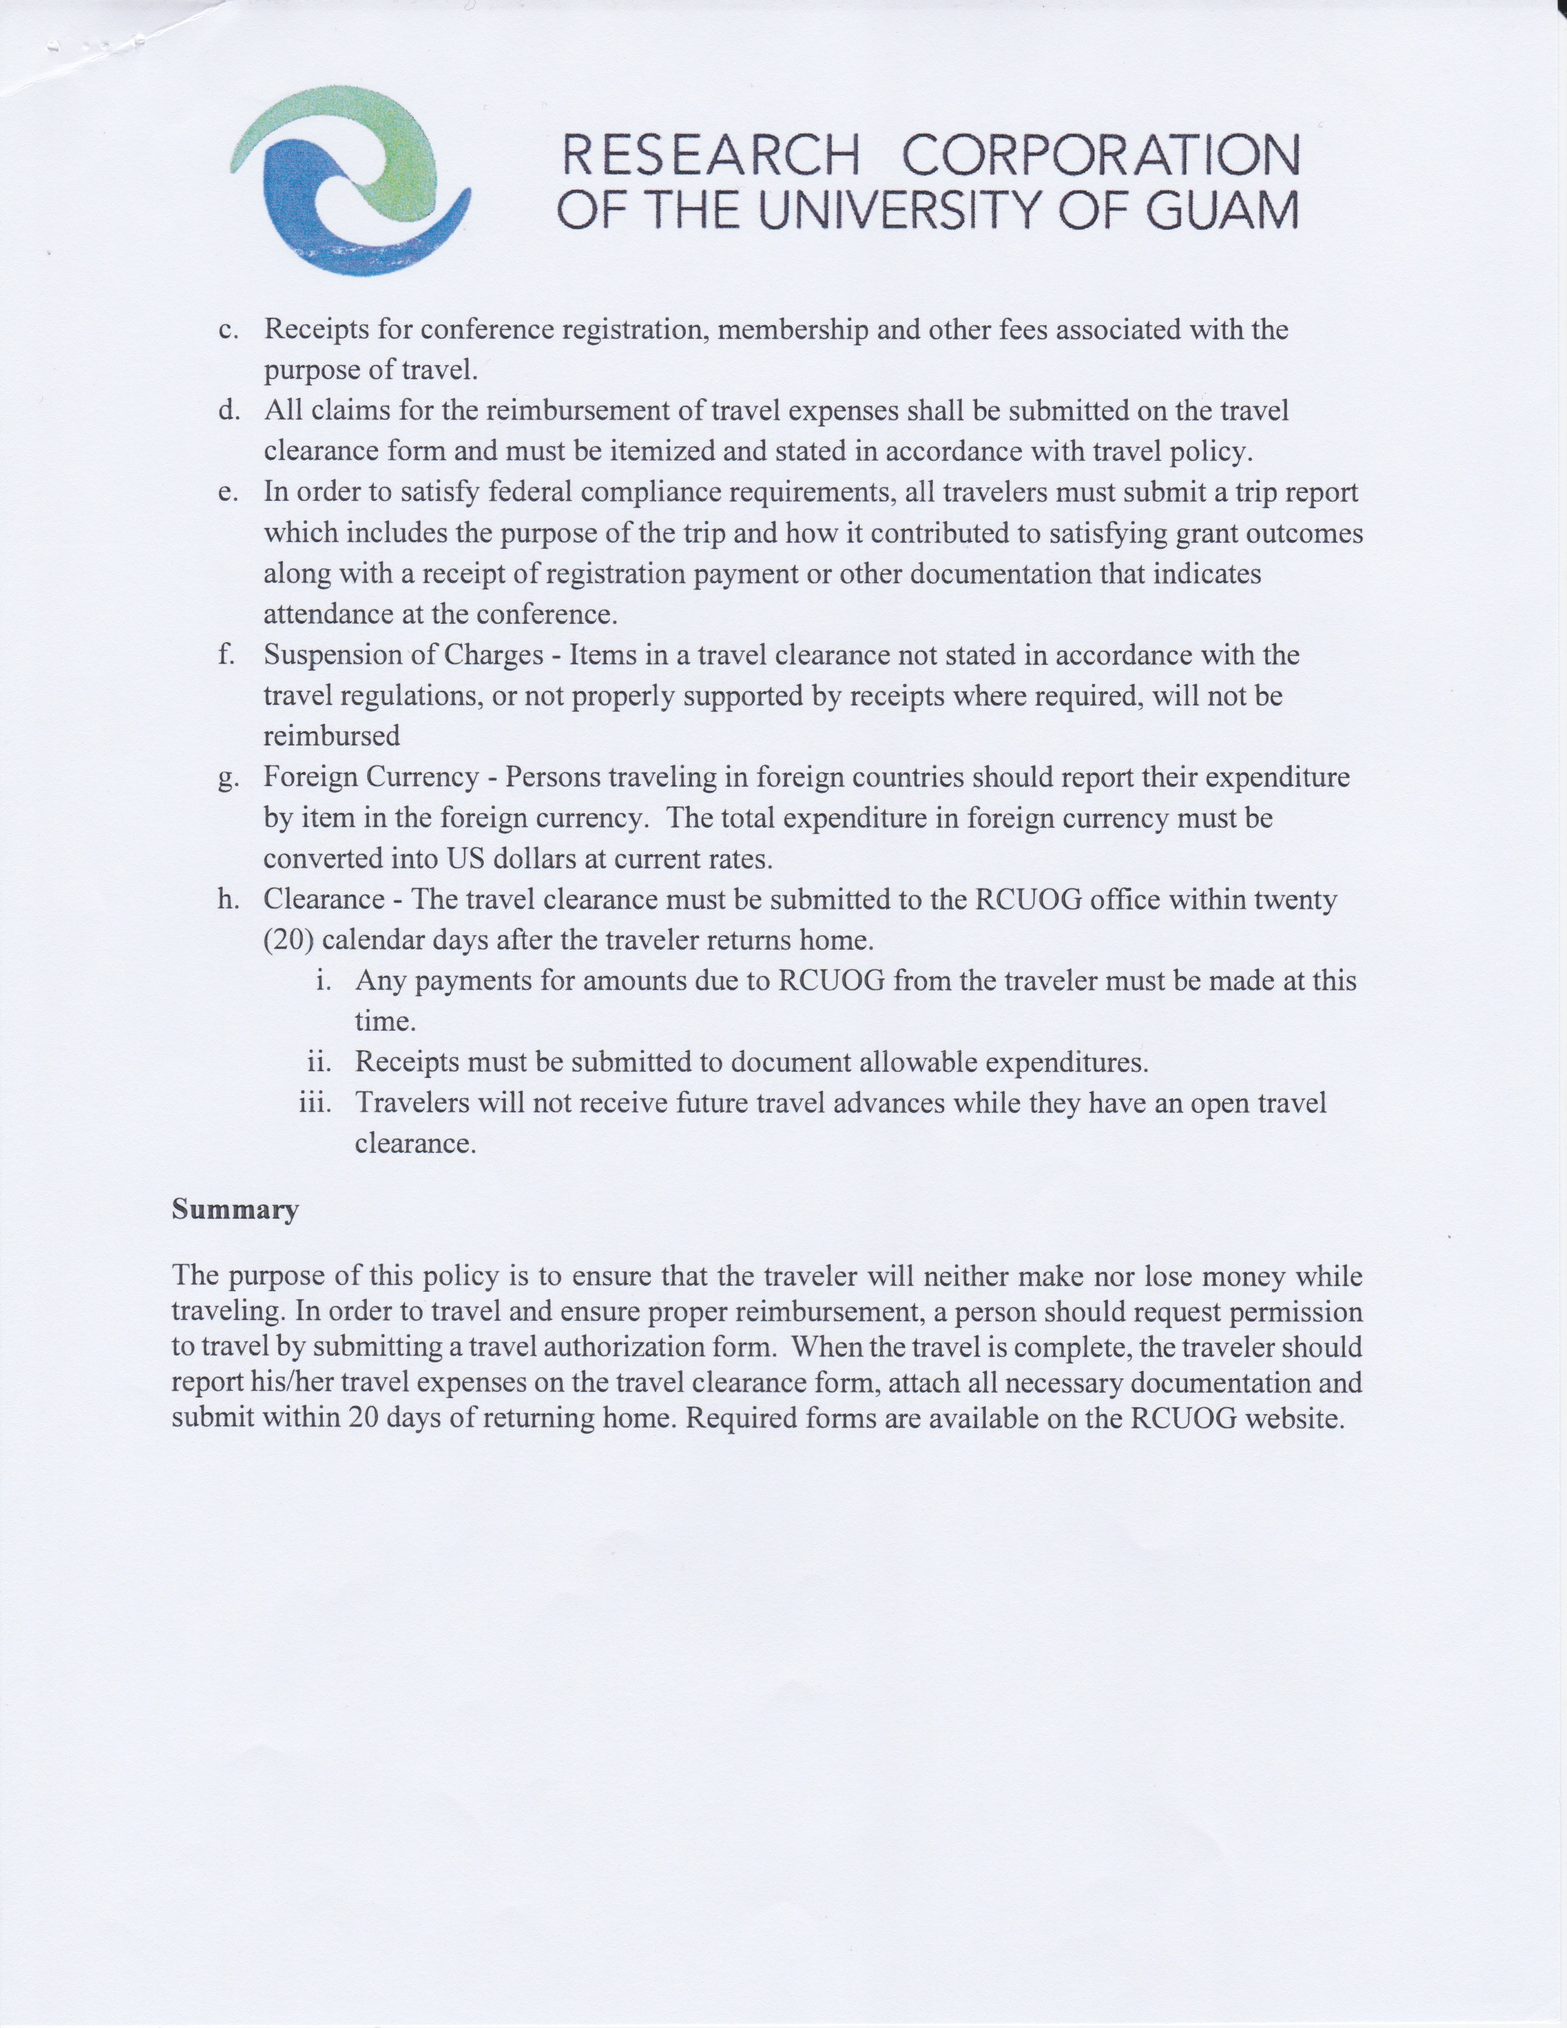

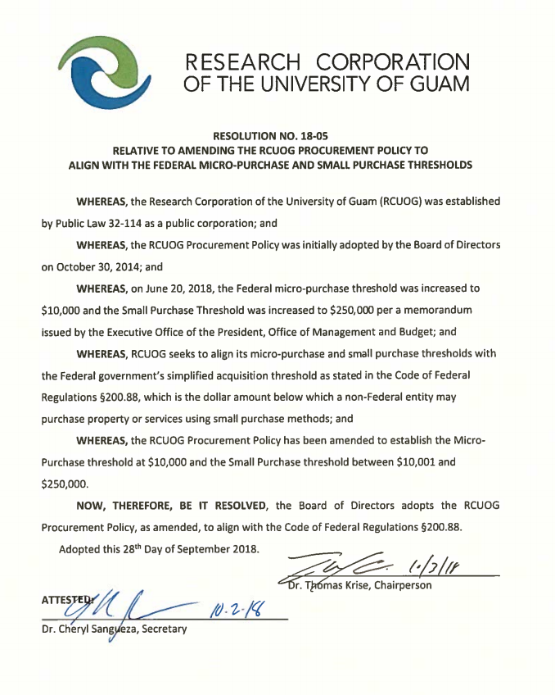
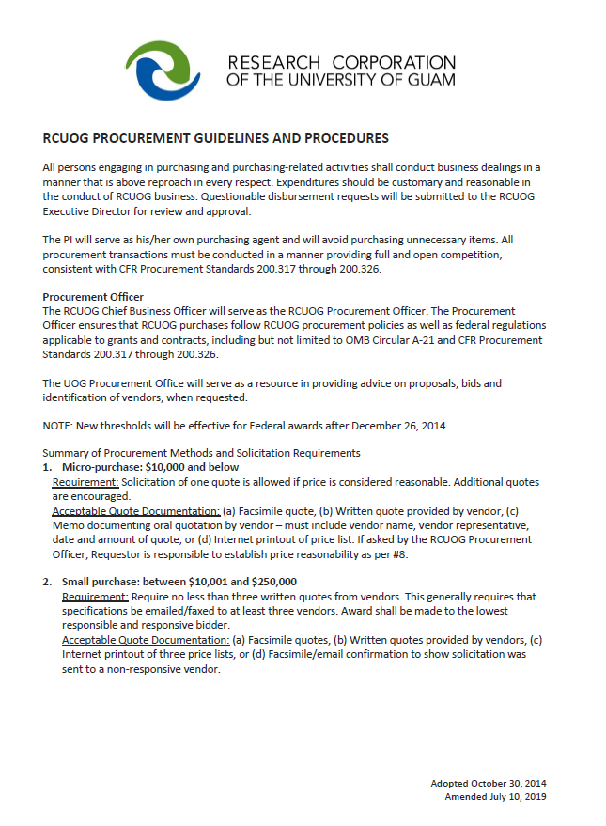
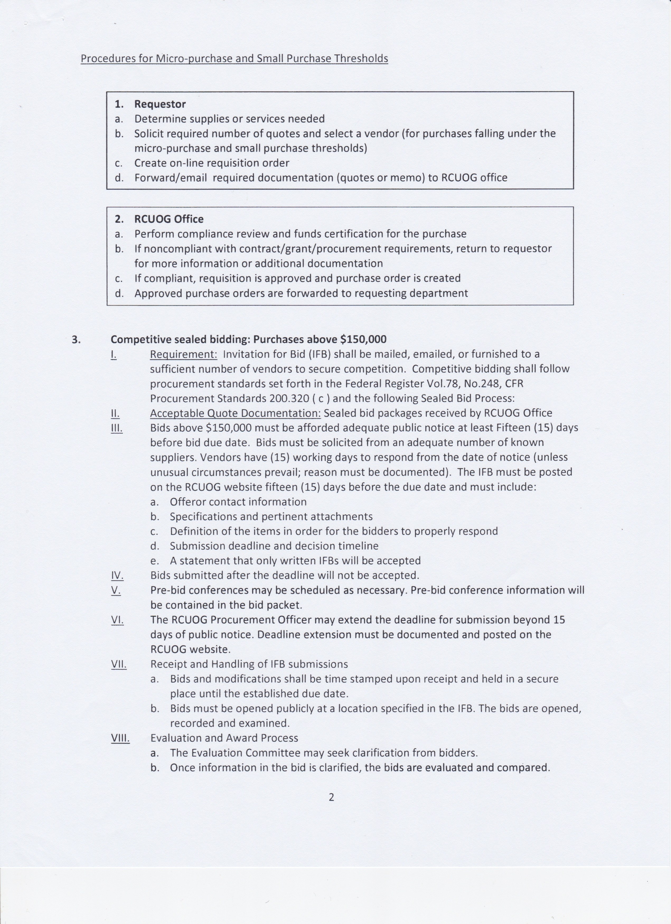

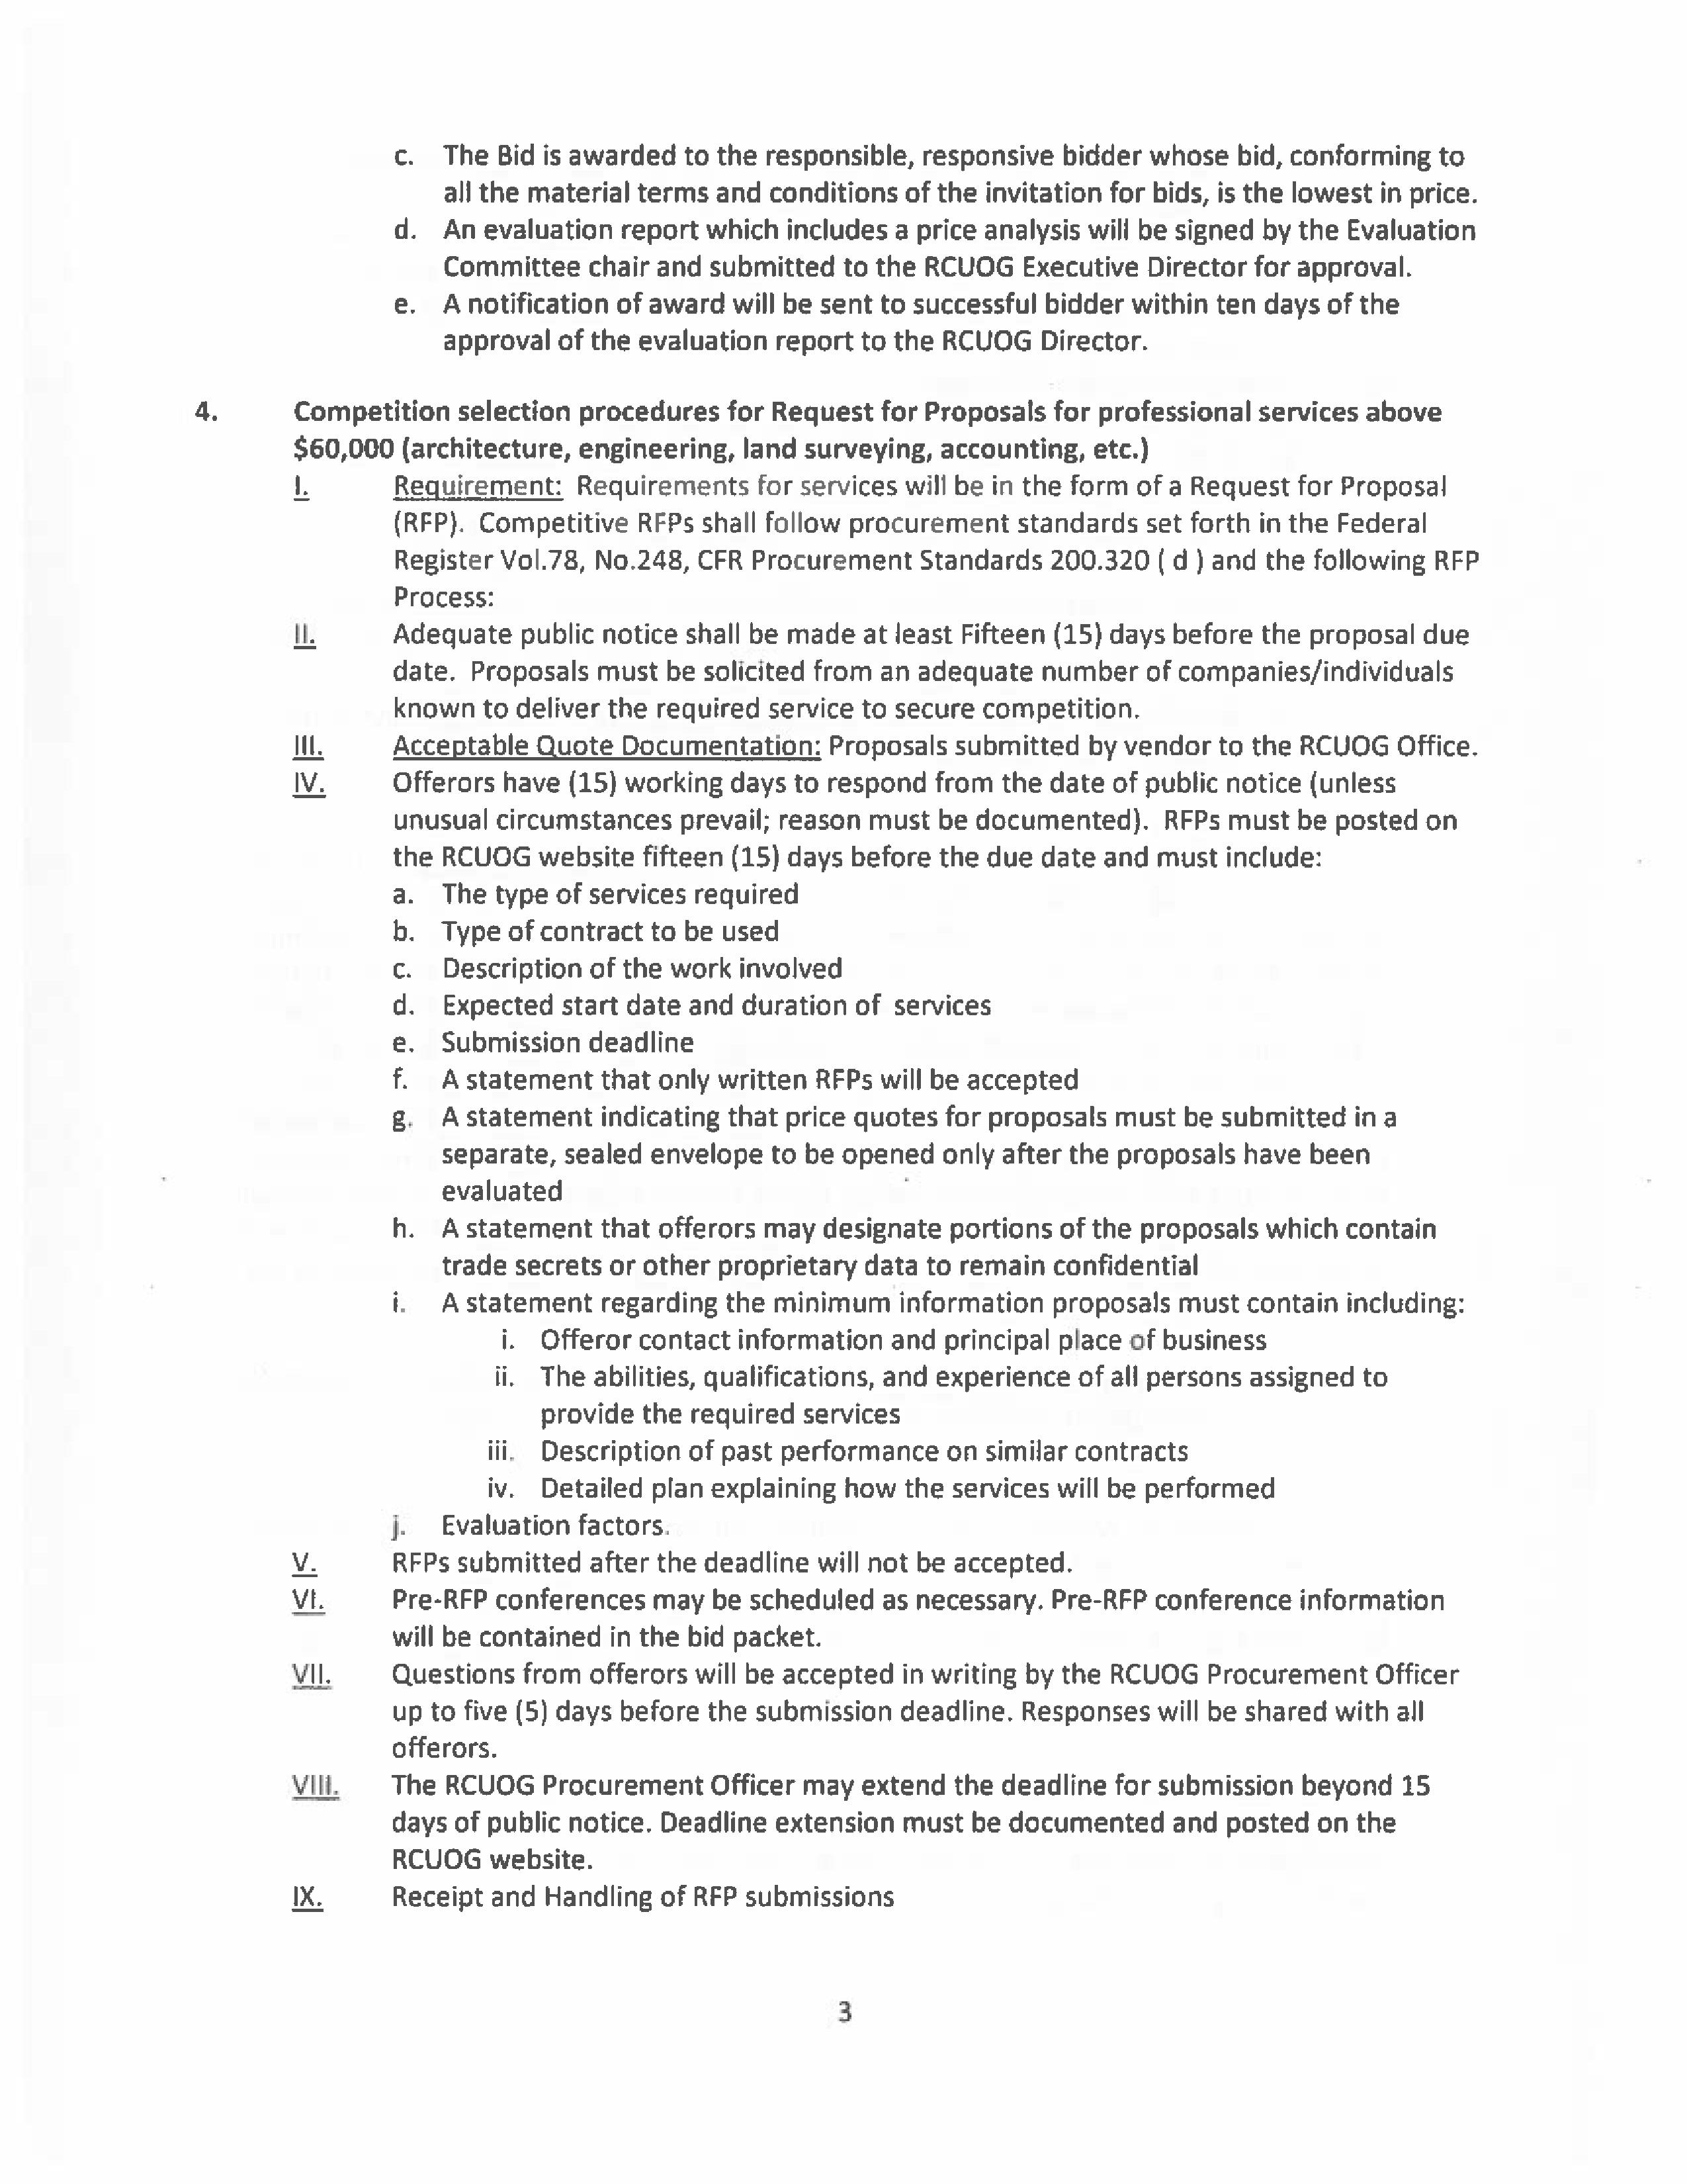
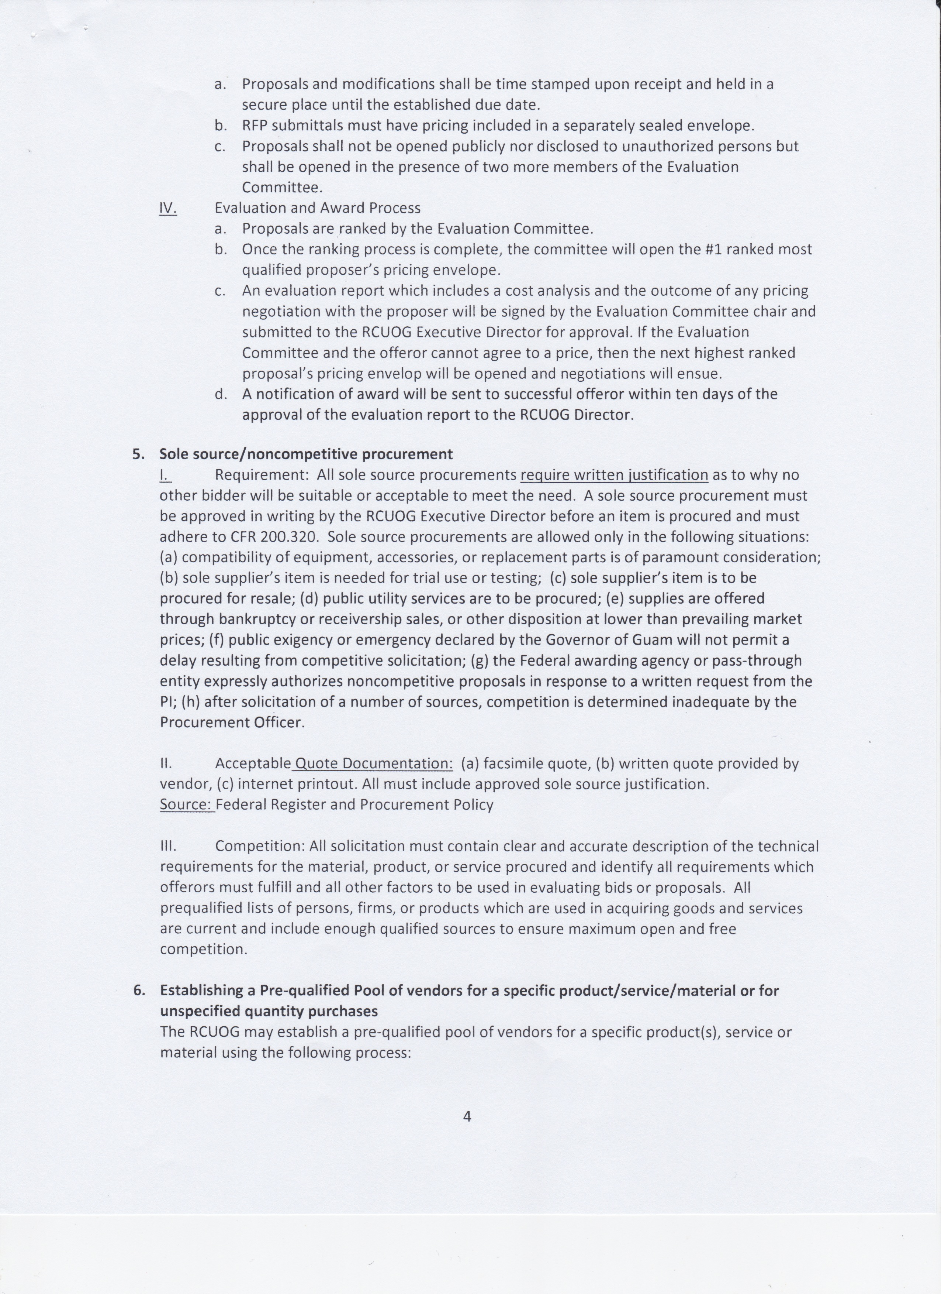

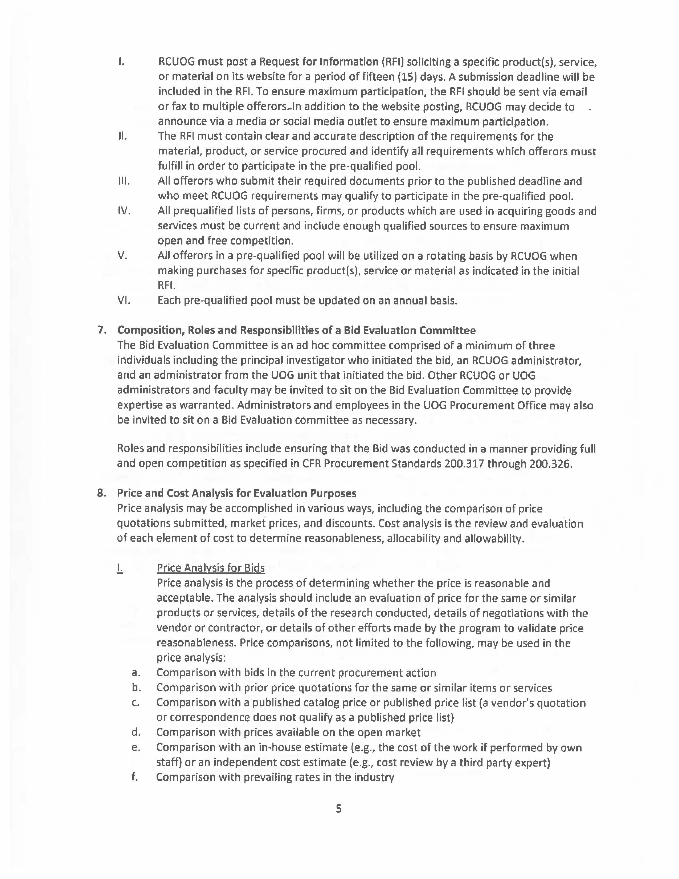
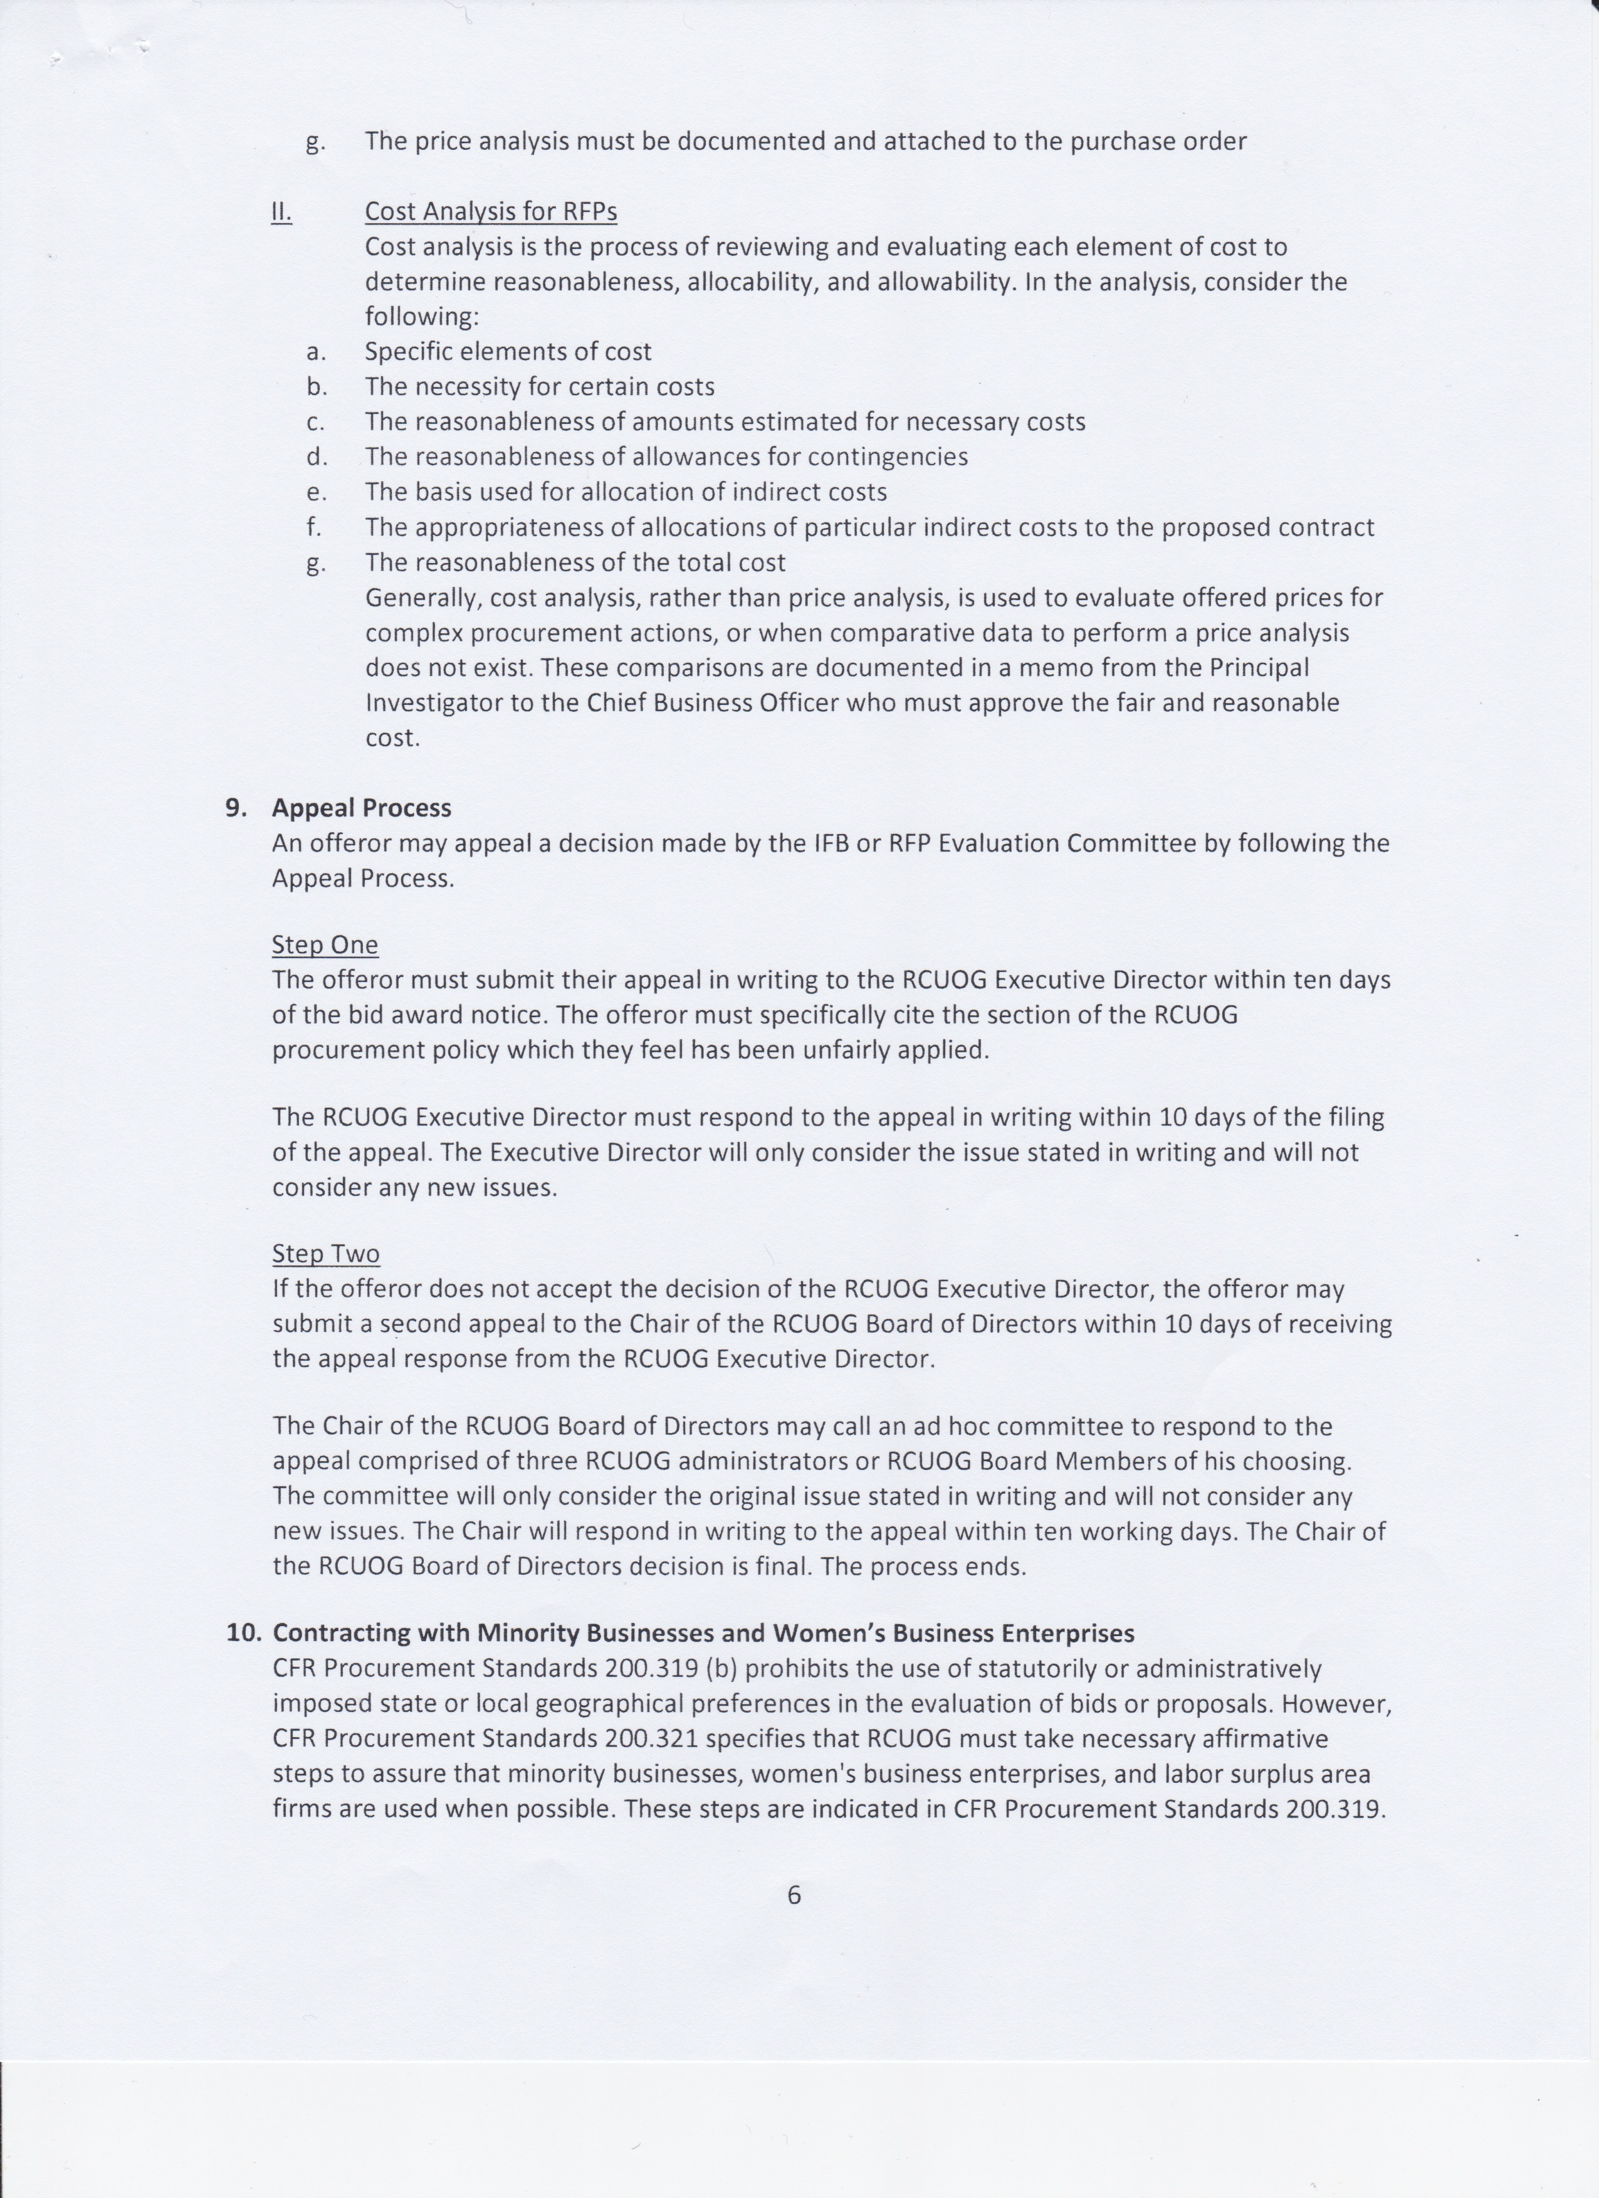
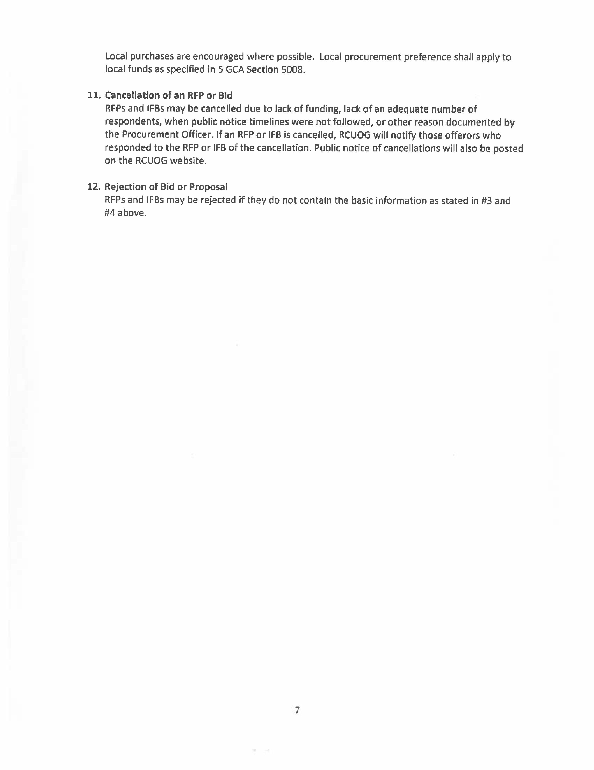
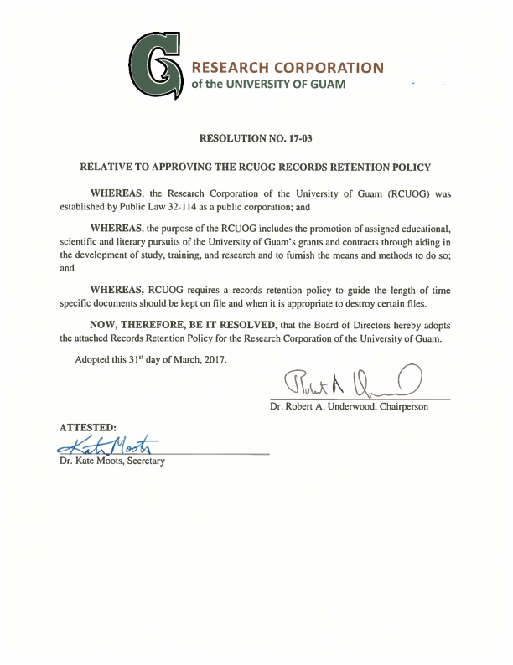
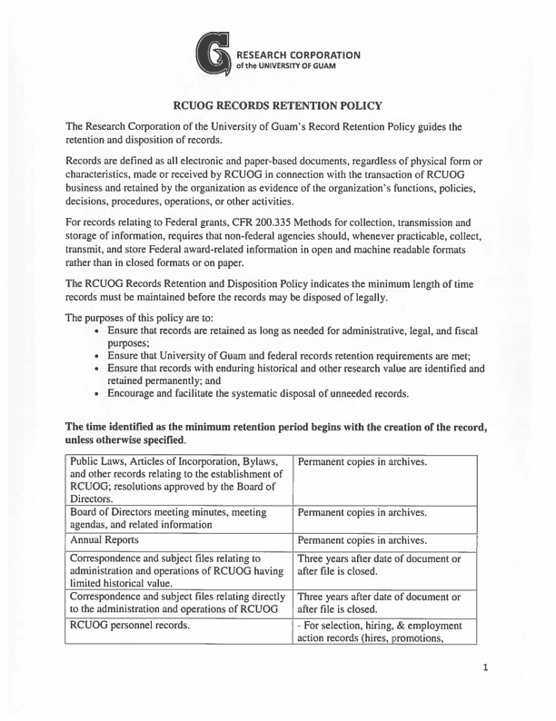
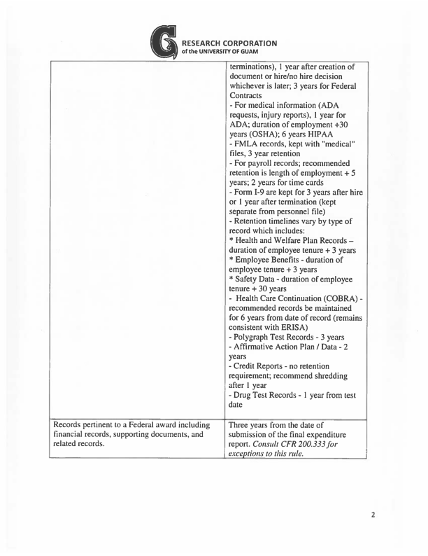
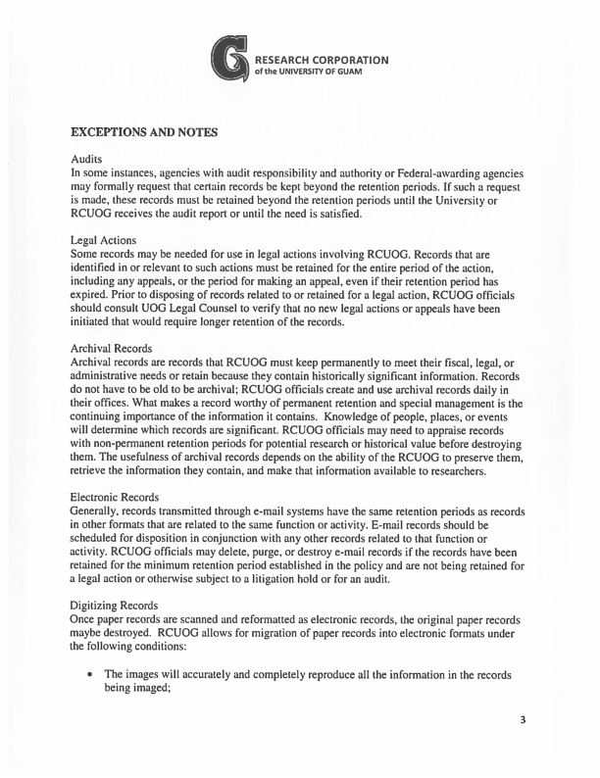
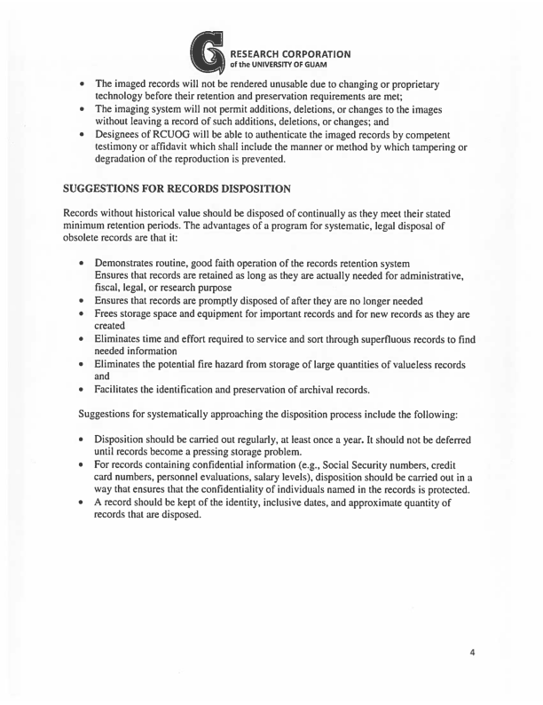

EMPLOYEE HANDBOOK AND POLICY MANUAL
October 30, 2014
Amended February 13, 2015
Amended December 18, 2015
Amended December 2, 106
Amended March 31, 2017

Employee Handbook and Policy Manual
Table of Contents

1. Acknowledgement……………………………………………………………………………3
2. Orientation……………………………………………………………………………………4
3. RCUOG is a Public Corporation………………………………………………………..........5
4. Code of Ethics and Conduct…………...……………………………………………………..6
5. Employment Hiring Policy and Procedures…………..……………………………….........11
6. Leave, Attendance, and Absenteeism Policy..……………………………………………...14
7. Time and Effort Reporting Policy an Procedures…………………………………………..19
8. Internet, Email, Social Media and Equipment Policy………..…………..…..…………......20
9. Progressive Discipline Policy………...……………………………………………………..21
10. Grievance Policy and Procedures…………...………………………………………………22
11. Harassment and Bullying Policy…………………………...…………………………….....24
12. Comprehensive Non-discrimination Policy…..………………………………………….....26
13. Tobacco Free Policy……………………...…………………………………………………28
14. Drug and Alcohol Abuse Policy……...……………………………………………………..29
15. Whistleblower Policy…… .………………………………………………………………...34
16. Safety and Security Policy……………………………..………………...............................35
17. Salary Increments and Employee Evaluation Policy…………..…………………………...36
18. Amending Personnel Actions/Employment Verification…..………………………………38
19. Volunteer Policy…………...………………………………………………………………..39
20. Employee Benefits……………..…………………………………………………………...40
21. Resignation……………..…………………………………………………………………..41
22. Contact Information……………………………..………………………………………….42

1. RCUOG EMPLOYEE HANDBOOK & POLICY MANUAL ACKNOWLDEGEMENT

Welcome to the Research Corporation of the University of Guam (RCUOG or Corporation). We hope that you will have a productive relationship with the RCUOG. To assist you in understanding RCUOG policies, we have provided you with a copy of the RCUOG Employee Handbook and Policy Manual. Please read this handbook carefully. The information contained within it will acquaint you with Corporation policies and will answer many of your questions. From time to time these policies may be updated in writing and updates will be posted on the RCUOG website: www.uog.edu/rcuog.

Please keep in mind that this handbook does not contain all of the information you will need to perform your job. This handbook highlights RCUOG policies, procedures, guidelines and employment benefits for your information. In order to retain necessary flexibility in the administration of policies and procedures, the RCUOG reserves the right to make revisions without notice. In the event of conflicts or differences between the wording of the policies themselves, and the summaries of this handbook, the terms of the policies will govern.

This handbook also summarizes benefits currently available to our employees. In the event of conflicts or differences between the wording of the benefit plans themselves, and the summaries of this handbook, the terms of the benefit plan will govern.

RCUOG has the sole discretion to determine eligibility for benefits and to interpret and administer these plans. RCUOG reserves the right to change, revise or terminate, or change the terms and conditions of any of the benefits discussed in this handbook without advance notice.

This handbook is not an employment contract. Unless you have a written contract with RCUOG signed by the Executive Director, you are an at-will employee. This means you or the RCUOG may terminate our employment relationship at any time, with or without a reason.

In the future, your status as an at-will employee can only be changed through a written contract signed by both you and the Executive Director of the RCUOG. If you have a question concerning any of the information contained in this handbook, please consult with your supervisor or the RCUOG administrative team.

RCUOG Employee Receipt and Acknowledgement

I have received a copy of the RCUOG Employee Handbook. I have read the above information and I acknowledge that it is a correct statement of my employment status. I understand that this handbook is not a contract for employment.

Print Name: _ Signature: _

Date: _

2. RCUOG EMPLOYEE ORIENTATION

All newly hired employees will participate in an orientation to familiarize themselves with the RCUOG’s policies and procedures and with the University of Guam. This orientation session demonstrates the collegial atmosphere of the RCUOG and introduces the positive employee relations environment in which you should work.

Orientations will cover the following information contained in the RCUOG Employee Handbook:

• Brief history of UOG and RCUOG
• Code of Ethics
• Hiring Practices and Procedures
• Attendance, Absenteeism, and Leave Policy
• Internet and Email Use and Social Media Guidelines
• Progressive Discipline Procedures
• Grievance Procedures
• Harassment and Bullying
• EEO, ADA and Title IX Compliance Statements
• Drug and Alcohol Abuse Policy
• Tobacco Free Policy
• Whistleblowing Policy
• Health and Safety Policy –UOG Clery Act Policy
• Performance Appraisal (Evaluation Policy)
• Employee Benefits
o Medical and dental insurance
o Social Security and Medicare

Campus tours and/or presentations from various UOG or RCUOG employees on relevant issues may be included in the orientation as needed. Additionally, during your new employee orientation period and on an ongoing basis during your career, your supervisor is the best source of information if you have questions regarding job duties, policies and procedures that must be followed in the workplace, and the use of facilities, equipment and supplies.

3. RCUOG IS A PUBLIC CORPORATION

Research Corporation of the University of Guam is public corporation created by Public Law 32-
114. PL 32-114 can be downloaded from the RCUOG website at www.uog.edu/rcuog.

4. RCUOG CODE OF ETHICS AND CONDUCT

4.1 Statement of Mission and Core Values

Mission

RCUOG provides an efficient managerial environment necessary to compete for and manage research funding. The purpose of the RCUOG includes but is not limited to promoting the educational, scientific, and literary pursuits of the University of Guam and encourages training, research and study by providing the infrastructure for streamlined grants and contracts management in compliance with federal rules and regulations as well as RCUOG policies.

Build Trust and Credibility

The success of the RCUOG is dependent on the trust and confidence we earn from our employees, funding agencies, and partners. We gain credibility by complying with federal rules and regulations, displaying honesty and integrity, and reaching goals solely through ethical and honorable conduct.

Respect for the Individual

We all deserve to work in an environment where we are treated with dignity and respect. RCUOG is committed to creating such an environment because this contributes directly to our success. RCUOG is an equal employment/affirmative action employer and is committed to providing a workplace that is free of discrimination of all types, and from abusive, offensive or harassing behavior. Any employee who feels harassed or discriminated against should report the incident to his or her supervisor or unit administrator, the RCUOG Executive Director, or the UOG Institutional Compliance Office.

Create a Culture of Open and Honest Communication

At RCUOG everyone should feel comfortable to speak his or her mind, particularly with respect to ethics concerns. Managers have a responsibility to create an open and supportive environment where employees feel comfortable raising such questions. The organization benefits when employees exercise their power to prevent mistakes or wrongdoing by asking the right questions at the right time.

RCUOG will initiate an investigation of all reported instances of questionable or unethical behavior. In every instance where improper behavior is found to have occurred, the RCUOG will take appropriate action. We will not tolerate retaliation against employees who raise genuine ethics concerns in good faith.

Uphold the Law, Rules and Regulations

RCUOG’s commitment to integrity begins with complying with laws, rules and regulations where we do business. Further, each of us must have an understanding of the RCUOG policies, laws, rules and federal regulations that apply to our specific roles. If we are unsure of whether a contemplated action is permitted by law or RCUOG policy, we should seek the advice from the resource expert. We are responsible for preventing violations of law, rules and regulations and for speaking up if we see possible violations.

4.2 Conflicts of Interest

We must avoid any relationship or activity that might impair our ability to make objective and fair decisions when performing our jobs. At times, we may be faced with situations where the business actions we take on behalf of RCUOG may conflict with our own personal or family interests because the course of action that is best for us personally may not also be the best course of action for RCUOG. We owe a duty to RCUOG to advance its legitimate interests when the opportunity to do so arises. We must never use RCUOG property or information for personal gain or personally take for ourselves any opportunity that is discovered through our position with RCUOG.

Examples of instances where conflicts of interest could arise include but are not limited to:

- Being employed by, or acting as a consultant to, a competitor or potential competitor, supplier or contractor, regardless of the nature of the employment, while you are employed with RCUOG.
- Hiring or supervising family members or closely related persons.
- Serving as a board member for an outside commercial company or organization doing business with RCUOG.
- Owning or having a substantial interest in a competitor, supplier or contractor.
- Having a personal interest, financial interest or potential gain in any RCUOG transaction.
- Placing organization business with a firm owned or controlled by a RCUOG employee or his or her family.
- Accepting gifts, discounts, favors or services from a customer/potential customer, competitor or supplier (for details see gifts, gratuities, and business courtesies below).

Determining whether a conflict of interest exists is not always easy to do. Employees with a
conflict of interest question should seek advice from management. Before engaging in any activity, transaction or relationship that might give rise to a conflict of interest, employees must seek review from their managers or the RCUOG administration for guidance.

4.3 Outside Employment or Dual Employment

A Concurrent Employment Form must be signed by the unit administrator and submitted to RCUOG at least two (2) days prior to the commencement of the concurrent employment. Upon the unit administrator and RCUOG’s approval, the employee will receive a Concurrent Employment Agreement. Employees must obtain an approved Concurrent Employment Agreement before accepting employment concurrently with RCUOG or RCUOG/UOG appointments. All Concurrent Employment Agreements will be reviewed annually. The Concurrent Employment Form is posted on the RCUOG website: www.uog.edu/rcuog.

4.4 Gifts, Gratuities and Business Courtesies

RCUOG is committed to competing solely on the merit of our products and services. We should avoid any actions that create a perception that favorable treatment of outside entities by RCUOG was sought, received or given in exchange for personal business courtesies. Business courtesies include gifts, gratuities, meals, refreshments, entertainment or other benefits from persons or companies with whom RCUOG does or may do business. We will neither give nor accept business courtesies that constitute, or could reasonably be perceived as constituting, unfair business inducements that would violate law, federal regulations, or polices of RCUOG, or would cause embarrassment or reflect negatively on RCUOG’s reputation.

Gifts

Employees may accept unsolicited gifts, other than money, that conform to the reasonable ethical practices of the marketplace, including:

- Flowers, fruit baskets and other modest presents that commemorate a special occasion.
- Gifts of nominal value, such as calendars, pens, mugs, caps and t-shirts (or other novelty, advertising or promotional items).

Generally, employees may not accept compensation, honoraria or money of any amount from entities with whom RCUOG does or may do business. Tangible gifts that have a market value greater than $100 may not be accepted.

Employees with questions about accepting business courtesies should talk to their managers or the RCUOG Executive Director.

Meals, Refreshments and Entertainment

Entertainment costs cannot be charged to a federal grant under any circumstances. Employees may accept occasional meals, refreshments, entertainment and similar business courtesies that are shared with the person who has offered to pay for the meal or entertainment, provided that:

- They are not inappropriately lavish or excessive.
- The courtesies are not frequent and do not reflect a pattern of frequent acceptance of courtesies from the same person or entity.
- The courtesy does not create the appearance of an attempt to influence business decisions such as accepting courtesies or entertainment from a supplier whose contract is expiring in the near future.
- The employee accepting the business courtesy would not feel uncomfortable discussing the courtesy with his or her manager or co-worker or having the courtesies known by the public.

Offering Business Courtesies

Entertainment costs cannot be charged to a federal grant under any circumstances. Any employee who offers a business courtesy must assure that it cannot reasonably be interpreted as an attempt to gain an unfair business advantage or otherwise reflect negatively upon RCUOG. An employee should not use personal funds or resources to do something that cannot be done with RCUOG resources. Accounting for business courtesies must be done in accordance with approved Corporation procedures.

Other than to our government customers, for whom special rules apply, we may provide nonmonetary gifts (i.e., RCUOG/UOG logo apparel or similar promotional items) to our customers. Further, management may approve other courtesies, including meals, refreshments or entertainment of reasonable value provided that:

- Business courtesies such as meals or entertainment are not charged to a federal grant.
- The practice does not violate any law or regulation or the standards of conduct of the recipient’s organization.
- The business courtesy is consistent with industry practice, is infrequent in nature and is not lavish.
- The business courtesy is properly reflected on the books and records of RCUOG.

4.5 Accurate Public Disclosures

We will make certain that all disclosures made in financial reports and public documents are full, fair, accurate, timely and understandable. This obligation applies to all employees, including all financial executives, with any responsibility for the preparation for such reports, including drafting, reviewing and signing or certifying the information contained therein. No business goal of any kind is ever an excuse for misrepresenting facts or falsifying records.

Employees should inform RCUOG management if they learn that information in any filing or public communication was untrue or misleading at the time it was made or if subsequent information would affect a similar future filing or public communication.

Recordkeeping

We create, retain and dispose of our organization records as part of our normal course of business in compliance with all RCUOG policies and guidelines, as well as all regulatory and legal requirements.

All corporate records must be true, accurate and complete, and Corporation data must be promptly and accurately entered in our books in accordance with RCUOG’s and other applicable accounting principles.

We must not improperly influence, manipulate or mislead any audit, nor interfere with any auditor engaged to perform an internal independent audit of RCUOG books, records, processes or internal controls.

Accountability

Employees are responsible for knowing and adhering to the values and standards set forth in this code. RCUOG takes seriously the standards set forth in the code, and violations are cause for disciplinary action up to and including termination of employment.

4.6 Confidential and Proprietary Information

Integral to RCUOG’s business success is our protection of confidential organization information, as well as nonpublic information entrusted to us by employees, researchers and other partners. Confidential and proprietary information includes research discoveries, financial data, customer names/addresses or nonpublic information about other companies, including current or potential supplier and vendors. We will not disclose confidential and nonpublic information without a valid business purpose and proper authorization.

We will not acquire or seek to acquire improper means of trade secrets or other proprietary or confidential information. We will not engage in unauthorized use, copying, distribution or alteration of software or other intellectual property.

4.7 Use of Corporation Resources

RCUOG resources, including time, material, equipment and information, are provided for RCUOG business use.

Employees and those who represent RCUOG are trusted to behave responsibly and use good judgment to conserve organization resources. Managers are responsible for the resources assigned to their departments and are empowered to resolve issues concerning their proper use.

Employees will not use Corporation equipment such as computers, copiers and fax machines in the conduct of an outside business or in support of any religious, political or other outside daily activity. We will not solicit contributions nor distribute non-work related materials during work hours.

RCUOG reserves the right to monitor or review all data and information contained on an employee’s RCUOG-issued computer or electronic device, the use of the internet or RCUOG’s intranet. We will not tolerate the use of RCUOG resources to create, access, store, print, solicit or send any materials that are harassing, threatening, abusive, sexually explicit or otherwise offensive or inappropriate. Questions about the proper use of RCUOG resources should be directed to your manager.

5. RCUOG EMPLOYMENT HIRING POLICY AND PROCEDURES

Employees of the Research Corporation of the University of Guam are employed to deliver grant or externally funded objectives. Employees can be full or part time. Fulltime employees will generally work 40 hours per week, receive Social Security and Medicare, and shall be entitled to benefits including annual leave and sick leave as well as medical/dental insurance. Equal Employment Opportunity: the RCUOG’s Equal Employment Opportunity (EEO) policy encompasses the principle that all qualified and eligible job applicants have the right to fair hiring practices. Only after a unit has reviewed qualified and eligible candidates should the most suitable person(s) be selected.

RCUOG’s commitment to EEO is displayed through a system of established hiring procedures that assures all qualified and eligible applicants receive fair treatment. All units are encouraged to familiarize themselves with such procedures. EEO is a policy of the University and required by federal law by any organization receiving federal funds. Non-compliance by any one unit could result in fines and penalties for the RCUOG and the University of Guam to include the loss of federal funding.

Employee Job Titles and Descriptions

Job titles and descriptions as well as minimum education and work experience can be obtained from the RCUOG website. These positions have been benchmarked to the Hay General Pay Plan and have been assigned a pay grade. New positions can be created but require a position description to be developed and approved by the unit administrator; new position descriptions will undergo review and assignment of a pay grade by UOG HRO as well as review by RCUOG.

Employee Pay Scale

RCUOG Employee Pay Scale is a guide established to maintain reasonable pay equity for all employees. In general practice, all initial appointments will be offered at Step 1 of the appropriate pay grade assigned to the job title. As in all competitive job markets, budgets, special demands and other unique circumstances, may influence a department’s hourly rate offer. Therefore, there are circumstances where a step higher than Step 1 may be offered but offers are not to exceed Step 10 of the pay grade.

5.1 Recruitment:

- Employee positions must be established within RCUOG.
- Units submit a request to hire memo to RCUOG which includes recommended job title and detailed job information. The unit dean or director must approve the request to hire memo.
- RCUOG certifies and approves the request to hire. If the job title is a newly created position, HRO reviews the job title and job information and assigns the appropriate grade for pay purposes. If the job title already exists, then a pay grade has been assigned to the position.
- Units will establish a selection committee for each job announcement. As a rule of general practice, the committee should consist of at least three (3) individuals. The committee chair may be appointed by the unit administrator or the committee members may select the chair. The committee chair ensures that all RCUOG hiring policies and procedures are carried out.

5.2 Notification:

- Job announcements are created in standard format and assigned RCUOG job numbers. Job announcements are available online and, as a general rule of practice, are posted for a period of seven (7) calendar days. The unit may request a longer period of time for the job announcement to be posted online in their request to hire memo. Applications shall be accepted only during the filing period specified in the announcement.
- Applicants can review available jobs online and apply for those employment opportunities that interest them.
- Applicants are required to complete a RCUOG employment application. Applicants may send documents, such as transcripts or letters of recommendation as required by the job announcement, via email to rcuoghr@gmail.com. RCUOG will analyze applications and the respective unit will be advised of a qualified employment applicant pool.
- Committee members will review the qualified pool of applicants and select individuals to interview and schedule interviews.

5.3 Interviewing

- Units should only interview applicants who have been referred by RCUOG through the Certification of Eligibles.
- A reasonable period of time should be allowed for the committee to schedule and conduct interviews so that all qualified and eligible applicants may be fairly interviewed.
- All interview questions should be non-discriminatory and must be approved by EEO.
- After interviews have been conducted, the committee should perform a reference check. Once the reference check is performed, the committee sends a recommendation memo to the unit administrator for approval. The approved memo is then routed to the RCUOG for final approval and processing. Once approved, the unit administrator or PI informs the candidate that they were selected for the position.
- Other candidates should be properly informed by RCUOG of the unit’s hiring decision so that they may continue their job search.

5.4 Hiring

- Once an applicant accepts the job offer, the unit will prepare a Personnel Action (RC-1).
- Form I-9 is a federal document to determine one’s eligibility to work in the U.S. and is required by the U.S. Citizenship and Immigration Office. This document is completed at UOG HRO on the employee’s FIRST DAY of work.
- The employee must submit police and court clearances to UOG HRO before they report for their first day of work.
- The employee must submit a completed tuberculosis (TB) screening form before they report for their first day of work. Section 25103, Title 10, Guam Code Annotated requires employees to be screened annually for tuberculosis as a condition of employment or doing volunteer work. TB screening form is available on RCUOG website at www.uog.edu/rcuog.
- Tax forms W-4 (federal tax withholding) will be provided to new employees during the on- boarding process. This form is submitted to Payroll office for continued processing.
- Employees shall not begin working until their Personnel Action (RC-1) is approved by RCUOG and UOG HRO. NOTE: Incomplete or incorrectly completed forms will result in a delay of processing.

5.5 Twenty (20) Week Limited Term Hiring

Employees may be hired for a maximum of 20 weeks working 40 hours or less per week. This is used when the immediate hire of an employee is critical to meet the performance outcomes of the grant or project. The principle investigator and unit administrator must follow 5.1 steps 1 – 4 and 5.4 steps 1-6. The individual must complete and submit a RCUOG application, and submit transcripts, letters of recommendation or other documentation as required by the principal investigator and unit administrator.

5.6 Hiring for Post-Doctoral Positions

Individuals hired for post-doctoral positions are not subject to a search process. The rate of pay and the person selected to fill the post-doctoral position are determined by the principal investigator and the unit administrator. The principle investigator and unit administrator must follow 5.1 steps 1 – 4 and 5.4 steps 1-6. The individual must complete and submit a RCUOG application, and submit transcripts, letters of recommendation or other documentation as required by the principal investigator and unit administrator.

6. RCUOG LEAVE, ATTENDANCE, AND ABSENTEEISM POLICY

RCUOG Leave, Attendance, and Absenteeism Policy applies to employees and covers the following:

- Annual Leave
- Sick Leave
- Paid Holidays
- Administrative Leave/
  - Travel Status
  - Jury Duty
  - Military Duty
  - Voting in primary and general elections
  - Workers’ Compensation
  - Pregnancy Related Medical Leave and Parental Leave
- Attendance, Tardiness, Absenteeism
- Family and Medical Leave Act

6.1 Annual Leave

RCUOG full-time employees earn annual leave per pay period on the following basis:

• Employees with less than five (5) years of employment with RCUOG earn four (4) hours of annual leave per pay period for a maximum of 104 hours of annual leave per year

• Employees with between five (5) and fifteen (15) years of employment with RCUOG earn six (6) hours per of annual leave pay period for a maximum of 156 hours of annual leave per year

• Upon completion of their 15th year of employment with RCUOG, employees earn eight (8) hours of annual leave per pay period for a maximum of 208 hours of annual leave per year

Employees are encouraged to use their accrued annual leave each year. Employees cannot cash out leave at the end of a fiscal year. Employees may carry over a maximum of eighty (80) hours of unused annual leave and eighty (80) hours of unused sick leave to the subsequent fiscal year. Accrued employee annual and sick leave exceeding the eighty (80) hour threshold per category will be forfeited on September 30 of each year. Leave accrual occurs only if the employee is on paid status for 80 hours (two 40 hour work weeks) in a pay period. If at any point during the two weeks an employee goes on leave without pay, no leave accrual occurs. As a rule of general practice, vacation days should be scheduled at least 24 hours in advance. Extended vacation of more than one week should be approved 48 hours in advance.

UOG and RCUOG service is combined to calculate earned annual leave for those UOG employees who migrate to RCUOG.

6.2 Sick Leave

RCUOG full-time employees earn four (4) hours of sick leave per pay period for a maximum of
104 hours per year. Sick leave of more than three days in duration requires a doctor’s certification. RCUOG employees do not participate in the Government of Guam leave sharing program

6.3 Administrative Leave

Paid administrative leave will be granted to eligible RCUOG employees who are on travel status, military duty, are voting in primary or general elections, pregnancy-related medical leave or parental leave, Worker’s Compensation, and jury duty provided that documents supporting administrative leave are attached to the leave request (i.e., military orders in the case of military duty or a jury certification document from the court in the case of jury duty). Any earnings from the court when on jury duty and paid administrative leave should be surrendered to RCUOG.

In the case of military leave, documents must be filed in employee’s official personnel jacket and UOG HRO and RCUOG must be notified. Full-time employees are allowed a maximum of 15 working days of military duty leave per fiscal year per Public Law 22-54. USERRA laws relative to extended military duty leave apply.

Pregnancy related medical leave shall be granted to a full-time female employee as a result of pregnancy, childbirth, or medical conditions related to pregnancy or childbirth. Pregnancy related medical leave shall consist of paid administrative leave not to exceed ten (10) working days, encompassing the date of the childbirth. The employee must submit a copy of their child’s birth certificate to RCUOG to receive paid pregnancy related medical leave.

Parental leave shall be granted to full-time employees upon the birth of a child or adoption of a child five years or younger. Parental leave consists of paid administrative leave not to exceed twenty (20) working days. The employee must submit a copy of their child’s birth certificate or adoption certificate to RCUOG to receive paid parental leave.

After pregnancy related medical leave and parental leave have been exhausted, a full-time employee may use accrued sick and annual leave and/or compensatory time to care for their newborn. All leave combined (pregnancy related medical, parental, sick, annual, compensatory) may not exceed forty (40) work days

The employee may seek unpaid leave under the Family and Medical Leave Act (FMLA) which allows a maximum of 12 weeks of unpaid leave per year inclusive of pregnancy-related medical leave, parental leave, annual leave, sick leave, and compensatory leave. FMLA leave is combined with all other leave so that the employee is capped at a maximum of 12 weeks or sixty (60) work days. Employees who pursue FMLA, and are eligible to participate in the program, must understand that they will be responsible for the employee share of their health insurance coverage. For more information on FMLA visit: https://www.dol.gov/general/topic/benefits-leave/fmla
6.4 Paid Holidays

RCUOG provides paid leave for full-time employees on the following 12 observed holidays:

New Year’s Day January 1
Martin Luther King Jr. Day Third Monday in Jan.
Guam History and Chamorro Heritage Day First Monday in March
Memorial Day Last Monday in May
Independence Day July 4
Liberation Day July 21
Labor Day First Monday in September
All Souls Day November 2
Veterans Day November 11
Thanksgiving Day Fourth Thursday in November
Santa Maria Kamalen Day December 8
Christmas Day December 25

• In the event that the President of the United States or the Governor of Guam declare an observed holiday, eligible employees will receive pay for that day. Holidays that fall on Saturdays are observed on the Friday before the holiday; holidays that fall on Sundays are observed on the Monday following the holiday.

6.5 Attendance

Your timely attendance at work is crucial to ensuring grant and contract work runs smoothly. You need to do your part to achieve this goal, and one way is to maintain a good attendance record. Even though you will be treated as a professional and will presumably behave as one, general absence guidelines are nevertheless necessary to ensure that we are able to conduct business in a predictable manner. Your supervisor needs to know, in advance where possible, when you will be absent from work. Here are those guidelines:

Authorized Absences

Employees are expected to be at work and to work their assigned schedule, except for authorized absences. Authorized absences are absences approved by the unit administrator for annual, sick or administrative leave.

Notification Procedure

To obtain an authorized absence, submit a leave form or, in cases when it is impossible to plan in advance, notify your supervisor that you are unable to come to work. As a general rule, notification should be made no later than your regular start time.

Failure to Notify

If you do not come to work and do not notify your supervisor, at some point we have the right to determine that you’re not coming back. Thus, our rule is that unauthorized absences of five (5) or more consecutive days without notice will be considered as a voluntary termination and we will remove you from the payroll. Repeated absences without authorization could result in counseling, suspension, or termination.

Repeated occurrences for both failure to notify, chronic tardiness, and/or chronic absenteeism may result in disciplinary action.

Authorized Absence Documentation

Documentation of authorized administrative leave must be approved before leave is taken. Documentation of sick leave in excess of three days is required. Verification of the documentation may be conducted.

Leave Without Pay
Leave without pay is highly discouraged. The unit administrator must approve leave without pay requests. An employee on leave without pay status does not accrue sick leave and annual leave or earn Social Security benefits. Medical and dental insurance coverage are also affected. The employee on leave without pay must cover RCUOG’s and the employee’s share of healthcare coverage costs.

6.6 Workers’ Compensation

The Department of Labor's Office of Workers' Compensation Programs administers four major disability compensation programs which provides to workers (or their dependents) who are injured at work or acquire an occupational disease: wage replacement benefits, medical treatment, vocational rehabilitation, other benefits. For more information visit the U.S. Department of Labor website at: http://www.dol.gov/dol/topic/workcomp/

6.7 Family Medical Leave Act

RCUOG employees may avail themselves of the Family Medical Leave Act and take leave without pay in specific circumstances. Visit the U.S. Department of Labor website for more information:
http://www.dol.gov/whd/fmla/

6.8 Biweekly Attendance Report

All employees of sponsored activities managed by RCUOG are required to submit Personal Activity Reports (PAR) biweekly to accurately document their total work activity for the reporting period. The PAR will be verified by a Responsible Official who will attest to the time allocated and reasonableness of the work performed and then submit the document to the Department/Unit Timekeeper.
The employee, the Responsible Official, and the Timekeeper are collectively accountable for the timely preparation and integrity of the time and effort documentation. If there are changes in actual hours worked, the employee and/or the Responsible Official must notify the Timekeeper who will make necessary adjustments, to include: 1) the changes are reflected on the PAR, 2) the Responsible Official initials the changes, 3) a reason for the change is documented on the PAR, and 4) a copy of the amended PAR is submitted to RCUOG.
Administrators, principal investigators, supervisors and employees should review the RCUOG Policy and Procedures for Time and Effort Reporting for more details and definitions. This document can be found at www.uog.edu/rcuog.
7. RCUOG POLICY AND PROCEDURES FOR TIME AND EFFORT REPORTING

The RCUOG Policy and Procedures for Time and Effort Reporting ensures that effort expended on sponsored activities justifies the salaries charged to those projects. This policy is in compliance with the Office of Management and Budget/Office of Federal Financial Management Super-circular, 2 CFR 200, also referred to as the Uniform Administrative Requirements, Cost Principles, and Audit Requirement for Federal Awards.

All employees of sponsored activities managed by RCUOG are required to adhere to this policy. Principal Investigators are reminded that by accepting federal funds, they are accepting the obligation to comply with time and effort reporting.

For complete policy details, download document from www.uog.edu/rcuog.

8. RCUOG INTERNET, EMAIL, SOCIAL MEDIA AND EQUIPMENT POLICY

8.1 Internet and Email Usage and Equipment

Internet access and email assigned to an employee's office computer is for the purpose of conducting RCUOG business. Internet access and e-mail systems are provided by the RCUOG at its expense for business use, therefore all messages sent by or received on those systems are organization documents. During work hours employees should limit their use of the computer, internet, and email for personal purposes. As an RCUOG employee, you play a major role in ensuring that work-related information that is discussed or disseminated is kept confidential. RCUOG confidential information must not be shared outside of RCUOG. You should always protect the confidentiality of your user ID, password, and all accounts you use to access data processing resources and facilities.

Under no circumstances may RCUOG owned computers or other electronic equipment, including devices owned by the employee, be used on RCUOG time, to obtain, view, or reach any pornographic internet sites or forward pornographic email. Any employee doing so is subject to the harassment policy and may lead to disciplinary action up to and including termination of employment. RCUOG reserves the right to access and to disclose the messages that you send or receive on the e-mail systems. Employees should also be aware that “deleted” messages from the computer screen may not actually be deleted from the e-mail system.

Any email content that discriminates against any protected classification including age, race, color, religion, sex, national origin, or disability is prohibited. Any employee who sends email that violates this policy will be subject to the harassment policy. RCUOG owns any communication sent via email or that is stored on corporation equipment. Management and other authorized RCUOG staff have the right to access any material in your email or on your computer at any time. Please do not consider your electronic communication, storage or access to be private if it is created or stored on work systems.

8.2 Social Media

Ensure that your social media activity does not interfere with your work commitments. Employees are prohibited from sharing any confidential or protected information that belongs to or is about the RCUOG on social media.

Participation in social media content that discriminates against any protected classification including age, race, color, religion, sex, national origin, disability is prohibited. Any employee who violates this policy is subject to the harassment policy and may be subject to disciplinary action up to and including termination of employment.

I have read, understand, and agree to comply with, the above stated policy.

Print Name: _ Signature: _ Date: _

9. RCUOG PROGRESSIVE DISCIPLINE POLICY

RCUOG uses progressive discipline to address an employee’s work performance issues and/or inappropriate behavior, including non-compliance with RCUOG policies and procedures. The intent of progressive discipline is to help employees correct their issue(s) to become successful, productive workers. Progressive discipline provides managers and supervisors with a consistent and fair process for handling disciplinary issues. Any employee conduct that, in the opinion of the RCUOG, interferes with or adversely affects our operations is sufficient grounds for disciplinary action. This action can range from verbal warnings to immediate discharge. Depending on the conduct, it is our general policy to take disciplinary steps in the following order:
1. Verbal Warnings
2. Written Warnings
3. Suspension
4. Termination

To decide on the appropriate action, we may consider the seriousness of your conduct, your employment record, your ability to correct the conduct, actions we have taken for similar conduct by other employees, how your action affects clients or partners, and other circumstances.

Some conduct may result in immediate dismissal. Here are examples:

• Acting violently or threatening to do so
• Theft of RCUOG property
• Excessive tardiness or absenteeism
• Arguing or fighting with customers or coworkers
• Using or possessing alcohol or illegal drugs at work
• Coming to work under the influence of alcohol or illegal drugs
• Failing to carry out reasonable job assignments
• Making false statements in a job application
• Violating organization rules and regulations, and
• Unlawful discrimination or harassment

These are only examples. You may terminate your employment at any time; the RCUOG reserves the same right.

10. RCUOG GRIEVANCE POLICY AND PROCEDURES

RCUOG realizes that there will be occasions when our employees may wish to formally raise issues or complaints about the Corporation or other employees. While in most cases these complaints can be resolved informally, we endeavor to effectively address any grievances that remain unresolved through the procedure outlined below.
Grievances are concerns, problems, or complaints that employees raise with management. Some issues that can cause grievances include:

• Terms and conditions of employment
• Health and safety
• Work relations
• Bullying and harassment
• New working practices
• Working environment
• Organizational change
• Discrimination

This grievance procedure applies to all employees, but does not confer any contractual rights.

Any employee pursuing a grievance should continue to work as usual while the grievance is being investigated. Generally, the status quo will be maintained during the grievance process unless doing so could result in serious problems for the employee or the RCUOG.

An employee who filed a grievance may be accompanied by a fellow employee, friend or relative (but not an attorney) at any stage of the procedure.

Where a grievance is against your immediate supervisor or line manager, the matter should be raised with the next manager above that person, or the RCUOG Executive Director.

Grievance Procedure

Step 1

A grievance begins with a written statement about the complaint or issue the employee has which may be submitted to the employee’s supervisor or, if the employee’s grievance is against the supervisor, the grievance is submitted to the supervisor’s manager, or the RCUOG Executive Director. An informal meeting between management and the employee who lodged the grievance will be arranged within five (5) working days. The employee will be allowed to explain their grievance and how they think it should be resolved. Discussion with management results in a remedy for the grievance. The remedy is communicated by management to the employee in writing within five (5) working days after the meeting; the process ends.

OR

Management may need time to investigate the facts and will call for another meeting within a reasonable amount of time but no more than ten (10) working days to allow management to gather information.

Step 2

A second meeting will be arranged no later than ten (10) working days after the initial meeting and management will review the facts with the employee. Management’s decision regarding the grievance and a resolution, if any, to be implemented will be communicated to the employee in writing within five (5) working days after the meeting; the grievance process ends.

Step 3
Appeal – the employee feels that his/her grievance has not been satisfactory resolved. The employee may appeal in writing to the UOG Chief Human Resources Officer within ten (10) working days after receiving the resolution from management. The UOG Chief Human Resources Officer will review the file and meet with the employee and RCUOG management regarding the outcome. The UOG CHRO has the final word on a RCUOG grievance appeal; the process ends.

Reporting

RCUOG Executive Director will report grievances and appeals and their outcomes to the Board of Directors on a regular basis as necessary.

11. RCUOG HARASSMENT AND BULLYING POLICY

The purpose of this policy is to communicate to all employees, including supervisors, managers and executives, that RCUOG will not in any instance tolerate bullying behavior. Employees found in violation of this policy will be disciplined, up to and including termination.

Definition

RCUOG defines bullying as repeated inappropriate behavior, either direct or indirect, whether verbal, physical or otherwise, conducted by one or more persons against another or others, at the place of work and/or in the course of employment. Such behavior violates RCUOG’s Code of Ethics, which clearly states that all employees will be treated with dignity and respect.

Examples

Bullying may be intentional or unintentional. However, it must be noted that when an allegation of bullying is made, the intention of the alleged bully is irrelevant, and will not be given consideration when meting out discipline. As in sexual harassment, it is the effect of the behavior on the individual that is important. RCUOG considers the following types of behavior examples of bullying:

• Verbal bullying: Slandering, ridiculing or maligning a person or his or her family; persistent name calling that is hurtful, insulting or humiliating; using a person as butt of jokes; abusive and offensive remarks.
• Physical bullying: Pushing, shoving, kicking, poking, tripping, assault or threat of physical assault, damage to a person’s work area or property.
• Gesture bullying: Nonverbal threatening gestures; glances that can convey threatening messages.
• Exclusion: Socially or physically excluding or disregarding a person in work-related activities.
• Cyberbullying: sending threatening emails, texts or other digital communication that slander, ridicule or otherwise intimidate the receiver.

In addition, the following examples may constitute or contribute to evidence of bullying in the workplace:

- Persistent singling out of one person.
- Shouting or raising voice at an individual in public or in private.
- Using verbal or obscene gestures.
- Not allowing the person to speak or express himself or herself (i.e., ignoring or interrupting).
- Personal insults and use of offensive nicknames.
- Public humiliation in any form.
- Constant criticism on matters unrelated or minimally related to the person’s job performance or description.
- Ignoring or interrupting an individual at meetings.
- Public reprimands.
- Repeatedly accusing someone of errors that cannot be documented
- Deliberately interfering with mail and other communications.
- Spreading rumors and gossip regarding individuals.
- Encouraging others to disregard a supervisor’s instructions.
- Manipulating the ability of someone to do his or her work (e.g., overloading, underloading, withholding information, assigning meaningless tasks, setting deadlines that cannot be met, giving deliberately ambiguous instructions).
- Inflicting menial tasks not in keeping with the normal responsibilities of the job.
- Taking credit for another person’s ideas.
- Refusing reasonable requests for leave in the absence of work-related reasons not to grant leave.
- Deliberately excluding an individual or isolating him or her from work-related activities, such as meetings.
- Unwanted physical contact, physical abuse or threats of abuse to an individual or an individual’s property (defacing or marking up property).

Reporting

All reports of harassment or bullying activities will be promptly submitted to RCUOG or UOG HRO following the Employee Grievance Policy and Procedures in this handbook. Employees with any questions regarding this policy should contact their supervisor, unit administrator or the RCUOG Executive Director.

12. RCUOG COMPREHENSIVE NON-DISCRIMINATION POLICY

RCUOG does not discriminate on the basis of gender, race, religion, national origin, disability, sexual orientation, gender identity, ethnicity, disability, age (except for minors), citizenship status, military service status, and/or any other status protected by law, in any of its policies, procedures, or practices in compliance with Title VII of the Civil Rights Act of 1964, Title IX of the Education Amendment of 1972, Section 504 of the Rehabilitation Act of 1973, the Age Discrimination Act, and the Americans with Disabilities Act of 1990. RCUOG also complies with the Readjustment Assistance Act of 1974 pertaining to Vietnam Era Veterans and other qualified veterans and the Pregnancy Discrimination Act of 1978 that makes it illegal to discriminate because of pregnancy, childbirth or related conditions.
This non-discrimination policy covers participation and employment in the RCUOG’s programs and activities. This policy prohibits retaliation because one has in good faith filed a complaint concerning behavior prohibited by this policy, or has reasonably opposed, reported or stated the intent to report such behavior, or is participating in a related investigation, proceeding or hearing regarding such a matter. Inquiries concerning the application of this policy to programs and activities of the RCUOG may be referred to:

UNIVERSITY OF GUAM EEO/ADA & Title IX Office

Dorm 2 Iya Hami Hall, Room 106
UOG Station, Mangilao, GU 96923
Telephone Number: (671) 735-2244

Telephone Device for the Deaf (TDD) Number: (671) 735-2243
Fax Number: (671) 734-0430
Email: eeo-ada@uguam.uog.edu

Concerns regarding the implementation of this policy by the EEO/ADA & Title IX Office may be referred to:

Elaine Faculo-Gogue
University of Guam
Institutional Compliance Officer
Telephone No. 735-2971
Email: efgogue@uguam.uog.edu

12.1 Americans with Disabilities Act of 1990 (ADA) Mission Statement

RCUOG is committed to achieving equal opportunity and full participation of persons with disabilities by providing for non-discriminatory access to its services and facilities through the University of Guam (UOG) ADA Office. The mission of the UOG ADA Office is to ensure non- discriminatory access to all benefits, privileges, opportunities and obligations to students with disabilities and to ensure a process for full compliance by UOG with the ADA of 1990, as amended, and Section 504 of the Rehabilitation Act of 1973, as amended, taking into account the economic climate and multi-cultural diversity of the institution.

The UOG ADA Office provides reasonable accommodation for students in accordance with the UOG Policy and Procedure for students and applicants with a disability. The ADA Office can be contacted at telephone number (671) 735-2244 or Telephone Device for the Deaf (TDD) number (671) 735-2243. The student must directly request for all ADA services four (4) to eight (8) weeks in advance.

12. 2 Equal Employment Opportunity Mission Statement

RCUOG is committed to ensuring a work environment free of discrimination and harassment on the basis of any status protected by law, to include: race, ethnicity, sexual orientation, gender identity, religion, religious creed, age, disability, citizenship status, and national origin. Administrators, directors, managers and supervisors must inform employees of the policies prohibiting discrimination and harassment, emphasize the policy of zero tolerance, and deal promptly with any problem situations. Each of us is expected to maintain high standards of honesty, integrity and conduct. Discrimination and harassment violate these standards.

Sexual Harassment is a specific form of prohibited harassment and complaints involve sensitive and complex issues. A prompt and effective inquiry into allegations is critical; not only to avoid liability and prevent future harassing behavior, but also to lay the groundwork for successful resolution. A healthy equal opportunity environment does not just happen. It takes commitment and active involvement – by everyone. Ultimately it is not laws, regulations, or policies that create a quality equal opportunity environment, it is people respecting and encouraging other people.

12.3 Title IX Compliance Statement

RCUOG does not discriminate on the basis of sex in the admission to or employment in its education programs or activities. Inquiries concerning the application of Title IX and its implementing regulations may be referred to the University of Guam’s Title IX Coordinator, located at the EEO/ADA & TITLE IX Office, Dorm 2 Iya Hami Hall, Room 106, Tel. No. 735-2244, TDD No.: 735-2243; or to the Office of Civil Rights (OCR).

13. RCUOG TOBACCO FREE POLICY

RCUOG adopts the UOG Tobacco Free policy which includes a total ban on the sales, smoking and the distribution and use of tobacco and tobacco-based products on the UOG Campus and properties. The full policy can be downloaded from the UOG website at: www.uog.edu

14. RCUOG DRUG AND ALCOHOL ABUSE POLICY

In compliance with the Drug-Free Workplace Act of 1988, RCUOG has a commitment to provide a safe, quality-oriented and productive work environment consistent with the standards of the community in which the organization operates. Alcohol and drug abuse poses a threat to the health and safety of RCUOG employees and to the security of the organization’s equipment and facilities. For these reasons, RCUOG is committed to the elimination of drug and alcohol use and abuse in
the workplace.
This policy outlines the practice and procedure designed to correct instances of identified alcohol and drug use in the workplace.

This policy applies to all employees and all applicants for employment of RCUOG.

Substance Abuse Awareness

Illegal drug use and alcohol misuse have many serious adverse health and safety consequences. Information about those consequences and sources of help for drug or alcohol problems is available from the UOG HRO department, which has been trained to make referrals and to assist employees with drug or alcohol problems.

Employee Assistance

RCUOG will assist and support employees who voluntarily seek help for such problems before becoming subject to discipline or termination under this or other RCUOG policies. Such employees will be allowed to use accrued paid time off, placed on leaves of absence, referred to treatment providers and otherwise accommodated as required by law. Such employees may be required to document that they are successfully following prescribed treatment and to take and pass follow-up tests if they hold jobs that are safety-sensitive or require driving, or if they have violated this policy previously. Once an employee fails a drug test, unless otherwise required by the Family and Medical Leave Act or the Americans with Disabilities Act, the employee will have forfeited the opportunity to be granted a leave of absence for treatment, and possible discipline, up to and including termination may occur.

Employees should report to work fit for duty and free of any adverse effects of illegal drugs or alcohol. This policy does not prohibit employees from the lawful use and possession of prescribed medications. Employees must, however, consult with their doctors about the medications’ effect on their fitness for duty and ability to work safely, and they must promptly disclose any work restrictions to their supervisor. Employees should not, however, disclose to RCUOG underlying medical conditions unless directed to do so.

Work Rules

1. Whenever employees are working, are operating any RCUOG or UOG vehicle, are present on RCUOG or UOG premises or are conducting organization-related work offsite, they are prohibited from:
- Using, possessing, buying, selling, manufacturing or dispensing an illegal drug (to include possession of drug paraphernalia).
- Being under the influence of alcohol or an illegal drug as defined in this policy.
- Possessing or consuming alcohol unless a waiver has been signed by the UOG president for a specific function at a specific time/day.
2. The presence of any detectable amount of any illegal drug or illegal controlled substance in an employee’s body system, while performing organization business or while in an organization facility, is prohibited.
3. RCUOG will also not allow employees to perform their duties while taking prescribed drugs that are adversely affecting their ability to safely and effectively perform their job duties. Employees taking a prescribed medication must produce the container labeled by a licensed pharmacist if asked to show proof of medication.
4. Any illegal drugs or drug paraphernalia will be turned over to the appropriate law enforcement agency and may result in criminal prosecution.

Required Testing

Reasonable suspicion

Employees are subject to testing based on (but not limited to) observations by the supervisor of apparent workplace use, possession or impairment. The RCUOG Executive Director should be consulted before sending an employee for testing. All levels of supervision making this decision should consult with each other to document specific observations and behaviors that create a reasonable suspicion that the person is under the influence of illegal drugs or alcohol. The manager or supervisor should confront the employee with the documentation with another member of management present. Under no circumstances will the employee be allowed to drive himself or herself to the testing facility. A member of supervision/management and a union rep (if appropriate) must escort the employee; the supervisor/manager will make arrangements for the employee to be transported home.

Post-Accident

Employees are subject to testing when they cause or contribute to accidents that seriously damage a RCUOG or UOG vehicle, machinery, equipment or property or result in an injury to themselves or others requiring offsite medical attention. A circumstance that constitutes probable belief will be presumed to arise in any instance involving a work-related accident or injury in which an employee who was operating a motorized vehicle (including a forklift, pickup truck, overhead cranes and aerial/man-lifts) is found to be responsible for causing the accident. In any of these instances, the investigation and subsequent testing must take place within two hours following the accident, if not sooner. Under no circumstances will the employee be allowed to drive himself or herself to the testing facility.

Follow-Up

Employees who have tested positive, or otherwise violated this policy, are subject to discipline, up to and including termination. Depending on the circumstances and the employee’s work history/record, RCUOG may offer an employee who violates this policy or tests positive the opportunity to return to work on a last-chance basis pursuant to mutually agreeable terms, which could include follow-up drug testing at times and frequencies determined by RCUOG for a minimum of one year but not more than two years as well as a waiver of the right to contest any termination resulting from a subsequent positive test. If the employee either does not complete the rehabilitation program or tests positive after completing the rehabilitation program, the employee will be subject to immediate termination from employment.

Collection and Testing Procedures

Employees subject to alcohol testing should be driven to a RCUOG-designated facility and directed to provide breath specimens. Breath specimens should be tested by trained technicians using federally approved breath alcohol testing devices capable of producing printed results that identify the employee. If an employee’s breath alcohol concentration is .04 or more, a second breath specimen should be tested approximately 20 minutes later. The results of the second test should be determinative. Alcohol tests may, however, be a breath, blood or saliva test, at the corporation’s discretion. For purposes of this policy, positive test results generated by law enforcement or medical providers may be considered by the corporation as work rule violations.

Employees subject to drug testing should be driven to a RCUOG-designated medical facility and directed to provide urine specimens. Employees may provide specimens in private unless they appear to be submitting altered, adulterated or substitute specimens. Collected specimens should be sent to a federally certified laboratory and tested for evidence of marijuana, cocaine, opiates, amphetamines, PCP, benzodiazepines, methadone, and crystal methamphetamine use. (Where indicated, specimens may be tested for other illegal drugs.) The laboratory should screen all specimens and confirm all positive screens. There must be a chain of custody from the time specimens are collected through testing and storage.

The laboratory should transmit all positive drug test results to a medical review officer (MRO) retained by RCUOG, who should offer persons with positive results a reasonable opportunity to rebut or explain the results. Individuals with positive test results may also ask the MRO to have their split specimen sent to another federally certified laboratory to be tested at the employee’s own expense. Such requests must be made within 72 hours of notice of test results. If the second facility fails to find any evidence of drug use in the split specimen, the employee will be treated as passing the test. In no event should a positive test result be communicated to RCUOG until such time that the MRO has confirmed the test to be positive.

Consequences

Employees who refuse to cooperate in required tests or who use, possess, buy, sell, manufacture or dispense an illegal drug in violation of this policy will be terminated. If the employee refuses to be tested, yet the corporation believes he or she is impaired, under no circumstances will the employee be allowed to drive himself or herself home.

The first time an employee tests positive for alcohol or illegal drug use under this policy, the result will be discipline up to and including termination.

Employees will be paid for time spent in alcohol or drug testing and then suspended pending the results of the drug or alcohol test. After the results of the test are received, a date and time will be scheduled to discuss the results of the test; this meeting will include a member of management/supervision, and UOG HRO. Should the results prove to be negative, the employee will receive back pay for the times/days of suspension.
Confidentiality

Information and records relating to positive test results, drug and alcohol dependencies, and legitimate medical explanations provided to the MRO should be kept confidential to the extent required by law and maintained in secure files separate from normal personnel files. Such records and information may be disclosed among managers and supervisors on a need-to-know basis and may also be disclosed when relevant to a grievance, charge, claim or other legal proceeding initiated by or on behalf of an employee.

Inspections

RCUOG reserves the right to inspect all portions of its premises for drugs, alcohol or other contraband. All employees, contract employees and visitors may be asked to cooperate in inspections of their persons, work areas and property that might conceal a drug, alcohol or other contraband. Employees who possess such contraband or refuse to cooperate in such inspections are subject to appropriate discipline, up to and including termination.

Crimes Involving Drugs

RCUOG prohibits all employees, including employees performing work under government contracts, from manufacturing, distributing, dispensing, possessing or using an illegal drug in or on corporation premises or while conducting corporation business. RCUOG employees are also prohibited from misusing legally prescribed or over-the-counter (OTC) drugs. Law enforcement personnel should be notified, as appropriate, when criminal activity is suspected.

RCUOG does not desire to intrude into the private lives of its employees, but recognizes that employees’ off-the-job involvement with drugs and alcohol may have an impact on the workplace. Therefore, RCUOG reserves the right to take appropriate disciplinary action for drug use, sale or distribution while off corporation premises. All employees who are convicted of, plead guilty to or are sentenced for a crime involving an illegal drug are required to report the conviction, plea or sentence to RCUOG management within five days. Failure to comply will result in automatic termination. Cooperation in complying may result in suspension without pay to allow management to review the nature of the charges and the employee’s past record with RCUOG.

Definitions

“Corporation premises” includes all buildings, offices, facilities, grounds, parking lots, lockers, places and vehicles owned, leased or managed by RCUOG or UOG or on any site on which the corporation is conducting business.

“Illegal drug” means a substance whose use or possession is controlled by federal law but that is not being used or possessed under the supervision of a licensed health care professional. (Controlled substances are listed in Schedules I-V of 21 C.F.R. Part 1308.)

“Refuse to cooperate” means to obstruct the collection or testing process; to submit an altered, adulterated or substitute sample; to fail to show up for a scheduled test; to refuse to complete the requested drug testing forms; or to fail to promptly provide specimen(s) for testing when directed to do so, without a valid medical basis for the failure. Employees who leave the scene of an accident without justifiable explanation prior to submission to drug and alcohol testing will also be considered to have refused to cooperate and will automatically be subject to termination.

“Under the influence of alcohol” means an alcohol concentration equal to or greater than
.04, or actions, appearance, speech or bodily odors that reasonably cause a supervisor to conclude that an employee is impaired because of alcohol use.

“Under the influence of drugs” means a confirmed positive test result for illegal drug use per this policy. In addition, it means the misuse of legal drugs (prescription and possibly OTC) when there is not a valid prescription from a physician for the lawful use of a drug in the course of medical treatment (containers must include the patient’s name, the name of the substance, quantity/amount to be taken and the period of authorization).

Reasonable Suspicion and Post-Accident Testing Protocol

- The employee will be advised that RCUOG believes that there is reasonable suspicion to believe that he or she is affected by illegal drugs or alcohol (or due to the nature of the accident, the policy mandates this) and that this test is being offered to confirm or deny this suspicion.
- The employee will be transported to a testing facility (e.g., health services, prompt care or the emergency department). One member of management or a designated attendant will accompany the employee along with a union representative, if requested by the employee. Under no circumstances will the employee be allowed to drive himself or herself to the testing facility.
- Prior to leaving for the testing facility, supervision/management will contact the testing facility to inform it that a staff member from RCUOG will be arriving and will need a drug or alcohol test completed.
- The employee should be provided water to drink prior to leaving the organization premises.
- The employee should be given reasonable time—not to exceed 15 minutes—to secure photo ID in the company of a RCUOG representative.
- The employee to be tested must present a photo ID (i.e., a driver’s license or state ID card) to the testing facility staff before the specimen can be obtained. Ensure that the employee brings the photo ID with him or her when leaving RCUOG premises.
- The employee to be tested must sign a consent form provided by the testing facility. Refusal to sign is addressed under the “Consequences” section of this document.
- A RCUOG representative must sign as a witness to the collection procedure, along with the tested employee.
- After returning to the organization or when leaving the testing facility, the supervisor/manager must make arrangements to transport the person home (unless testing results are immediate). Under no circumstances will the tested employee be allowed to drive himself or herself home.

Enforcement

RCUOG is responsible for policy interpretation, administration and enforcement.

Drug and Alcohol Policy Certificate of Receipt

I hereby certify that I have received a copy of this latest version of the RCUOG Drug and Alcohol Policy, dated _ _.
Print Name _ _ _ Signature _ _ _

15. RCUOG WHISTLEBLOWER POLICY

Definition

A whistleblower as defined by this policy is an employee of RCUOG who reports an activity that he/she considers to be illegal or dishonest to one or more of the parties specified in this Policy. The whistleblower is not responsible for investigating the activity or for determining fault or corrective measures; appropriate management officials are charged with these responsibilities. Examples of illegal or dishonest activities are violations of federal, state or local laws; billing for services not performed or for goods not delivered; and other fraudulent financial reporting.

If an employee has knowledge of or a concern of illegal or dishonest fraudulent activity, the employee is to contact his/her immediate supervisor or the RCUOG Executive Director. The employee must exercise sound judgment to avoid baseless allegations. An employee who intentionally files a false report of wrongdoing will be subject to discipline up to and including termination.

Protections

Whistleblower protections are provided in two important areas -- confidentiality and against retaliation. Insofar as possible, the confidentiality of the whistleblower will be maintained. However, identity may have to be disclosed to conduct a thorough investigation, to comply with the law and to provide accused individuals their legal rights of defense. RCUOG will not retaliate against a whistleblower. This includes, but is not limited to, protection from retaliation in the form of an adverse employment action such as termination, compensation decreases, or poor work assignments and threats of physical harm. Any whistleblower who believes he/she is being retaliated against must contact the RCUOG Executive Director immediately. The right of a whistleblower for protection against retaliation does not include immunity for any personal wrongdoing that is alleged and investigated.

Reporting

All reports of illegal and dishonest activities will be promptly submitted to the RCUOG Executive Director who is responsible for investigating and coordinating corrective action. Employees with any questions regarding this policy should contact the RCUOG Executive Director.

16. SAFETY AND SECURITY

RCUOG follows the University of Guam Policy Compliance for the Clery Act as part of the Higher Education Act which is posted on the RCUOG website at www.uog.edu/rcuog as RCUOG Safety and Security Policy and includes the following information:

• Policy Statement Addressing Timely Warnings
• Policy Statement Addressing Emergency Response and Evacuation Procedures
• Policy Statement Addressing Preparation of Disclosure of Crime Statistics
• Policy Statement Addressing the Monitoring and Reporting of Criminal Offenses
• Policy Statement Addressing Voluntary Confidential Reporting
• Policy Statement Addressing Limited Voluntary Confidential Reporting
• Policy Statement Addressing Whistleblowers
• Policy Statement Addressing Missing Persons
• Policy Statement Addressing Campus Security and Access
• Policy Statement Addressing the Authority of Non-Sworn Public Safety Officers on Campus
• Policy Statement Addressing the Encouragement of Accurate and Prompt Crime Reporting
- General Procedures for Reporting a Crime or Emergency
• Policy Statement Addressing Counselors
• Policy Statement Addressing Security Awareness and Crime Prevention Programs
• Policy Statement Addressing Alcoholic Beverages
• Policy Statement Addressing Substance Abuse Education
• Policy Statement Addressing Sex Offenses, Domestic Violence, Dating Violence, Sexual
Assault and Stalking
• Policy Statement Addressing Fire Safety Procedures, Statistics, Reports, and
Documentation for Campus Residence Halls Facility

Access to Facilities
As an employee, you have access to the facilities where you work. Access to your work location should be only for work purposes. For most employees, this access is usually limited on nights and weekends.

Accidents
If you become involved in an accident on the job, report it immediately to your supervisor and complete the accident report form provided by your supervisor. This report is the basis for correcting any safety hazards, complying with insurance requirements, and protecting employees from future injury. Should you have concerns about the safety of your work environment, discuss your concerns with your supervisor. Failure to report accidents may result in disciplinary action.
17. SALARY INCREMENTS AND EMPLOYEE EVALUATION POLICY

With the approval of the unit administrator and the RCUOG Executive Director, and availability of funds, the employees may be granted a salary increment based on the step or range of the salary level of their positions for satisfactory performance of their duties during the service period under review. Each RCUOG position is assigned a pay grade which is aligned to the Hay General Pay Plan. Employee increments will reflect the amount listed in next step on the pay grade to which the job positions is assigned.

RCUOG employees will be evaluated on their work performance on an annual basis. Evaluations are placed in employee files.

A sample performance review document is posted on the RCUOG website at www.uog.edu/rcuog. Units may use their own employee evaluation documents to assess an employee’s performance.

Awarding of Increments

Full-Time Employees

Increments will be awarded according to the following timelines depending on whether or not there is funding in the grant or contract to support the pay increase.

- Increments will be awarded to full-time employees when merited and are based on satisfactory employment evaluation and work performances and funding.
- Full-time employees at Steps 1-6 on the RCUOG pay scale will receive an increment after 12 months of satisfactory performance.
- Employees at Steps 7-10 of the RCUOG pay scale will receive an increment upon completion of 18 months of satisfactory performance.
- Employees at Steps 11-18 will an increment after 24 months of satisfactory performance.
- Employees who are at Step 18+ will receive an increment equivalent of up to 3.5% of an employee’s base salary after 24 months of satisfactory performance.

Part-Time Employees

Increments will be awarded according to the following timelines depending on whether or not there is funding in the grant or contract to support the pay increase. The following is general rule for part-time employees but may not apply to all grant or contract funded positions.

- Increments will be awarded to part-time employees when merited and are based on satisfactory employment evaluation and work performances and funding.
- Part-time employees at Steps 1-6 on the RCUOG pay scale will receive an increment after 12 months of satisfactory performance.
- Part-time employees at Steps 7-10 of the RCUOG pay scale will receive an increment upon completion of 18 months of satisfactory performance.
- Part-time employees at Steps 11-18 will an increment after 24 months of satisfactory performance.
- Part-time employees who are at Step 18+ will receive an increment equivalent of up to 3.5% of an employee’s base salary after 24 months of satisfactory performance

Procedure for Implementing Increments

- The employee’s annual performance evaluation and a memo recommending an increment must be completed and approved by the unit administrator.
- The memo and performance evaluation are routed to RCUOG for certification.
- Approved documents are returned to the unit so the unit can prepare an amended RC-1. Documents are routed to UOG HRO.
- UOG HRO reviews documents and forwards to RCUOG for signature.
- UOG HRO contacts unit/employee to sign RC-1.

18. AMMENDING PERSONNEL ACTIONS AND EMPLOYMENT VERIFICATION

18.1 RC-1

Personnel action can be amended subject to an approved memo from the unit director which includes employee name, employee number, and effective date of amendment. Memo is forwarded to RCUOG for the following amendments:
• Employee name change
• Change of position title
• Conversion from part-time to full-time (or vice versa) or increase in work hours
• Change/addition of account number
• Increase in hourly rate/salary after employee evaluation, certification and approval
• Inclusion of benefits
• Effective/termination date

RCUOG certifies in the case of additional encumbrances and is responsible for forwarding to UOG HRO. UOG HRO notifies unit/employee when document is ready for signature.

18.2 Verification of Employment

Verification of employment forms may be obtained at RCUOG offices.

19. VOLUNTEER POLICY

Supervisors must ensure that volunteers working on any RCUOG project must complete the Volunteer Agreement form which can be downloaded from the RCUOG website at www.uog.edu/rcuog.

20. EMPLOYEE BENEFITS

Benefits received will be determined by the employee’s job status as either a full-time or part-time employee.
All employees:
Social Security and Medicare

Part-time employees working between 20 to 39 hours per week*:
Medical Insurance
Dental Insurance
*Medical and dental benefits may be offered to part-time employees depending on whether or not there is funding in the grant or contract to support the employer portion of medical and dental benefit premiums and whether or not there is a provider available willing to provide affordable coverage.

Full-time employees only:
Medical Insurance
Dental Insurance
Paid Holidays (GovGuam observed holidays)
Annual Leave Accrual
Sick Leave Accrual

RCUOG offers medical and dental insurance plans. Eligible employees have a choice between two medical plans: a high deductible plan or plan that is more expensive but offers more coverage.

Eligible employees can sign up for a healthcare plan at the UOG HRO on their first day of work. Information regarding medical and dental coverage is available from the RCUOG website: www.uog.edu/rcuog.

21. RCUOG EMPLOYEE RESIGNATION

HRO will notify the employee when the following documents, if applicable, are ready for signature:

- Termination RC-1 form
- On-campus clearance form – this form lists the various units that need to sign off indicating that employees have no outstanding debts, materials, etc.
- Cancellation of health insurance forms

Employees must return equipment assigned to them within two-days of their resignation date. Employees must check with their specific unit administrators if there are any unit-specific actions required upon resignation.

All resources purchased thru RCUOG are property of RCUOG and must be left in office of the unit to which the employee was assigned. Prior to departure, employees must provide their supervisor with any passwords assigned to them for access to RCUOG or UOG systems so they can be accessed and the passwords updated. Employees must provide a written update regarding the status of the projects on which they worked. The employee’s final paycheck will be held until the employee completes the resignation process.

22. CONTACT INFORMATION

For further information on the information contained in this document you may contact:

Research Corporation: Cathleen Moore-Linn, Executive Director
Email: cmoore@triton.uog.edu Tel.: 671-735-0252

